The name of the dataset is D:\Python_workspace\Klaus_long2.avi

The data set is successfully opened

The value of PC_VT_INJECT_ENERGY is 1

The value of PC_DIM_XY is 10

The vaule of PC_DIM_TH is 1

The value of PC_W_E&I_DIM is 5

The vaule of EXP_DELTA_PC_THRESHOLD is 1.5

The value of VT_MATCH_THRESHOLD is 840000.0

The value of FOV_DEG is 60

The value of VTRANS_SCALE is 100

The quantization on img is 8

The simulation is started at 02/20/19 09:06:00

over

The counter is 1

The maximum pc value is 0.224

-----------------------------------------------------------

The current number of the iteration is 100

0.288000106812 seconds are elapsed per 100 frames.

The number of units of the VT is 47

The number of units of the experience map is 47

02/20/19 09:06:00

-----------------------------------------------------------

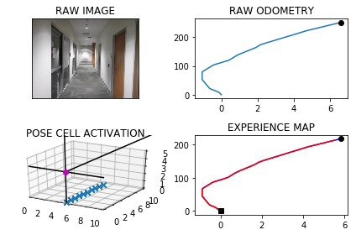

-----------------------------------------------------------

The current number of the iteration is 200

0.740999937057 seconds are elapsed per 100 frames.

The number of units of the VT is 94

The number of units of the experience map is 94

02/20/19 09:06:01

-----------------------------------------------------------

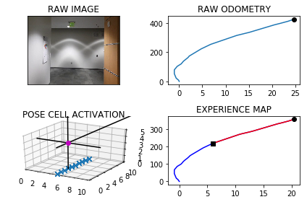

-----------------------------------------------------------

The current number of the iteration is 300

0.771999835968 seconds are elapsed per 100 frames.

The number of units of the VT is 136

The number of units of the experience map is 136

02/20/19 09:06:01

-----------------------------------------------------------

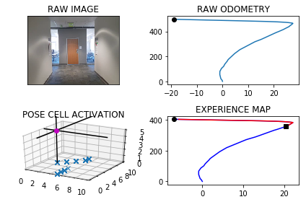

-----------------------------------------------------------

The current number of the iteration is 400

0.8109998703 seconds are elapsed per 100 frames.

The number of units of the VT is 196

The number of units of the experience map is 196

02/20/19 09:06:02

-----------------------------------------------------------

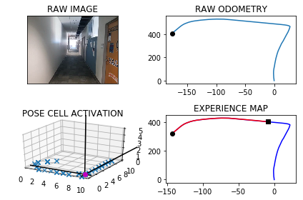

over

over

-----------------------------------------------------------

The current number of the iteration is 500

0.898000001907 seconds are elapsed per 100 frames.

The number of units of the VT is 241

The number of units of the experience map is 241

02/20/19 09:06:03

-----------------------------------------------------------

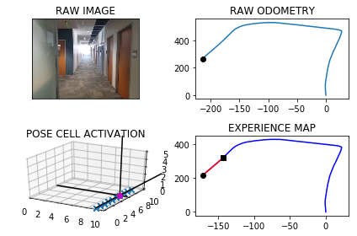

-----------------------------------------------------------

The current number of the iteration is 600

0.983999967575 seconds are elapsed per 100 frames.

The number of units of the VT is 283

The number of units of the experience map is 283

02/20/19 09:06:04

-----------------------------------------------------------

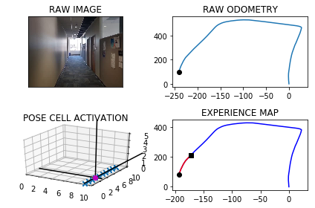

-----------------------------------------------------------

The current number of the iteration is 700

1.00300002098 seconds are elapsed per 100 frames.

The number of units of the VT is 328

The number of units of the experience map is 328

02/20/19 09:06:05

-----------------------------------------------------------

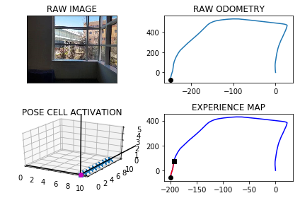

-----------------------------------------------------------

The current number of the iteration is 800

1.00600004196 seconds are elapsed per 100 frames.

The number of units of the VT is 378

The number of units of the experience map is 378

02/20/19 09:06:06

-----------------------------------------------------------

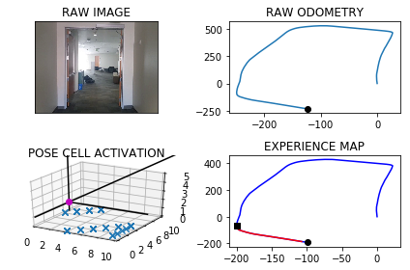

-----------------------------------------------------------

The current number of the iteration is 900

1.05400013924 seconds are elapsed per 100 frames.

The number of units of the VT is 416

The number of units of the experience map is 416

02/20/19 09:06:07

-----------------------------------------------------------

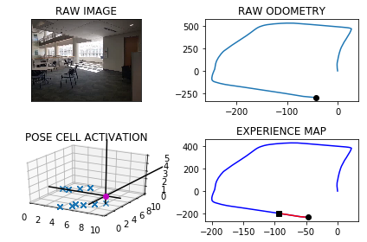

-----------------------------------------------------------

The current number of the iteration is 1000

1.07800006866 seconds are elapsed per 100 frames.

The number of units of the VT is 445

The number of units of the experience map is 445

02/20/19 09:06:08

-----------------------------------------------------------

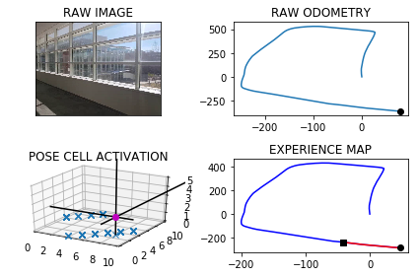

-----------------------------------------------------------

The current number of the iteration is 1100

1.13700008392 seconds are elapsed per 100 frames.

The number of units of the VT is 496

The number of units of the experience map is 496

02/20/19 09:06:09

-----------------------------------------------------------

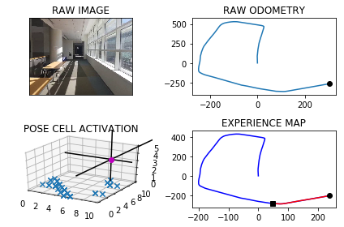

over

over

The counter is 1184

The angle is reset to 126.07500000000022

Energy injection at [9, 6]

min_delta_val

0.0

e_pc 9 6

current pc 9 6

loop closure

max_exp 1

over

over

-----------------------------------------------------------

The current number of the iteration is 1200

1.47200012207 seconds are elapsed per 100 frames.

The number of units of the VT is 544

The number of units of the experience map is 544

02/20/19 09:06:11

-----------------------------------------------------------

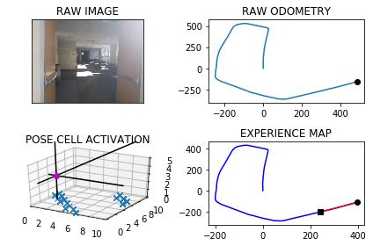

over

-----------------------------------------------------------

The current number of the iteration is 1300

1.2349998951 seconds are elapsed per 100 frames.

The number of units of the VT is 592

The number of units of the experience map is 592

02/20/19 09:06:12

-----------------------------------------------------------

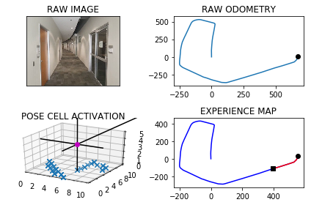

-----------------------------------------------------------

The current number of the iteration is 1400

1.28299999237 seconds are elapsed per 100 frames.

The number of units of the VT is 638

The number of units of the experience map is 638

02/20/19 09:06:13

-----------------------------------------------------------

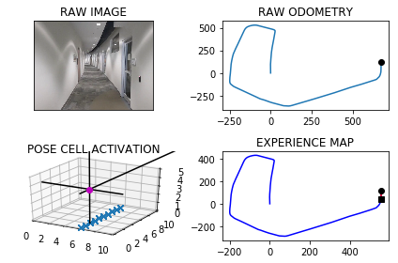

The counter is 1410

The angle is reset to 185.30250000000024

Energy injection at [6, 4]

-----------------------------------------------------------

The current number of the iteration is 1500

1.36000013351 seconds are elapsed per 100 frames.

The number of units of the VT is 681

The number of units of the experience map is 683

02/20/19 09:06:15

-----------------------------------------------------------

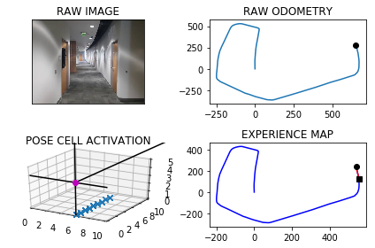

-----------------------------------------------------------

The current number of the iteration is 1600

1.3599998951 seconds are elapsed per 100 frames.

The number of units of the VT is 726

The number of units of the experience map is 729

02/20/19 09:06:16

-----------------------------------------------------------

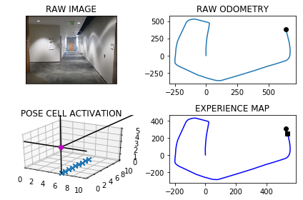

The counter is 1652

The angle is reset to 189.48675000000017

Energy injection at [6, 3]

min_delta_val

0.0

e_pc 6 3

current pc 6 3

loop closure

max_exp 2

The counter is 1653

The angle is reset to 186.6407250000001

Energy injection at [6, 3]

The counter is 1653

The maximum pc value is 0.24

The counter is 1654

The angle is reset to 184.64850750000008

Energy injection at [6, 3]

The counter is 1654

The maximum pc value is 0.256

The counter is 1671

The angle is reset to 197.27895525000005

Energy injection at [3, 6]

The counter is 1683

The angle is reset to 204.54526867500002

Energy injection at [3, 6]

min_delta_val

0.0

e_pc 3 6

current pc 3 6

loop closure

-----------------------------------------------------------

The current number of the iteration is 1700

2.32999992371 seconds are elapsed per 100 frames.

The number of units of the VT is 758

The number of units of the experience map is 762

02/20/19 09:06:18

-----------------------------------------------------------

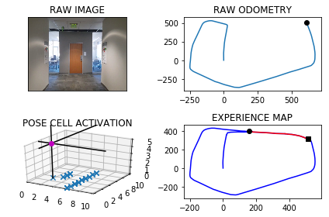

The counter is 1723

The angle is reset to 214.88168807250003

Energy injection at [8, 1]

min_delta_val

0.0

e_pc 8 1

current pc 8 1

loop closure

The counter is 1724

The angle is reset to 217.91718165075002

Energy injection at [8, 1]

The counter is 1725

The angle is reset to 220.04202715552498

Energy injection at [8, 1]

min_delta_val

0.0

e_pc 8 1

current pc 8 1

loop closure

over

The counter is 1769

The angle is reset to 326.07941900886755

Energy injection at [9, 6]

-----------------------------------------------------------

The current number of the iteration is 1800

2.47300004959 seconds are elapsed per 100 frames.

The number of units of the VT is 817

The number of units of the experience map is 822

02/20/19 09:06:21

-----------------------------------------------------------

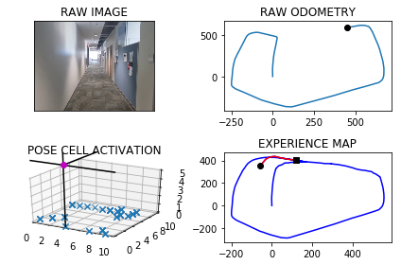

The counter is 1830

The angle is reset to 336.78059330620727

Energy injection at [9, 6]

The counter is 1849

The angle is reset to 344.27141531434506

Energy injection at [9, 9]

min_delta_val

0.0

e_pc 9 9

current pc 9 9

loop closure

The counter is 1850

The angle is reset to 348.98999072004153

Energy injection at [9, 0]

min_delta_val

0.0

e_pc 9 0

current pc 9 0

The counter is 1851

The angle is reset to 352.292993504029

Energy injection at [9, 0]

min_delta_val

0.0

e_pc 9 0

current pc 9 0

The counter is 1852

The angle is reset to 354.60509545282025

Energy injection at [9, 0]

The counter is 1853

The angle is reset to 356.22356681697426

Energy injection at [9, 0]

min_delta_val

0.0

e_pc 9 0

current pc 9 0

The counter is 1854

The angle is reset to 357.35649677188195

Energy injection at [9, 0]

The counter is 1855

The angle is reset to 358.1495477403173

Energy injection at [9, 0]

The counter is 1856

The angle is reset to 358.7046834182221

Energy injection at [9, 1]

min_delta_val

0.0

e_pc 9 1

current pc 9 1

The counter is 1857

The angle is reset to 359.0932783927555

Energy injection at [9, 1]

The counter is 1858

The angle is reset to 359.36529487492885

Energy injection at [9, 1]

The counter is 1859

The angle is reset to 359.55570641245015

Energy injection at [9, 1]

The counter is 1862

The angle is reset to 359.6889944887151

Energy injection at [9, 2]

min_delta_val

1.0

e_pc 9 2

current pc 9 1

loop closure

The counter is 1863

The angle is reset to 359.7822961421005

Energy injection at [9, 2]

The counter is 1864

The angle is reset to 359.8476072994703

Energy injection at [9, 2]

The counter is 1865

The angle is reset to 359.89332510962925

Energy injection at [9, 2]

The counter is 1866

The angle is reset to 359.9253275767405

Energy injection at [9, 2]

The counter is 1867

The angle is reset to 359.9477293037183

Energy injection at [9, 2]

min_delta_val

0.0

e_pc 9 2

current pc 9 2

The counter is 1868

The angle is reset to 359.96341051260276

Energy injection at [9, 2]

The counter is 1890

The angle is reset to 359.9743873588219

Energy injection at [9, 6]

min_delta_val

0.0

e_pc 9 6

current pc 9 6

loop closure

The counter is 1891

The angle is reset to 359.9820711511753

Energy injection at [9, 6]

min_delta_val

1.0

e_pc 9 7

current pc 9 6

The counter is 1892

The angle is reset to 359.98744980582273

Energy injection at [9, 6]

The counter is 1893

The angle is reset to 359.99121486407586

Energy injection at [9, 7]

min_delta_val

1.0

e_pc 9 7

current pc 9 6

The counter is 1894

The angle is reset to 359.99385040485305

Energy injection at [9, 7]

The counter is 1895

The angle is reset to 359.99569528339714

Energy injection at [9, 7]

min_delta_val

0.0

e_pc 9 7

current pc 9 7

The counter is 1897

The angle is reset to 359.99698669837795

Energy injection at [9, 7]

min_delta_val

1.0

e_pc 9 8

current pc 9 7

loop closure

-----------------------------------------------------------

The current number of the iteration is 1900

7.70200014114 seconds are elapsed per 100 frames.

The number of units of the VT is 854

The number of units of the experience map is 860

02/20/19 09:06:29

-----------------------------------------------------------

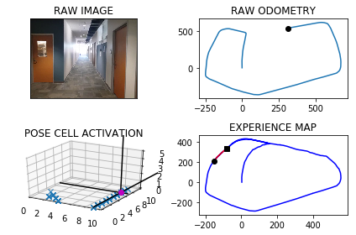

The counter is 1903

The angle is reset to 359.9978906888646

Energy injection at [9, 9]

The counter is 1904

The angle is reset to 359.4735234822052

Energy injection at [9, 9]

The counter is 1905

The angle is reset to 359.6314664375436

Energy injection at [9, 9]

min_delta_val

0.0

e_pc 9 9

current pc 9 9

loop closure

The counter is 1906

The angle is reset to 359.7420265062805

Energy injection at [9, 9]

The counter is 1910

The angle is reset to 0.8694185543963725

Energy injection at [9, 0]

The counter is 1911

The angle is reset to 1.1335929880774607

Energy injection at [9, 0]

The counter is 1912

The angle is reset to 1.3185150916542223

Energy injection at [9, 0]

The counter is 1913

The angle is reset to 0.9229605641579557

Energy injection at [9, 0]

min_delta_val

1.0

e_pc 9 1

current pc 9 0

loop closure

The counter is 1914

The angle is reset to 0.646072394910569

Energy injection at [9, 0]

The counter is 1915

The angle is reset to 0.45225067643739825

Energy injection at [9, 1]

min_delta_val

1.0

e_pc 9 1

current pc 9 0

The counter is 1916

The angle is reset to 0.3165754735061787

Energy injection at [9, 1]

The counter is 1917

The angle is reset to 0.22160283145432508

Energy injection at [9, 1]

The counter is 1926

The angle is reset to 0.15512198201802757

Energy injection at [9, 3]

The counter is 1927

The angle is reset to 0.10858538741261929

Energy injection at [9, 3]

The counter is 1937

The angle is reset to 2.176009771188833

Energy injection at [9, 5]

The counter is 1938

The angle is reset to 1.523206839832183

Energy injection at [9, 5]

The counter is 1939

The angle is reset to 1.066244787882528

Energy injection at [9, 5]

The counter is 1940

The angle is reset to 0.7463713515177696

Energy injection at [9, 5]

The counter is 1945

The angle is reset to 0.5224599460624386

Energy injection at [9, 7]

min_delta_val

0.0

e_pc 9 7

current pc 9 7

loop closure

The counter is 1946

The angle is reset to 0.365721962243707

Energy injection at [9, 7]

The counter is 1947

The angle is reset to 0.25600537357059494

Energy injection at [9, 7]

min_delta_val

1.0

e_pc 9 8

current pc 9 7

The counter is 1948

The angle is reset to 0.17920376149941641

Energy injection at [9, 7]

The counter is 1957

The angle is reset to 0.1254426330495915

Energy injection at [9, 9]

min_delta_val

0.0

e_pc 9 9

current pc 9 9

loop closure

The counter is 1958

The angle is reset to 0.08780984313471404

Energy injection at [9, 9]

The counter is 1959

The angle is reset to 0.06146689019429983

Energy injection at [9, 9]

min_delta_val

1.0

e_pc 9 0

current pc 9 9

The counter is 1960

The angle is reset to 0.04302682313600988

Energy injection at [9, 9]

The counter is 1963

The angle is reset to 0.030118776195206913

Energy injection at [9, 0]

min_delta_val

0.0

e_pc 9 0

current pc 9 0

loop closure

The counter is 1976

The angle is reset to 0.5460831433366448

Energy injection at [9, 2]

The counter is 1977

The angle is reset to 0.3822582003356514

Energy injection at [9, 2]

The counter is 1978

The angle is reset to 0.2675807402349559

Energy injection at [9, 2]

The counter is 1979

The angle is reset to 0.18730651816446917

Energy injection at [9, 2]

The counter is 1980

The angle is reset to 0.6561145627151285

Energy injection at [9, 3]

min_delta_val

0.0

e_pc 9 3

current pc 9 3

loop closure

The counter is 1981

The angle is reset to 0.9842801939005897

Energy injection at [9, 3]

The counter is 1984

The angle is reset to 0.6889961357304127

Energy injection at [9, 3]

min_delta_val

1.0

e_pc 9 4

current pc 9 3

loop closure

The counter is 1985

The angle is reset to 0.4822972950112889

Energy injection at [9, 3]

The counter is 1986

The angle is reset to 359.81260810650787

Energy injection at [9, 3]

The counter is 1990

The angle is reset to 359.8688256745554

Energy injection at [9, 5]

min_delta_val

1.0

e_pc 9 5

current pc 9 4

loop closure

The counter is 1991

The angle is reset to 0.4331779721888278

Energy injection at [9, 5]

The counter is 1992

The angle is reset to 0.3032245805321795

Energy injection at [9, 4]

min_delta_val

0.0

e_pc 9 5

current pc 9 5

loop closure

The counter is 1993

The angle is reset to 0.7372572063725255

Energy injection at [9, 5]

min_delta_val

1.0

e_pc 9 6

current pc 9 5

loop closure

The counter is 1994

The angle is reset to 0.5160800444607679

Energy injection at [9, 5]

The counter is 1995

The angle is reset to 0.36125603112253746

Energy injection at [9, 6]

min_delta_val

1.0

e_pc 9 6

current pc 9 5

The counter is 1996

The angle is reset to 0.25287922178577626

Energy injection at [9, 6]

The counter is 1997

The angle is reset to 0.17701545525004336

Energy injection at [9, 6]

The counter is 1998

The angle is reset to 0.12391081867503034

Energy injection at [9, 6]

The counter is 1999

The angle is reset to 0.08673757307252122

Energy injection at [9, 6]

The counter is 2000

The angle is reset to 0.06071630115076486

Energy injection at [9, 6]

-----------------------------------------------------------

The current number of the iteration is 2000

8.76300001144 seconds are elapsed per 100 frames.

The number of units of the VT is 878

The number of units of the experience map is 889

02/20/19 09:06:37

-----------------------------------------------------------

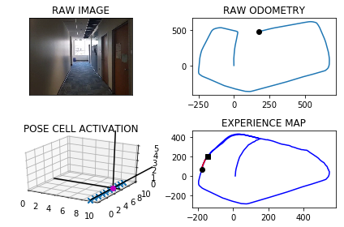

The counter is 2003

The angle is reset to 0.0425014108055354

Energy injection at [9, 7]

min_delta_val

1.0

e_pc 9 7

current pc 9 6

loop closure

The counter is 2009

The angle is reset to 0.029750987563874776

Energy injection at [9, 8]

min_delta_val

0.0

e_pc 9 8

current pc 9 8

loop closure

The counter is 2015

The angle is reset to 0.5458256912947123

Energy injection at [9, 9]

min_delta_val

1.0

e_pc 9 0

current pc 9 9

loop closure

The counter is 2016

The angle is reset to 0.38207798390629855

Energy injection at [9, 9]

The counter is 2017

The angle is reset to 0.26745458873440897

Energy injection at [9, 9]

The counter is 2018

The angle is reset to 0.18721821211408626

Energy injection at [9, 0]

min_delta_val

0.0

e_pc 9 0

current pc 9 0

The counter is 2019

The angle is reset to 0.13105274847986037

Energy injection at [9, 0]

min_delta_val

0.0

e_pc 9 0

current pc 9 0

The counter is 2020

The angle is reset to 0.09173692393590226

Energy injection at [9, 0]

The counter is 2021

The angle is reset to 359.5392158467551

Energy injection at [9, 1]

min_delta_val

1.0

e_pc 9 1

current pc 9 0

loop closure

The counter is 2022

The angle is reset to 359.6774510927286

Energy injection at [9, 1]

The counter is 2025

The angle is reset to 359.77421576490997

Energy injection at [9, 1]

min_delta_val

1.0

e_pc 9 1

current pc 9 2

loop closure

The counter is 2026

The angle is reset to 359.841951035437

Energy injection at [9, 1]

The counter is 2027

The angle is reset to 359.8893657248059

Energy injection at [9, 1]

The counter is 2028

The angle is reset to 359.9225560073641

Energy injection at [9, 1]

The counter is 2030

The angle is reset to 359.9457892051548

Energy injection at [9, 2]

min_delta_val

1.0

e_pc 9 2

current pc 9 1

loop closure

The counter is 2031

The angle is reset to 359.9620524436084

Energy injection at [9, 2]

The counter is 2037

The angle is reset to 0.49843671052586364

Energy injection at [9, 3]

min_delta_val

1.0

e_pc 9 3

current pc 9 4

loop closure

The counter is 2042

The angle is reset to 0.8739056973681044

Energy injection at [9, 4]

min_delta_val

0.0

e_pc 9 4

current pc 9 4

loop closure

The counter is 2043

The angle is reset to 0.08673398815767312

Energy injection at [9, 4]

The counter is 2055

The angle is reset to 0.5857137917103711

Energy injection at [9, 7]

min_delta_val

1.0

e_pc 9 7

current pc 9 6

loop closure

The counter is 2077

The angle is reset to 359.88499965419726

Energy injection at [9, 9]

min_delta_val

0.0

e_pc 9 0

current pc 9 0

loop closure

The counter is 2078

The angle is reset to 359.91949975793807

Energy injection at [9, 9]

-----------------------------------------------------------

The current number of the iteration is 2100

7.92199993134 seconds are elapsed per 100 frames.

The number of units of the VT is 923

The number of units of the experience map is 934

02/20/19 09:06:45

-----------------------------------------------------------

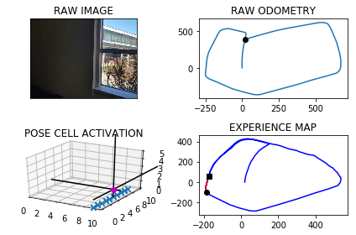

The counter is 2102

The angle is reset to 41.268649830556654

Energy injection at [9, 5]

min_delta_val

0.0

e_pc 9 5

current pc 9 5

loop closure

The counter is 2103

The angle is reset to 36.61305488138965

Energy injection at [9, 5]

min_delta_val

0.0

e_pc 9 5

current pc 9 5

The counter is 2105

The angle is reset to 39.12913841697275

Energy injection at [9, 5]

min_delta_val

0.0

e_pc 9 5

current pc 9 5

loop closure

The counter is 2106

The angle is reset to 34.06539689188092

Energy injection at [9, 5]

min_delta_val

0.0

e_pc 9 5

current pc 9 5

The counter is 2107

The angle is reset to 37.34577782431665

Energy injection at [9, 5]

min_delta_val

1.4142135623730951

e_pc 9 5

current pc 0 6

The counter is 2108

The angle is reset to 43.31704447702164

Energy injection at [9, 5]

min_delta_val

0.0

e_pc 0 6

current pc 0 6

The counter is 2109

The angle is reset to 43.82193113391514

Energy injection at [0, 6]

min_delta_val

0.0

e_pc 1 7

current pc 1 7

The counter is 2112

The angle is reset to 49.4253517937406

Energy injection at [1, 7]

min_delta_val

0.0

e_pc 1 7

current pc 1 7

loop closure

The counter is 2171

The angle is reset to 53.34774625561841

Energy injection at [8, 4]

min_delta_val

0.0

e_pc 8 4

current pc 8 4

loop closure

The counter is 2172

The angle is reset to 50.843422378932885

Energy injection at [8, 4]

The counter is 2173

The angle is reset to 49.09039566525302

Energy injection at [8, 4]

The counter is 2174

The angle is reset to 47.86327696567711

Energy injection at [8, 4]

The counter is 2175

The angle is reset to 47.00429387597397

Energy injection at [8, 4]

min_delta_val

0.0

e_pc 8 4

current pc 8 4

The counter is 2176

The angle is reset to 45.878005713181786

Energy injection at [8, 4]

-----------------------------------------------------------

The current number of the iteration is 2200

7.30900001526 seconds are elapsed per 100 frames.

The number of units of the VT is 969

The number of units of the experience map is 980

02/20/19 09:06:53

-----------------------------------------------------------

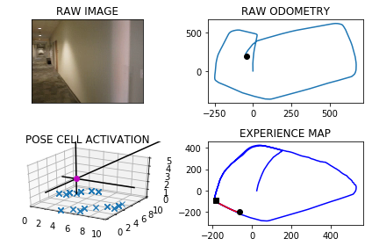

-----------------------------------------------------------

The current number of the iteration is 2300

1.72699999809 seconds are elapsed per 100 frames.

The number of units of the VT is 1031

The number of units of the experience map is 1042

02/20/19 09:06:54

-----------------------------------------------------------

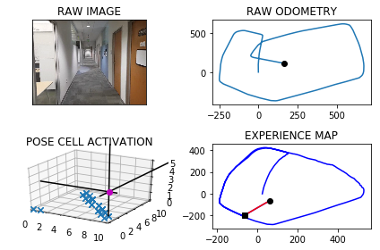

The counter is 2342

The angle is reset to 148.06460399922722

Energy injection at [5, 5]

The counter is 2346

The angle is reset to 157.64522279945905

Energy injection at [5, 2]

The counter is 2347

The angle is reset to 164.87665595962136

Energy injection at [5, 3]

min_delta_val

0.0

e_pc 5 3

current pc 5 3

loop closure

The counter is 2348

The angle is reset to 169.93865917173494

Energy injection at [5, 2]

The counter is 2349

The angle is reset to 173.48206142021445

Energy injection at [5, 2]

The counter is 2350

The angle is reset to 175.9624429941501

Energy injection at [5, 1]

min_delta_val

0.0

e_pc 5 1

current pc 5 1

loop closure

The counter is 2352

The angle is reset to 177.17371009590508

Energy injection at [5, 0]

min_delta_val

1.0

e_pc 5 0

current pc 5 1

loop closure

The counter is 2367

The angle is reset to 177.49659706713354

Energy injection at [5, 8]

min_delta_val

1.0

e_pc 5 7

current pc 5 8

loop closure

The counter is 2368

The angle is reset to 177.72261794699344

Energy injection at [5, 7]

min_delta_val

0.0

e_pc 5 7

current pc 5 7

The counter is 2369

The angle is reset to 178.40583256289543

Energy injection at [5, 7]

min_delta_val

0.0

e_pc 5 7

current pc 5 7

The counter is 2370

The angle is reset to 178.88408279402677

Energy injection at [5, 7]

The counter is 2371

The angle is reset to 179.21885795581872

Energy injection at [5, 6]

min_delta_val

0.0

e_pc 5 6

current pc 5 6

The counter is 2372

The angle is reset to 179.4532005690731

Energy injection at [5, 6]

min_delta_val

0.0

e_pc 5 6

current pc 5 6

The counter is 2373

The angle is reset to 179.61724039835119

Energy injection at [5, 6]

min_delta_val

1.0

e_pc 5 5

current pc 5 6

The counter is 2374

The angle is reset to 179.73206827884582

Energy injection at [5, 6]

The counter is 2375

The angle is reset to 179.81244779519207

Energy injection at [5, 6]

The counter is 2380

The angle is reset to 179.34371345663445

Energy injection at [5, 4]

min_delta_val

0.0

e_pc 5 4

current pc 5 4

loop closure

The counter is 2398

The angle is reset to 180.06559941964412

Energy injection at [5, 7]

The counter is 2399

The angle is reset to 180.5709195937509

Energy injection at [5, 7]

-----------------------------------------------------------

The current number of the iteration is 2400

8.27600002289 seconds are elapsed per 100 frames.

The number of units of the VT is 1078

The number of units of the experience map is 1094

02/20/19 09:07:03

-----------------------------------------------------------

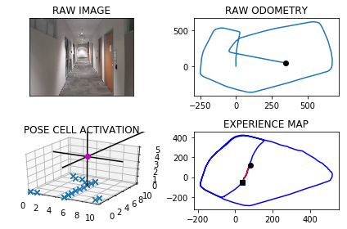

The counter is 2404

The angle is reset to 180.39964371562561

Energy injection at [5, 5]

min_delta_val

0.0

e_pc 5 5

current pc 5 5

loop closure

The counter is 2405

The angle is reset to 180.27975060093792

Energy injection at [5, 4]

min_delta_val

0.0

e_pc 5 4

current pc 5 4

The counter is 2406

The angle is reset to 180.19582542065652

Energy injection at [5, 4]

The counter is 2407

The angle is reset to 180.66207779445958

Energy injection at [5, 4]

min_delta_val

1.0

e_pc 5 3

current pc 5 4

The counter is 2408

The angle is reset to 180.46345445612167

Energy injection at [5, 4]

The counter is 2415

The angle is reset to 179.79941811928518

Energy injection at [5, 1]

min_delta_val

0.0

e_pc 5 1

current pc 5 1

loop closure

The counter is 2420

The angle is reset to 179.85959268349964

Energy injection at [5, 0]

min_delta_val

0.0

e_pc 5 0

current pc 5 0

loop closure

The counter is 2427

The angle is reset to 179.90171487844972

Energy injection at [5, 8]

min_delta_val

0.0

e_pc 5 8

current pc 5 8

loop closure

The counter is 2428

The angle is reset to 179.9312004149148

Energy injection at [5, 8]

The counter is 2431

The angle is reset to 179.95184029044034

Energy injection at [5, 7]

min_delta_val

0.0

e_pc 5 7

current pc 5 7

loop closure

The counter is 2437

The angle is reset to 179.96628820330824

Energy injection at [5, 5]

min_delta_val

0.0

e_pc 5 5

current pc 5 5

loop closure

The counter is 2440

The angle is reset to 179.97640174231577

Energy injection at [5, 4]

The counter is 2448

The angle is reset to 179.983481219621

Energy injection at [5, 2]

min_delta_val

1.0

e_pc 5 2

current pc 5 1

loop closure

The counter is 2449

The angle is reset to 179.98843685373467

Energy injection at [5, 2]

The counter is 2450

The angle is reset to 179.99190579761424

Energy injection at [5, 1]

min_delta_val

0.0

e_pc 5 1

current pc 5 1

The counter is 2451

The angle is reset to 179.99433405833

Energy injection at [5, 1]

The counter is 2454

The angle is reset to 179.996033840831

Energy injection at [5, 0]

min_delta_val

0.0

e_pc 5 0

current pc 5 0

loop closure

The counter is 2455

The angle is reset to 179.99722368858167

Energy injection at [5, 0]

The counter is 2456

The angle is reset to 179.99805658200714

Energy injection at [5, 0]

The counter is 2459

The angle is reset to 179.99863960740498

Energy injection at [5, 9]

min_delta_val

0.0

e_pc 5 9

current pc 5 9

loop closure

The counter is 2460

The angle is reset to 179.9990477251835

Energy injection at [5, 0]

min_delta_val

0.0

e_pc 5 0

current pc 5 0

loop closure

The counter is 2478

The angle is reset to 180.52433340762846

Energy injection at [5, 6]

The counter is 2483

The angle is reset to 180.36703338533988

Energy injection at [5, 6]

min_delta_val

0.0

e_pc 5 6

current pc 5 6

loop closure

The counter is 2484

The angle is reset to 180.2569233697379

Energy injection at [5, 6]

min_delta_val

0.0

e_pc 5 6

current pc 5 6

The counter is 2485

The angle is reset to 180.17984635881652

Energy injection at [5, 6]

The counter is 2486

The angle is reset to 179.60089245117157

Energy injection at [5, 5]

min_delta_val

0.0

e_pc 5 5

current pc 5 5

The counter is 2487

The angle is reset to 179.72062471582007

Energy injection at [5, 5]

The counter is 2488

The angle is reset to 179.80443730107405

Energy injection at [5, 5]

min_delta_val

0.0

e_pc 5 5

current pc 5 5

-----------------------------------------------------------

The current number of the iteration is 2500

13.2139999866 seconds are elapsed per 100 frames.

The number of units of the VT is 1119

The number of units of the experience map is 1138

02/20/19 09:07:16

-----------------------------------------------------------

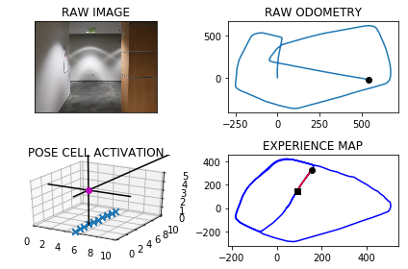

The counter is 2517

The angle is reset to 179.33810611075185

Energy injection at [5, 2]

min_delta_val

1.0

e_pc 5 1

current pc 5 2

loop closure

The counter is 2518

The angle is reset to 179.53667427752626

Energy injection at [5, 2]

The counter is 2519

The angle is reset to 179.67567199426838

Energy injection at [5, 2]

The counter is 2520

The angle is reset to 179.24797039598786

Energy injection at [5, 2]

The counter is 2521

The angle is reset to 178.9485792771915

Energy injection at [5, 2]

The counter is 2522

The angle is reset to 179.26400549403405

Energy injection at [5, 2]

The counter is 2523

The angle is reset to 179.48480384582382

Energy injection at [5, 2]

The counter is 2524

The angle is reset to 179.11436269207667

Energy injection at [5, 1]

min_delta_val

1.0

e_pc 5 1

current pc 5 2

The counter is 2525

The angle is reset to 179.38005388445364

Energy injection at [5, 1]

The counter is 2526

The angle is reset to 179.56603771911753

Energy injection at [5, 1]

The counter is 2527

The angle is reset to 179.69622640338227

Energy injection at [5, 1]

The counter is 2528

The angle is reset to 180.31235848236759

Energy injection at [5, 1]

The counter is 2529

The angle is reset to 180.7436509376573

Energy injection at [5, 1]

The counter is 2530

The angle is reset to 180.5205556563601

Energy injection at [5, 0]

min_delta_val

0.0

e_pc 5 0

current pc 5 0

The counter is 2531

The angle is reset to 180.36438895945204

Energy injection at [5, 0]

The counter is 2532

The angle is reset to 180.25507227161643

Energy injection at [5, 0]

The counter is 2533

The angle is reset to 180.17855059013152

Energy injection at [5, 0]

The counter is 2534

The angle is reset to 180.12498541309202

Energy injection at [5, 0]

The counter is 2539

The angle is reset to 179.0374897891644

Energy injection at [5, 0]

min_delta_val

1.0

e_pc 5 0

current pc 5 9

loop closure

The counter is 2540

The angle is reset to 179.32624285241508

Energy injection at [5, 0]

The counter is 2541

The angle is reset to 180.05336999669055

Energy injection at [5, 0]

The counter is 2542

The angle is reset to 180.03735899768336

Energy injection at [5, 0]

The counter is 2543

The angle is reset to 180.02615129837838

Energy injection at [5, 0]

The counter is 2544

The angle is reset to 180.01830590886485

Energy injection at [5, 0]

The counter is 2557

The angle is reset to 229.21281413620537

Energy injection at [5, 8]

min_delta_val

0.0

e_pc 5 8

current pc 5 8

loop closure

The counter is 2590

The angle is reset to 234.92396989534384

Energy injection at [3, 5]

-----------------------------------------------------------

The current number of the iteration is 2600

5.30099987984 seconds are elapsed per 100 frames.

The number of units of the VT is 1156

The number of units of the experience map is 1176

02/20/19 09:07:21

-----------------------------------------------------------

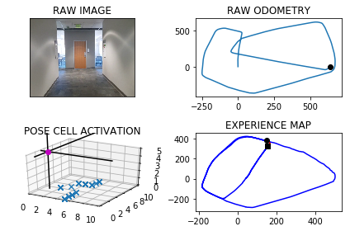

The counter is 2604

The angle is reset to 232.99677892674066

Energy injection at [2, 5]

The counter is 2619

The angle is reset to 232.69774524871843

Energy injection at [1, 2]

The counter is 2620

The angle is reset to 230.38842167410291

Energy injection at [1, 2]

min_delta_val

1.4142135623730951

e_pc 1 2

current pc 0 1

loop closure

The counter is 2631

The angle is reset to 229.29689517187205

Energy injection at [8, 1]

The counter is 2632

The angle is reset to 228.00782662031042

Energy injection at [8, 1]

The counter is 2633

The angle is reset to 227.1054786342173

Energy injection at [8, 1]

The counter is 2634

The angle is reset to 226.4738350439521

Energy injection at [8, 1]

min_delta_val

1.4142135623730951

e_pc 8 1

current pc 7 0

loop closure

The counter is 2635

The angle is reset to 226.03168453076648

Energy injection at [8, 1]

The counter is 2636

The angle is reset to 225.72217917153654

Energy injection at [8, 1]

The counter is 2639

The angle is reset to 226.55552542007558

Energy injection at [7, 0]

min_delta_val

0.0

e_pc 7 0

current pc 7 0

loop closure

The counter is 2640

The angle is reset to 226.6138677940529

Energy injection at [7, 0]

The counter is 2641

The angle is reset to 226.65470745583704

Energy injection at [7, 0]

min_delta_val

1.4142135623730951

e_pc 6 9

current pc 7 0

The counter is 2643

The angle is reset to 227.2082952190859

Energy injection at [6, 9]

min_delta_val

0.0

e_pc 6 9

current pc 6 9

loop closure

over

The counter is 2661

The angle is reset to 309.1958066533601

Energy injection at [0, 8]

min_delta_val

0.0

e_pc 0 8

current pc 0 8

loop closure

The counter is 2662

The angle is reset to 313.03706465735206

Energy injection at [0, 8]

min_delta_val

0.0

e_pc 0 8

current pc 0 8

The counter is 2664

The angle is reset to 317.3009452601464

Energy injection at [0, 8]

min_delta_val

0.0

e_pc 0 8

current pc 0 8

loop closure

The counter is 2670

The angle is reset to 318.71066168210245

Energy injection at [8, 8]

min_delta_val

1.0

e_pc 8 9

current pc 8 8

loop closure

The counter is 2673

The angle is reset to 317.59746317747175

Energy injection at [8, 9]

min_delta_val

0.0

e_pc 8 9

current pc 8 9

loop closure

The counter is 2676

The angle is reset to 317.3432242242302

Energy injection at [8, 7]

The counter is 2677

The angle is reset to 317.69025695696115

Energy injection at [8, 7]

The counter is 2683

The angle is reset to 316.35817986987274

Energy injection at [7, 6]

The counter is 2695

The angle is reset to 315.4257259089109

Energy injection at [6, 8]

-----------------------------------------------------------

The current number of the iteration is 2700

9.44900012016 seconds are elapsed per 100 frames.

The number of units of the VT is 1202

The number of units of the experience map is 1228

02/20/19 09:07:31

-----------------------------------------------------------

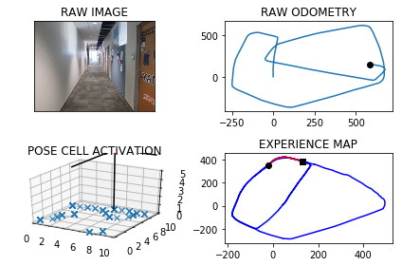

The counter is 2704

The angle is reset to 314.77300813623765

Energy injection at [4, 0]

min_delta_val

0.0

e_pc 4 0

current pc 4 0

loop closure

The counter is 2705

The angle is reset to 314.84110569536637

Energy injection at [4, 0]

The counter is 2706

The angle is reset to 314.88877398675646

Energy injection at [4, 0]

The counter is 2707

The angle is reset to 314.3971417907295

Energy injection at [4, 0]

The counter is 2715

The angle is reset to 314.0529992535107

Energy injection at [3, 1]

min_delta_val

0.0

e_pc 3 1

current pc 3 1

loop closure

The counter is 2716

The angle is reset to 314.3370994774574

Energy injection at [3, 1]

The counter is 2717

The angle is reset to 314.5359696342202

Energy injection at [3, 1]

The counter is 2724

The angle is reset to 315.2001787439541

Energy injection at [2, 1]

min_delta_val

0.0

e_pc 2 1

current pc 2 1

loop closure

The counter is 2725

The angle is reset to 315.14012512076783

Energy injection at [2, 1]

The counter is 2726

The angle is reset to 315.0980875845375

Energy injection at [2, 1]

The counter is 2727

The angle is reset to 315.06866130917626

Energy injection at [2, 1]

min_delta_val

1.0

e_pc 2 1

current pc 1 1

The counter is 2731

The angle is reset to 315.04806291642336

Energy injection at [2, 2]

min_delta_val

0.0

e_pc 2 2

current pc 2 2

loop closure

The counter is 2732

The angle is reset to 315.03364404149636

Energy injection at [2, 2]

The counter is 2733

The angle is reset to 315.02355082904745

Energy injection at [2, 2]

The counter is 2734

The angle is reset to 315.0164855803332

Energy injection at [2, 2]

min_delta_val

0.0

e_pc 1 3

current pc 1 3

The counter is 2735

The angle is reset to 315.53653990623326

Energy injection at [2, 2]

The counter is 2736

The angle is reset to 315.37557793436326

Energy injection at [9, 6]

min_delta_val

7.810249675906654

e_pc 9 6

current pc 2 2

new experience map with case 2

The counter is 2737

The angle is reset to 315.2629045540543

Energy injection at [9, 6]

The counter is 2738

The angle is reset to 315.18403318783794

Energy injection at [9, 6]

counter 2740

multiple peak # >2

[8L, 9L, 9L] [7L, 6L, 7L]

counter 2742

multiple peak # >2

[8L, 8L, 9L, 9L] [6L, 7L, 6L, 7L]

counter 2743

multiple peak # >2

[8L, 8L, 9L, 9L] [6L, 7L, 6L, 7L]

The counter is 2744

The angle is reset to 328.10382323148656

Energy injection at [9, 7]

min_delta_val

6.082762530298219

e_pc 9 8

current pc 9 7

new experience map with case 2

The counter is 2745

The angle is reset to 337.67267626204057

Energy injection at [9, 8]

The counter is 2746

The angle is reset to 344.3708733834284

Energy injection at [9, 8]

min_delta_val

0.0

e_pc 9 8

current pc 9 8

loop closure

The counter is 2747

The angle is reset to 349.58461136839986

Energy injection at [9, 7]

min_delta_val

0.0

e_pc 9 7

current pc 9 7

loop closure

The counter is 2748

The angle is reset to 352.70922795787993

Energy injection at [9, 7]

min_delta_val

1.0

e_pc 9 8

current pc 9 7

The counter is 2753

The angle is reset to 353.8464595705159

Energy injection at [9, 8]

min_delta_val

0.0

e_pc 9 8

current pc 9 8

loop closure

The counter is 2754

The angle is reset to 355.16752169936115

Energy injection at [9, 9]

min_delta_val

1.0

e_pc 9 9

current pc 9 8

The counter is 2755

The angle is reset to 356.0922651895528

Energy injection at [9, 0]

min_delta_val

1.0

e_pc 9 0

current pc 9 9

The counter is 2759

The angle is reset to 357.26458563268693

Energy injection at [9, 0]

min_delta_val

0.0

e_pc 9 0

current pc 9 0

loop closure

The counter is 2760

The angle is reset to 358.0852099428809

Energy injection at [9, 0]

The counter is 2761

The angle is reset to 358.6596469600166

Energy injection at [9, 0]

The counter is 2762

The angle is reset to 358.53675287201156

Energy injection at [9, 1]

min_delta_val

0.0

e_pc 9 1

current pc 9 1

The counter is 2763

The angle is reset to 358.4507270104081

Energy injection at [9, 1]

The counter is 2764

The angle is reset to 358.91550890728564

Energy injection at [9, 1]

min_delta_val

0.0

e_pc 9 1

current pc 9 1

The counter is 2765

The angle is reset to 359.24085623509995

Energy injection at [9, 1]

The counter is 2766

The angle is reset to 359.46859936456997

Energy injection at [9, 1]

The counter is 2770

The angle is reset to 359.62801955519893

Energy injection at [9, 2]

min_delta_val

0.0

e_pc 9 2

current pc 9 2

loop closure

The counter is 2771

The angle is reset to 359.7396136886392

Energy injection at [9, 2]

The counter is 2772

The angle is reset to 359.8177295820474

Energy injection at [9, 2]

The counter is 2773

The angle is reset to 359.8724107074332

Energy injection at [9, 2]

min_delta_val

0.0

e_pc 9 2

current pc 9 2

The counter is 2774

The angle is reset to 359.91068749520315

Energy injection at [9, 2]

The counter is 2775

The angle is reset to 359.9374812466423

Energy injection at [9, 2]

min_delta_val

0.0

e_pc 9 2

current pc 9 2

The counter is 2776

The angle is reset to 359.4312368726495

Energy injection at [9, 3]

min_delta_val

0.0

e_pc 9 3

current pc 9 3

loop closure

The counter is 2781

The angle is reset to 0.12686581085467932

Energy injection at [9, 3]

min_delta_val

0.0

e_pc 9 3

current pc 9 3

loop closure

The counter is 2782

The angle is reset to 0.6138060675982754

Energy injection at [9, 4]

min_delta_val

0.0

e_pc 9 4

current pc 9 4

The counter is 2783

The angle is reset to 0.9546642473187927

Energy injection at [9, 4]

The counter is 2784

The angle is reset to 0.6682649731231549

Energy injection at [9, 4]

min_delta_val

0.0

e_pc 9 4

current pc 9 4

The counter is 2785

The angle is reset to 0.9927854811862082

Energy injection at [9, 4]

The counter is 2788

The angle is reset to 0.1699498368303458

Energy injection at [9, 4]

min_delta_val

1.0

e_pc 9 5

current pc 9 4

loop closure

-----------------------------------------------------------

The current number of the iteration is 2800

21.6289999485 seconds are elapsed per 100 frames.

The number of units of the VT is 1226

The number of units of the experience map is 1256

02/20/19 09:07:52

-----------------------------------------------------------

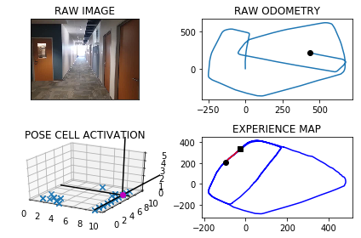

-----------------------------------------------------------

The current number of the iteration is 2900

2.0039999485 seconds are elapsed per 100 frames.

The number of units of the VT is 1281

The number of units of the experience map is 1314

02/20/19 09:07:54

-----------------------------------------------------------

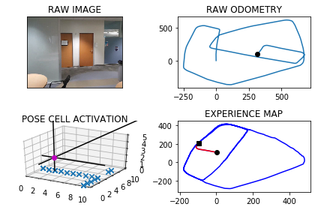

The counter is 2966

The angle is reset to 172.7689648857813

Energy injection at [5, 0]

The counter is 2967

The angle is reset to 175.46327542004693

Energy injection at [5, 0]

The counter is 2968

The angle is reset to 177.3492927940328

Energy injection at [5, 0]

min_delta_val

1.0

e_pc 5 0

current pc 5 9

loop closure

The counter is 2970

The angle is reset to 178.14450495582295

Energy injection at [5, 9]

min_delta_val

0.0

e_pc 5 9

current pc 5 9

loop closure

The counter is 2971

The angle is reset to 178.70115346907605

Energy injection at [5, 9]

min_delta_val

1.0

e_pc 5 8

current pc 5 9

The counter is 2975

The angle is reset to 178.56580742835322

Energy injection at [5, 6]

The counter is 2976

The angle is reset to 178.99606519984727

Energy injection at [5, 6]

-----------------------------------------------------------

The current number of the iteration is 3000

4.61599993706 seconds are elapsed per 100 frames.

The number of units of the VT is 1343

The number of units of the experience map is 1378

02/20/19 09:07:59

-----------------------------------------------------------

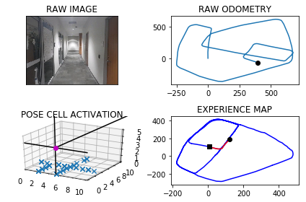

The counter is 3008

The angle is reset to 179.82224563989308

Energy injection at [5, 6]

The counter is 3009

The angle is reset to 179.35057194792515

Energy injection at [5, 6]

min_delta_val

1.0

e_pc 5 5

current pc 5 6

loop closure

The counter is 3012

The angle is reset to 179.54540036354757

Energy injection at [5, 5]

The counter is 3013

The angle is reset to 179.68178025448327

Energy injection at [5, 5]

The counter is 3014

The angle is reset to 179.77724617813828

Energy injection at [5, 3]

min_delta_val

1.0

e_pc 5 3

current pc 5 4

loop closure

The counter is 3015

The angle is reset to 179.8440723246968

Energy injection at [5, 3]

The counter is 3017

The angle is reset to 179.89085062728776

Energy injection at [5, 3]

min_delta_val

1.0

e_pc 5 3

current pc 5 2

loop closure

The counter is 3018

The angle is reset to 179.39859543910143

Energy injection at [5, 3]

The counter is 3019

The angle is reset to 179.579016807371

Energy injection at [5, 3]

min_delta_val

1.0

e_pc 5 2

current pc 5 3

loop closure

The counter is 3026

The angle is reset to 179.70531176515965

Energy injection at [5, 1]

The counter is 3027

The angle is reset to 179.79371823561175

Energy injection at [5, 1]

The counter is 3030

The angle is reset to 180.3806027649282

Energy injection at [5, 0]

min_delta_val

1.0

e_pc 5 9

current pc 5 0

loop closure

The counter is 3048

The angle is reset to 181.31642193544974

Energy injection at [5, 7]

min_delta_val

0.0

e_pc 5 7

current pc 5 7

loop closure

The counter is 3049

The angle is reset to 181.4464953548148

Energy injection at [5, 7]

The counter is 3050

The angle is reset to 181.01254674837034

Energy injection at [5, 5]

min_delta_val

1.0

e_pc 5 5

current pc 5 6

loop closure

The counter is 3051

The angle is reset to 180.70878272385923

Energy injection at [5, 5]

min_delta_val

0.0

e_pc 5 5

current pc 5 5

The counter is 3052

The angle is reset to 180.49614790670148

Energy injection at [5, 5]

The counter is 3053

The angle is reset to 180.347303534691

Energy injection at [5, 5]

The counter is 3054

The angle is reset to 180.24311247428372

Energy injection at [5, 5]

The counter is 3074

The angle is reset to 181.74517873199858

Energy injection at [5, 3]

min_delta_val

0.0

e_pc 5 2

current pc 5 2

loop closure

The counter is 3079

The angle is reset to 180.171625112399

Energy injection at [5, 2]

min_delta_val

0.0

e_pc 5 2

current pc 5 2

loop closure

The counter is 3080

The angle is reset to 180.1201375786793

Energy injection at [5, 2]

The counter is 3084

The angle is reset to 180.6090963050755

Energy injection at [5, 2]

min_delta_val

1.0

e_pc 5 2

current pc 5 1

loop closure

The counter is 3085

The angle is reset to 180.95136741355284

Energy injection at [5, 2]

The counter is 3086

The angle is reset to 180.665957189487

Energy injection at [5, 2]

The counter is 3087

The angle is reset to 180.99117003264092

Energy injection at [5, 2]

min_delta_val

1.0

e_pc 5 1

current pc 5 2

The counter is 3088

The angle is reset to 180.69381902284863

Energy injection at [5, 2]

The counter is 3089

The angle is reset to 180.48567331599403

Energy injection at [5, 2]

The counter is 3090

The angle is reset to 180.3399713211958

Energy injection at [5, 2]

The counter is 3091

The angle is reset to 179.71297992483704

Energy injection at [5, 2]

The counter is 3092

The angle is reset to 179.79908594738592

Energy injection at [5, 2]

The counter is 3093

The angle is reset to 179.85936016317015

Energy injection at [5, 2]

The counter is 3094

The angle is reset to 179.90155211421907

Energy injection at [5, 1]

min_delta_val

1.0

e_pc 5 1

current pc 5 2

The counter is 3095

The angle is reset to 180.45608647995334

Energy injection at [5, 1]

The counter is 3096

The angle is reset to 180.31926053596735

Energy injection at [5, 1]

The counter is 3097

The angle is reset to 180.74848237517713

Energy injection at [5, 0]

min_delta_val

1.0

e_pc 5 0

current pc 5 1

The counter is 3098

The angle is reset to 180.52393766262398

Energy injection at [5, 0]

The counter is 3099

The angle is reset to 180.36675636383677

Energy injection at [5, 0]

The counter is 3100

The angle is reset to 180.25672945468574

Energy injection at [5, 0]

-----------------------------------------------------------

The current number of the iteration is 3100

14.5780000687 seconds are elapsed per 100 frames.

The number of units of the VT is 1374

The number of units of the experience map is 1413

02/20/19 09:08:13

-----------------------------------------------------------

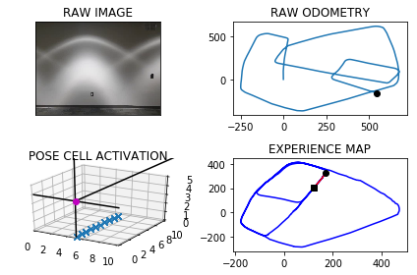

The counter is 3101

The angle is reset to 180.17971061828

Energy injection at [5, 0]

The counter is 3102

The angle is reset to 180.125797432796

Energy injection at [5, 0]

The counter is 3103

The angle is reset to 180.08805820295717

Energy injection at [5, 0]

The counter is 3104

The angle is reset to 180.06164074207

Energy injection at [5, 0]

min_delta_val

0.0

e_pc 5 0

current pc 5 0

The counter is 3105

The angle is reset to 180.043148519449

Energy injection at [5, 0]

The counter is 3106

The angle is reset to 179.5052039636143

Energy injection at [5, 0]

The counter is 3107

The angle is reset to 179.12864277453

Energy injection at [5, 0]

The counter is 3108

The angle is reset to 178.865049942171

Energy injection at [5, 0]

The counter is 3109

The angle is reset to 179.2055349595197

Energy injection at [5, 0]

The counter is 3110

The angle is reset to 179.96887447166375

Energy injection at [5, 0]

The counter is 3111

The angle is reset to 179.97821213016462

Energy injection at [5, 0]

The counter is 3112

The angle is reset to 180.50974849111523

Energy injection at [5, 0]

The counter is 3113

The angle is reset to 180.35682394378065

Energy injection at [5, 0]

The counter is 3114

The angle is reset to 181.29977676064644

Energy injection at [5, 9]

min_delta_val

1.0

e_pc 5 9

current pc 5 0

loop closure

The counter is 3115

The angle is reset to 181.9598437324525

Energy injection at [5, 9]

The counter is 3116

The angle is reset to 182.42189061271677

Energy injection at [5, 9]

min_delta_val

0.0

e_pc 5 9

current pc 5 9

loop closure

The counter is 3117

The angle is reset to 183.7953234289017

Energy injection at [5, 9]

min_delta_val

0.0

e_pc 5 9

current pc 5 9

The counter is 3118

The angle is reset to 184.75672640023117

Energy injection at [5, 9]

The counter is 3119

The angle is reset to 186.4797084801618

Energy injection at [5, 9]

min_delta_val

0.0

e_pc 5 9

current pc 5 9

The counter is 3120

The angle is reset to 187.16079593611326

Energy injection at [5, 9]

min_delta_val

0.0

e_pc 5 9

current pc 5 9

The counter is 3121

The angle is reset to 203.76255715527927

Energy injection at [5, 9]

min_delta_val

0.0

e_pc 5 9

current pc 5 9

The counter is 3122

The angle is reset to 214.85879000869545

Energy injection at [5, 9]

min_delta_val

1.0

e_pc 5 9

current pc 5 8

The counter is 3123

The angle is reset to 208.6011530060868

Energy injection at [5, 8]

min_delta_val

0.0

e_pc 5 8

current pc 5 8

loop closure

The counter is 3124

The angle is reset to 204.22080710426076

Energy injection at [5, 8]

min_delta_val

0.0

e_pc 5 8

current pc 5 8

The counter is 3133

The angle is reset to 245.47956497298253

Energy injection at [5, 7]

min_delta_val

0.0

e_pc 5 7

current pc 5 7

loop closure

The counter is 3134

The angle is reset to 253.88569548108774

Energy injection at [5, 7]

min_delta_val

0.0

e_pc 5 7

current pc 5 7

The counter is 3136

The angle is reset to 246.79498683676138

Energy injection at [4, 7]

min_delta_val

0.0

e_pc 4 7

current pc 4 7

loop closure

The counter is 3137

The angle is reset to 227.28149078573296

Energy injection at [6, 2]

min_delta_val

5.385164807134504

e_pc 6 2

current pc 4 7

new experience map with case 2

The counter is 3138

The angle is reset to 240.62204355001305

Energy injection at [4, 7]

min_delta_val

0.0

e_pc 4 7

current pc 4 7

loop closure

The counter is 3139

The angle is reset to 249.96043048500914

Energy injection at [4, 7]

min_delta_val

0.0

e_pc 4 7

current pc 4 7

The counter is 3140

The angle is reset to 255.97230133950637

Energy injection at [4, 7]

The counter is 3144

The angle is reset to 259.1306109376544

Energy injection at [4, 7]

min_delta_val

0.0

e_pc 4 7

current pc 4 7

loop closure

The counter is 3148

The angle is reset to 235.91642765635814

Energy injection at [6, 1]

The counter is 3154

The angle is reset to 219.66649935945068

Energy injection at [3, 6]

The counter is 3155

The angle is reset to 207.76654955161547

Energy injection at [3, 6]

The counter is 3156

The angle is reset to 199.4365846861308

Energy injection at [3, 6]

The counter is 3157

The angle is reset to 193.60560928029156

Energy injection at [3, 6]

-----------------------------------------------------------

The current number of the iteration is 3200

16.7249999046 seconds are elapsed per 100 frames.

The number of units of the VT is 1406

The number of units of the experience map is 1448

02/20/19 09:08:30

-----------------------------------------------------------

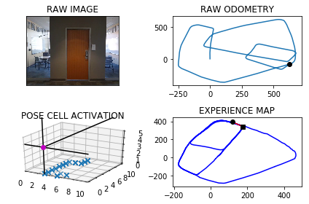

The counter is 3209

The angle is reset to 214.94892649620408

Energy injection at [7, 0]

The counter is 3211

The angle is reset to 216.91424854734285

Energy injection at [6, 9]

min_delta_val

0.0

e_pc 6 9

current pc 6 9

loop closure

The counter is 3212

The angle is reset to 218.28997398314

Energy injection at [6, 9]

The counter is 3213

The angle is reset to 219.777981788198

Energy injection at [6, 9]

min_delta_val

1.4142135623730951

e_pc 5 9

current pc 6 8

-----------------------------------------------------------

The current number of the iteration is 3300

5.02900004387 seconds are elapsed per 100 frames.

The number of units of the VT is 1457

The number of units of the experience map is 1500

02/20/19 09:08:35

-----------------------------------------------------------

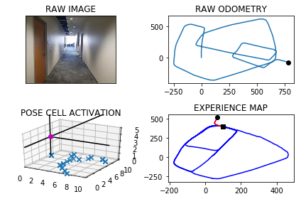

-----------------------------------------------------------

The current number of the iteration is 3400

2.48699998856 seconds are elapsed per 100 frames.

The number of units of the VT is 1490

The number of units of the experience map is 1533

02/20/19 09:08:38

-----------------------------------------------------------

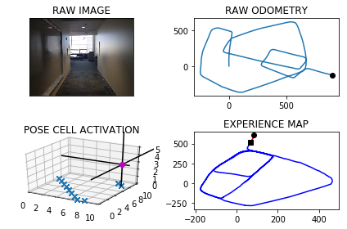

The counter is 3409

The angle is reset to 148.6695872517386

Energy injection at [0, 7]

min_delta_val

0.0

e_pc 0 7

current pc 0 7

loop closure

The counter is 3410

The angle is reset to 144.043711076217

Energy injection at [0, 7]

-----------------------------------------------------------

The current number of the iteration is 3500

3.63499999046 seconds are elapsed per 100 frames.

The number of units of the VT is 1530

The number of units of the experience map is 1573

02/20/19 09:08:41

-----------------------------------------------------------

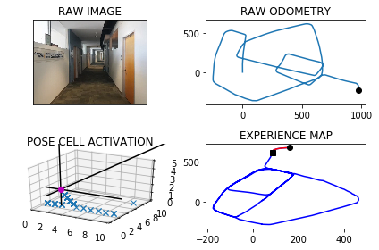

-----------------------------------------------------------

The current number of the iteration is 3600

2.29200005531 seconds are elapsed per 100 frames.

The number of units of the VT is 1577

The number of units of the experience map is 1620

02/20/19 09:08:44

-----------------------------------------------------------

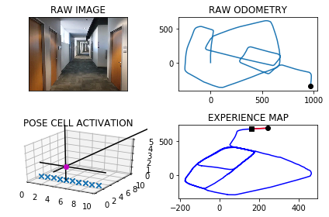

-----------------------------------------------------------

The current number of the iteration is 3700

2.43000006676 seconds are elapsed per 100 frames.

The number of units of the VT is 1627

The number of units of the experience map is 1670

02/20/19 09:08:46

-----------------------------------------------------------

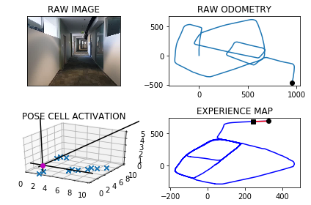

-----------------------------------------------------------

The current number of the iteration is 3800

2.40499997139 seconds are elapsed per 100 frames.

The number of units of the VT is 1668

The number of units of the experience map is 1711

02/20/19 09:08:48

-----------------------------------------------------------

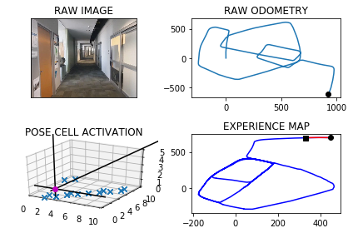

-----------------------------------------------------------

The current number of the iteration is 3900

2.56999993324 seconds are elapsed per 100 frames.

The number of units of the VT is 1718

The number of units of the experience map is 1761

02/20/19 09:08:51

-----------------------------------------------------------

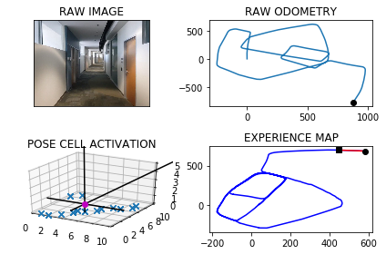

-----------------------------------------------------------

The current number of the iteration is 4000

2.69799995422 seconds are elapsed per 100 frames.

The number of units of the VT is 1760

The number of units of the experience map is 1803

02/20/19 09:08:54

-----------------------------------------------------------

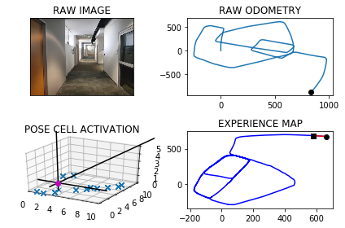

The counter is 4095

The angle is reset to 321.3305977533517

Energy injection at [0, 4]

min_delta_val

0.0

e_pc 0 4

current pc 0 4

loop closure

-----------------------------------------------------------

The current number of the iteration is 4100

3.91299986839 seconds are elapsed per 100 frames.

The number of units of the VT is 1811

The number of units of the experience map is 1854

02/20/19 09:08:58

-----------------------------------------------------------

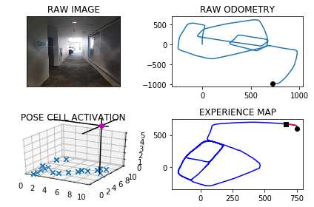

-----------------------------------------------------------

The current number of the iteration is 4200

2.59200000763 seconds are elapsed per 100 frames.

The number of units of the VT is 1837

The number of units of the experience map is 1880

02/20/19 09:09:00

-----------------------------------------------------------

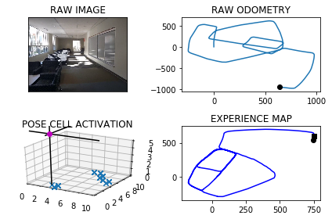

The counter is 4214

The angle is reset to 321.00641842734615

Energy injection at [2, 2]

min_delta_val

1.4142135623730951

e_pc 2 3

current pc 1 2

loop closure

The counter is 4275

The angle is reset to 320.7794928991423

Energy injection at [2, 2]

min_delta_val

1.4142135623730951

e_pc 2 2

current pc 1 3

loop closure

The counter is 4276

The angle is reset to 319.0456450293996

Energy injection at [2, 2]

The counter is 4277

The angle is reset to 318.35695152057974

Energy injection at [2, 2]

-----------------------------------------------------------

The current number of the iteration is 4300

5.24000000954 seconds are elapsed per 100 frames.

The number of units of the VT is 1868

The number of units of the experience map is 1912

02/20/19 09:09:05

-----------------------------------------------------------

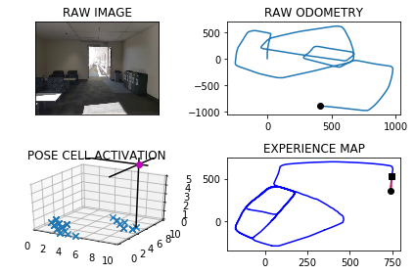

The counter is 4366

The angle is reset to 228.02486606440584

Energy injection at [6, 2]

min_delta_val

0.0

e_pc 6 2

current pc 6 2

loop closure

The counter is 4367

The angle is reset to 214.14240624508412

Energy injection at [6, 2]

min_delta_val

0.0

e_pc 6 2

current pc 6 2

The counter is 4368

The angle is reset to 203.89968437155886

Energy injection at [6, 1]

min_delta_val

0.0

e_pc 6 1

current pc 6 1

The counter is 4369

The angle is reset to 196.7297790600912

Energy injection at [6, 1]

The counter is 4370

The angle is reset to 191.7108453420638

Energy injection at [6, 1]

min_delta_val

0.0

e_pc 6 1

current pc 6 1

The counter is 4371

The angle is reset to 187.67259173944467

Energy injection at [6, 1]

The counter is 4372

The angle is reset to 185.37081421761124

Energy injection at [6, 1]

min_delta_val

0.0

e_pc 6 1

current pc 6 1

The counter is 4373

The angle is reset to 183.75956995232787

Energy injection at [6, 1]

The counter is 4374

The angle is reset to 182.63169896662947

Energy injection at [6, 1]

The counter is 4375

The angle is reset to 181.84218927664062

Energy injection at [6, 1]

The counter is 4376

The angle is reset to 181.81453249364841

Energy injection at [6, 0]

min_delta_val

0.0

e_pc 6 0

current pc 6 0

The counter is 4377

The angle is reset to 181.27017274555388

Energy injection at [6, 0]

The counter is 4378

The angle is reset to 181.4141209218877

Energy injection at [6, 0]

The counter is 4379

The angle is reset to 180.98988464532138

Energy injection at [6, 7]

min_delta_val

3.0

e_pc 6 7

current pc 6 0

new experience map with case 2

counter 4381

multiple peak # >2

[6L, 6L, 6L, 6L] [0L, 1L, 6L, 7L]

counter 4382

multiple peak # >2

[6L, 6L, 6L, 6L] [0L, 1L, 6L, 7L]

counter 4383

multiple peak # >2

[6L, 6L, 6L, 6L] [0L, 1L, 6L, 7L]

counter 4384

multiple peak # >2

[6L, 6L, 6L, 6L] [0L, 1L, 6L, 7L]

counter 4385

multiple peak # >2

[6L, 6L, 6L, 6L] [0L, 1L, 6L, 7L]

counter 4386

multiple peak # >2

[6L, 6L, 6L, 6L] [0L, 5L, 6L, 9L]

counter 4387

multiple peak # >2

[6L, 6L, 6L, 6L] [0L, 5L, 6L, 9L]

counter 4388

multiple peak # >2

[6L, 6L, 6L, 6L] [0L, 5L, 6L, 9L]

counter 4389

multiple peak # >2

[6L, 6L, 6L, 6L] [0L, 5L, 6L, 9L]

counter 4390

multiple peak # >2

[6L, 6L, 6L, 6L] [0L, 5L, 6L, 9L]

counter 4391

multiple peak # >2

[6L, 6L, 6L, 6L] [0L, 5L, 6L, 9L]

counter 4392

multiple peak # >2

[6L, 6L, 6L, 6L] [0L, 5L, 6L, 9L]

counter 4393

multiple peak # >2

[6L, 6L, 6L, 6L] [0L, 5L, 6L, 9L]

counter 4394

multiple peak # >2

[6L, 6L, 6L, 6L] [0L, 5L, 6L, 9L]

counter 4395

multiple peak # >2

[6L, 6L, 6L, 6L] [0L, 5L, 6L, 9L]

counter 4396

multiple peak # >2

[6L, 6L, 6L, 6L] [0L, 5L, 6L, 9L]

counter 4397

multiple peak # >2

[6L, 6L, 6L, 6L] [0L, 5L, 6L, 9L]

counter 4398

multiple peak # >2

[6L, 6L, 6L, 6L] [0L, 5L, 6L, 9L]

counter 4399

multiple peak # >2

[6L, 6L, 6L, 6L] [4L, 5L, 8L, 9L]

counter 4400

multiple peak # >2

[6L, 6L, 6L, 6L] [4L, 5L, 8L, 9L]

-----------------------------------------------------------

The current number of the iteration is 4400

12.8529999256 seconds are elapsed per 100 frames.

The number of units of the VT is 1920

The number of units of the experience map is 1967

02/20/19 09:09:18

-----------------------------------------------------------

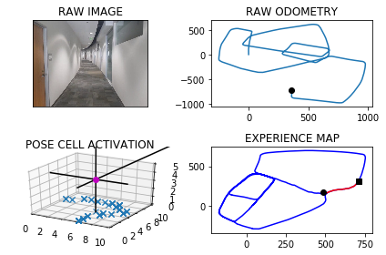

counter 4401

multiple peak # >2

[6L, 6L, 6L, 6L] [4L, 5L, 8L, 9L]

counter 4402

multiple peak # >2

[6L, 6L, 6L, 6L] [4L, 5L, 8L, 9L]

The counter is 4403

The angle is reset to 183.84291925172496

Energy injection at [6, 7]

The counter is 4404

The angle is reset to 182.69004347620748

Energy injection at [6, 7]

The counter is 4405

The angle is reset to 181.88303043334523

Energy injection at [6, 7]

The counter is 4406

The angle is reset to 181.31812130334166

Energy injection at [6, 7]

The counter is 4407

The angle is reset to 180.39768491233914

Energy injection at [6, 6]

min_delta_val

1.0

e_pc 6 6

current pc 6 7

loop closure

The counter is 4408

The angle is reset to 180.2783794386374

Energy injection at [6, 6]

The counter is 4409

The angle is reset to 180.19486560704613

Energy injection at [6, 6]

The counter is 4410

The angle is reset to 180.1364059249323

Energy injection at [6, 6]

min_delta_val

0.0

e_pc 6 6

current pc 6 6

The counter is 4411

The angle is reset to 180.09548414745262

Energy injection at [6, 6]

The counter is 4412

The angle is reset to 180.06683890321682

Energy injection at [6, 6]

The counter is 4413

The angle is reset to 180.04678723225177

Energy injection at [6, 6]

min_delta_val

0.0

e_pc 6 6

current pc 6 6

The counter is 4414

The angle is reset to 180.03275106257624

Energy injection at [6, 6]

The counter is 4465

The angle is reset to 184.2229257438034

Energy injection at [6, 4]

The counter is 4473

The angle is reset to 182.95604802066237

Energy injection at [6, 3]

min_delta_val

0.0

e_pc 6 3

current pc 6 3

loop closure

The counter is 4477

The angle is reset to 182.06923361446366

Energy injection at [6, 2]

min_delta_val

0.0

e_pc 6 2

current pc 6 2

loop closure

The counter is 4478

The angle is reset to 180.92346353012456

Energy injection at [6, 2]

-----------------------------------------------------------

The current number of the iteration is 4500

9.60800004005 seconds are elapsed per 100 frames.

The number of units of the VT is 1957

The number of units of the experience map is 2006

02/20/19 09:09:28

-----------------------------------------------------------

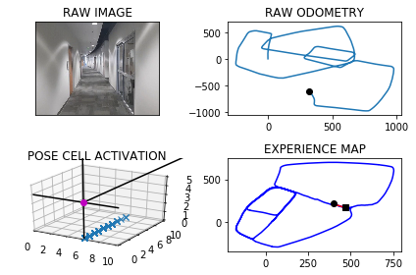

The counter is 4535

The angle is reset to 187.9964244710872

Energy injection at [6, 3]

min_delta_val

0.0

e_pc 6 3

current pc 6 3

loop closure

The counter is 4536

The angle is reset to 185.59749712976102

Energy injection at [6, 3]

min_delta_val

0.0

e_pc 6 2

current pc 6 2

The counter is 4537

The angle is reset to 183.3932479908327

Energy injection at [6, 3]

The counter is 4554

The angle is reset to 183.9502735935829

Energy injection at [6, 0]

min_delta_val

0.0

e_pc 6 8

current pc 6 0

loop closure

The counter is 4555

The angle is reset to 183.290191515508

Energy injection at [6, 0]

The counter is 4564

The angle is reset to 182.8281340608556

Energy injection at [6, 8]

min_delta_val

0.0

e_pc 6 8

current pc 6 8

loop closure

The counter is 4565

The angle is reset to 181.9796938425989

Energy injection at [6, 8]

min_delta_val

0.0

e_pc 6 8

current pc 6 8

The counter is 4569

The angle is reset to 181.38578568981922

Energy injection at [6, 8]

min_delta_val

0.0

e_pc 6 8

current pc 6 8

loop closure

The counter is 4570

The angle is reset to 180.97004998287343

Energy injection at [6, 8]

min_delta_val

0.0

e_pc 6 8

current pc 6 8

The counter is 4571

The angle is reset to 180.67903498801138

Energy injection at [6, 8]

min_delta_val

1.0

e_pc 6 7

current pc 6 8

The counter is 4572

The angle is reset to 180.475324491608

Energy injection at [6, 8]

The counter is 4573

The angle is reset to 179.80772714412555

Energy injection at [6, 8]

The counter is 4574

The angle is reset to 179.8654090008879

Energy injection at [6, 8]

The counter is 4575

The angle is reset to 179.90578630062151

Energy injection at [6, 8]

The counter is 4576

The angle is reset to 179.93405041043505

Energy injection at [6, 7]

min_delta_val

0.0

e_pc 6 7

current pc 6 7

The counter is 4577

The angle is reset to 180.47883528730452

Energy injection at [6, 7]

The counter is 4578

The angle is reset to 180.86018470111316

Energy injection at [6, 7]

min_delta_val

0.0

e_pc 6 7

current pc 6 7

The counter is 4579

The angle is reset to 180.6021292907792

Energy injection at [6, 7]

min_delta_val

0.0

e_pc 6 7

current pc 6 7

The counter is 4580

The angle is reset to 180.42149050354544

Energy injection at [6, 7]

The counter is 4581

The angle is reset to 180.29504335248183

Energy injection at [6, 7]

The counter is 4582

The angle is reset to 180.20653034673725

Energy injection at [6, 7]

The counter is 4587

The angle is reset to 180.14457124271607

Energy injection at [6, 6]

The counter is 4588

The angle is reset to 180.10119986990122

Energy injection at [6, 6]

min_delta_val

0.0

e_pc 6 6

current pc 6 6

loop closure

The counter is 4589

The angle is reset to 180.07083990893085

Energy injection at [6, 6]

The counter is 4590

The angle is reset to 180.04958793625156

Energy injection at [6, 6]

The counter is 4591

The angle is reset to 180.0347115553761

Energy injection at [6, 6]

min_delta_val

0.0

e_pc 6 6

current pc 6 6

The counter is 4592

The angle is reset to 180.02429808876323

Energy injection at [6, 6]

The counter is 4593

The angle is reset to 180.01700866213426

Energy injection at [6, 6]

The counter is 4594

The angle is reset to 180.011906063494

Energy injection at [6, 5]

min_delta_val

1.0

e_pc 6 5

current pc 6 6

The counter is 4595

The angle is reset to 180.00833424444576

Energy injection at [6, 5]

The counter is 4596

The angle is reset to 180.00583397111203

Energy injection at [6, 5]

The counter is 4597

The angle is reset to 179.4790837797784

Energy injection at [6, 5]

The counter is 4598

The angle is reset to 179.63535864584486

Energy injection at [6, 5]

-----------------------------------------------------------

The current number of the iteration is 4600

21.9400000572 seconds are elapsed per 100 frames.

The number of units of the VT is 1995

The number of units of the experience map is 2047

02/20/19 09:09:50

-----------------------------------------------------------

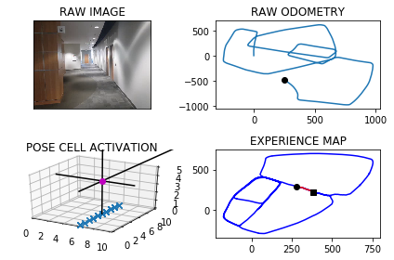

The counter is 4643

The angle is reset to 184.46975105209145

Energy injection at [6, 0]

The counter is 4644

The angle is reset to 183.128825736464

Energy injection at [6, 0]

The counter is 4649

The angle is reset to 182.19017801552476

Energy injection at [6, 0]

min_delta_val

0.0

e_pc 6 0

current pc 6 0

loop closure

The counter is 4650

The angle is reset to 182.05812461086734

Energy injection at [6, 0]

min_delta_val

0.0

e_pc 6 0

current pc 6 0

The counter is 4651

The angle is reset to 181.96568722760713

Energy injection at [6, 0]

The counter is 4652

The angle is reset to 181.375981059325

Energy injection at [6, 0]

min_delta_val

0.0

e_pc 6 0

current pc 6 0

The counter is 4653

The angle is reset to 180.9631867415275

Energy injection at [6, 0]

The counter is 4654

The angle is reset to 180.67423071906924

Energy injection at [6, 0]

The counter is 4655

The angle is reset to 180.47196150334847

Energy injection at [6, 0]

The counter is 4656

The angle is reset to 179.80537305234392

Energy injection at [6, 0]

min_delta_val

0.0

e_pc 6 0

current pc 6 0

The counter is 4657

The angle is reset to 179.33876113664073

Energy injection at [6, 0]

The counter is 4658

The angle is reset to 179.53713279564852

Energy injection at [6, 0]

The counter is 4659

The angle is reset to 179.67599295695396

Energy injection at [6, 0]

The counter is 4660

The angle is reset to 179.77319506986777

Energy injection at [6, 0]

min_delta_val

0.0

e_pc 6 0

current pc 6 0

The counter is 4661

The angle is reset to 179.8412365489074

Energy injection at [6, 0]

The counter is 4662

The angle is reset to 179.88886558423516

Energy injection at [6, 0]

The counter is 4686

The angle is reset to 181.49720590896462

Energy injection at [6, 5]

The counter is 4687

The angle is reset to 181.04804413627522

Energy injection at [6, 4]

min_delta_val

1.0

e_pc 6 4

current pc 6 5

loop closure

The counter is 4698

The angle is reset to 181.25863089539266

Energy injection at [6, 3]

min_delta_val

0.0

e_pc 6 3

current pc 6 3

loop closure

The counter is 4699

The angle is reset to 180.88104162677487

Energy injection at [6, 3]

The counter is 4700

The angle is reset to 180.6167291387424

Energy injection at [6, 3]

-----------------------------------------------------------

The current number of the iteration is 4700

12.4229998589 seconds are elapsed per 100 frames.

The number of units of the VT is 2025

The number of units of the experience map is 2081

02/20/19 09:10:02

-----------------------------------------------------------

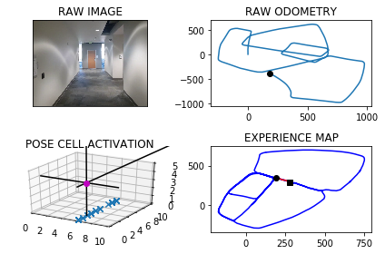

The counter is 4701

The angle is reset to 180.43171039711967

Energy injection at [6, 3]

The counter is 4702

The angle is reset to 180.30219727798374

Energy injection at [6, 3]

The counter is 4703

The angle is reset to 180.21153809458863

Energy injection at [6, 3]

The counter is 4704

The angle is reset to 180.14807666621203

Energy injection at [6, 3]

The counter is 4705

The angle is reset to 207.10365366634838

Energy injection at [4, 7]

The counter is 4706

The angle is reset to 225.97255756644387

Energy injection at [4, 7]

The counter is 4710

The angle is reset to 212.7057902965107

Energy injection at [6, 2]

The counter is 4711

The angle is reset to 229.89405320755745

Energy injection at [4, 7]

The counter is 4715

The angle is reset to 242.4508372452902

Energy injection at [4, 7]

min_delta_val

1.4142135623730951

e_pc 4 7

current pc 3 6

loop closure

The counter is 4716

The angle is reset to 250.71558607170311

Energy injection at [4, 7]

counter 4716

multiple peak # >2

[3L, 3L, 4L] [6L, 7L, 7L]

The counter is 4717

The angle is reset to 256.50091025019213

Energy injection at [4, 7]

The counter is 4718

The angle is reset to 233.55063717513448

Energy injection at [6, 1]

min_delta_val

4.47213595499958

e_pc 6 1

current pc 4 7

new experience map with case 2

The counter is 4721

The angle is reset to 244.48544602259412

Energy injection at [4, 7]

min_delta_val

1.0

e_pc 3 7

current pc 4 7

loop closure

The counter is 4722

The angle is reset to 252.13981221581588

Energy injection at [4, 7]

The counter is 4726

The angle is reset to 230.49786855107106

Energy injection at [3, 5]

The counter is 4729

The angle is reset to 228.84850798574976

Energy injection at [3, 5]

min_delta_val

0.0

e_pc 3 5

current pc 3 5

loop closure

The counter is 4730

The angle is reset to 227.6939555900248

Energy injection at [3, 5]

The counter is 4731

The angle is reset to 226.88576891301733

Energy injection at [3, 5]

The counter is 4732

The angle is reset to 226.32003823911214

Energy injection at [3, 5]

The counter is 4733

The angle is reset to 225.92402676737848

Energy injection at [2, 4]

min_delta_val

0.0

e_pc 2 4

current pc 2 4

The counter is 4734

The angle is reset to 225.64681873716495

Energy injection at [3, 6]

min_delta_val

1.0

e_pc 3 6

current pc 3 5

loop closure

The counter is 4735

The angle is reset to 225.97777311601547

Energy injection at [3, 6]

The counter is 4740

The angle is reset to 225.1594411812108

Energy injection at [2, 5]

hash collision

The counter is 4741

The angle is reset to 225.11160882684754

Energy injection at [2, 5]

hash collision

The counter is 4742

The angle is reset to 225.07812617879327

Energy injection at [2, 5]

hash collision

The counter is 4743

The angle is reset to 225.05468832515527

Energy injection at [2, 5]

The counter is 4744

The angle is reset to 225.5632818276087

Energy injection at [2, 5]

min_delta_val

0.0

e_pc 1 4

current pc 1 4

loop closure

The counter is 4745

The angle is reset to 225.39429727932608

Energy injection at [2, 5]

The counter is 4751

The angle is reset to 223.70100809552824

Energy injection at [1, 4]

min_delta_val

0.0

e_pc 1 4

current pc 1 4

loop closure

The counter is 4759

The angle is reset to 225.14070566686974

Energy injection at [1, 2]

min_delta_val

0.0

e_pc 1 2

current pc 1 2

loop closure

The counter is 4760

The angle is reset to 225.6234939668088

Energy injection at [9, 2]

The counter is 4761

The angle is reset to 225.43644577676616

Energy injection at [9, 2]

The counter is 4762

The angle is reset to 225.83051204373632

Energy injection at [9, 2]

min_delta_val

1.4142135623730951

e_pc 8 1

current pc 9 2

loop closure

max_exp 3

The counter is 4763

The angle is reset to 225.58135843061544

Energy injection at [9, 2]

The counter is 4764

The angle is reset to 225.40695090143075

Energy injection at [0, 1]

The counter is 4765

The angle is reset to 225.28486563100154

Energy injection at [0, 1]

The counter is 4766

The angle is reset to 225.19940594170103

Energy injection at [0, 1]

The counter is 4767

The angle is reset to 225.13958415919072

Energy injection at [9, 0]

min_delta_val

1.0

e_pc 9 0

current pc 0 0

loop closure

The counter is 4768

The angle is reset to 225.0977089114335

Energy injection at [9, 0]

The counter is 4771

The angle is reset to 225.06839623800346

Energy injection at [8, 1]

min_delta_val

0.0

e_pc 8 1

current pc 8 1

loop closure

The counter is 4772

The angle is reset to 225.04787736660242

Energy injection at [8, 1]

The counter is 4773

The angle is reset to 225.0335141566217

Energy injection at [8, 1]

min_delta_val

1.4142135623730951

e_pc 8 1

current pc 7 0

The counter is 4774

The angle is reset to 225.02345990963516

Energy injection at [8, 1]

The counter is 4775

The angle is reset to 225.0164219367446

Energy injection at [8, 1]

min_delta_val

0.0

e_pc 8 1

current pc 8 1

The counter is 4777

The angle is reset to 224.48649535572122

Energy injection at [7, 0]

min_delta_val

0.0

e_pc 7 0

current pc 7 0

loop closure

The counter is 4778

The angle is reset to 224.64054674900487

Energy injection at [7, 0]

The counter is 4779

The angle is reset to 224.74838272430338

Energy injection at [7, 0]

min_delta_val

1.4142135623730951

e_pc 6 9

current pc 7 0

The counter is 4781

The angle is reset to 225.87386790701234

Energy injection at [7, 0]

min_delta_val

1.0

e_pc 7 9

current pc 6 9

loop closure

The counter is 4783

The angle is reset to 226.66170753490863

Energy injection at [6, 9]

min_delta_val

1.0

e_pc 5 9

current pc 6 9

loop closure

The counter is 4784

The angle is reset to 226.68819527443605

Energy injection at [6, 9]

The counter is 4785

The angle is reset to 229.3317366921052

Energy injection at [5, 9]

min_delta_val

1.0

e_pc 4 8

current pc 5 8

The counter is 4786

The angle is reset to 228.55721568447365

Energy injection at [4, 8]

min_delta_val

0.0

e_pc 4 8

current pc 4 8

The counter is 4787

The angle is reset to 230.11505097913152

Energy injection at [4, 8]

min_delta_val

0.0

e_pc 4 8

current pc 4 8

The counter is 4788

The angle is reset to 229.10553568539206

Energy injection at [4, 8]

The counter is 4794

The angle is reset to 253.44887497977444

Energy injection at [3, 8]

min_delta_val

0.0

e_pc 3 8

current pc 3 8

loop closure

over

-----------------------------------------------------------

The current number of the iteration is 4800

36.5559999943 seconds are elapsed per 100 frames.

The number of units of the VT is 2053

The number of units of the experience map is 2117

02/20/19 09:10:39

-----------------------------------------------------------

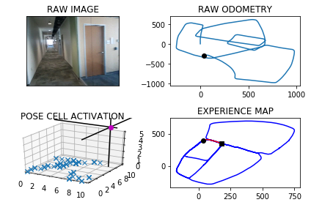

The counter is 4818

The angle is reset to 309.1892124858421

Energy injection at [8, 8]

min_delta_val

1.4142135623730951

e_pc 7 9

current pc 8 8

loop closure

The counter is 4821

The angle is reset to 310.93244874008946

Energy injection at [8, 7]

hash collision

The counter is 4822

The angle is reset to 312.1527141180626

Energy injection at [8, 7]

hash collision

The counter is 4823

The angle is reset to 313.0068998826438

Energy injection at [8, 8]

min_delta_val

1.0

e_pc 8 8

current pc 7 8

loop closure

The counter is 4824

The angle is reset to 314.12982991785066

Energy injection at [8, 8]

The counter is 4825

The angle is reset to 314.91588094249545

Energy injection at [8, 8]

The counter is 4826

The angle is reset to 314.9411166597468

Energy injection at [8, 8]

min_delta_val

0.0

e_pc 8 8

current pc 8 8

The counter is 4827

The angle is reset to 314.95878166182274

Energy injection at [8, 8]

The counter is 4828

The angle is reset to 314.97114716327593

Energy injection at [8, 8]

The counter is 4829

The angle is reset to 314.45480301429313

Energy injection at [7, 7]

min_delta_val

0.0

e_pc 7 7

current pc 7 7

loop closure

The counter is 4830

The angle is reset to 314.09336211000516

Energy injection at [7, 7]

The counter is 4831

The angle is reset to 314.36535347700357

Energy injection at [7, 7]

The counter is 4832

The angle is reset to 314.55574743390247

Energy injection at [6, 6]

min_delta_val

1.4142135623730951

e_pc 6 6

current pc 7 7

loop closure

The counter is 4833

The angle is reset to 314.6890232037317

Energy injection at [6, 6]

The counter is 4834

The angle is reset to 314.7823162426122

Energy injection at [6, 6]

min_delta_val

0.0

e_pc 5 7

current pc 5 7

The counter is 4835

The angle is reset to 314.8476213698285

Energy injection at [6, 6]

The counter is 4836

The angle is reset to 314.89333495887996

Energy injection at [5, 7]

min_delta_val

0.0

e_pc 5 7

current pc 5 7

The counter is 4837

The angle is reset to 314.925334471216

Energy injection at [5, 7]

The counter is 4838

The angle is reset to 314.94773412985114

Energy injection at [5, 7]

min_delta_val

1.4142135623730951

e_pc 5 7

current pc 4 8

The counter is 4839

The angle is reset to 314.9634138908958

Energy injection at [5, 7]

The counter is 4840

The angle is reset to 314.449389723627

Energy injection at [5, 7]

The counter is 4841

The angle is reset to 314.08957280653885

Energy injection at [6, 8]

counter 4841

multiple peak # >2

[5L, 5L, 6L] [7L, 8L, 8L]

min_delta_val

1.4142135623730951

e_pc 5 9

current pc 5 7

loop closure

The counter is 4842

The angle is reset to 314.36270096457724

Energy injection at [5, 8]

min_delta_val

0.0

e_pc 5 8

current pc 5 8

The counter is 4843

The angle is reset to 314.55389067520406

Energy injection at [5, 8]

The counter is 4844

The angle is reset to 314.68772347264286

Energy injection at [5, 8]

min_delta_val

0.0

e_pc 5 8

current pc 5 8

The counter is 4845

The angle is reset to 314.78140643085

Energy injection at [5, 9]

min_delta_val

1.0

e_pc 5 9

current pc 5 8

loop closure

The counter is 4846

The angle is reset to 314.84698450159493

Energy injection at [5, 8]

min_delta_val

2.23606797749979

e_pc 4 0

current pc 5 8

new experience map with case 2

The counter is 4847

The angle is reset to 314.89288915111644

Energy injection at [5, 8]

The counter is 4848

The angle is reset to 314.92502240578153

Energy injection at [5, 8]

The counter is 4849

The angle is reset to 314.947515684047

Energy injection at [4, 0]

counter 4849

multiple peak # >2

[4L, 4L, 5L] [0L, 9L, 9L]

The counter is 4850

The angle is reset to 314.96326097883286

Energy injection at [4, 0]

The counter is 4851

The angle is reset to 314.97428268518297

Energy injection at [4, 0]

The counter is 4854

The angle is reset to 314.45699787962803

Energy injection at [4, 0]

min_delta_val

0.0

e_pc 4 0

current pc 4 0

loop closure

The counter is 4855

The angle is reset to 314.61989851573964

Energy injection at [4, 0]

The counter is 4856

The angle is reset to 314.73392896101774

Energy injection at [4, 0]

min_delta_val

0.0

e_pc 4 0

current pc 4 0

The counter is 4860

The angle is reset to 314.81375027271235

Energy injection at [4, 0]

min_delta_val

0.0

e_pc 4 0

current pc 4 0

loop closure

The counter is 4861

The angle is reset to 314.86962519089866

Energy injection at [3, 1]

min_delta_val

0.0

e_pc 3 1

current pc 3 1

The counter is 4864

The angle is reset to 314.38373763362904

Energy injection at [3, 1]

min_delta_val

0.0

e_pc 3 1

current pc 3 1

loop closure

The counter is 4865

The angle is reset to 314.04361634354035

Energy injection at [3, 1]

The counter is 4866

The angle is reset to 314.3305314404782

Energy injection at [3, 2]

min_delta_val

1.0

e_pc 3 2

current pc 3 1

loop closure

The counter is 4867

The angle is reset to 314.53137200833476

Energy injection at [3, 2]

The counter is 4872

The angle is reset to 315.7219604058343

Energy injection at [2, 1]

min_delta_val

0.0

e_pc 2 1

current pc 2 1

loop closure

The counter is 4873

The angle is reset to 315.505372284084

Energy injection at [1, 1]

min_delta_val

0.0

e_pc 1 1

current pc 1 1

The counter is 4877

The angle is reset to 315.35376059885874

Energy injection at [2, 2]

min_delta_val

1.0

e_pc 1 3

current pc 1 2

loop closure

The counter is 4878

The angle is reset to 315.2476324192011

Energy injection at [2, 2]

The counter is 4879

The angle is reset to 315.1733426934407

Energy injection at [2, 2]

The counter is 4880

The angle is reset to 315.1213398854085

Energy injection at [2, 2]

The counter is 4881

The angle is reset to 315.08493791978594

Energy injection at [9, 6]

min_delta_val

1.4142135623730951

e_pc 8 7

current pc 1 3

The counter is 4882

The angle is reset to 315.05945654385016

Energy injection at [8, 7]

The counter is 4883

The angle is reset to 315.0416195806951

Energy injection at [8, 7]

The counter is 4887

The angle is reset to 328.5291337064866

Energy injection at [9, 7]

min_delta_val

6.0

e_pc 9 7

current pc 9 7

new experience map with case 2

The counter is 4888

The angle is reset to 337.9703935945406

Energy injection at [9, 7]

The counter is 4889

The angle is reset to 344.57927551617837

Energy injection at [9, 8]

min_delta_val

1.0

e_pc 9 8

current pc 9 7

loop closure

The counter is 4891

The angle is reset to 349.20549286132484

Energy injection at [9, 7]

min_delta_val

1.0

e_pc 9 8

current pc 9 7

loop closure

The counter is 4892

The angle is reset to 352.44384500292733

Energy injection at [9, 7]

min_delta_val

1.0

e_pc 9 7

current pc 9 8

The counter is 4893

The angle is reset to 354.7106915020491

Energy injection at [9, 7]

min_delta_val

1.0

e_pc 9 7

current pc 9 8

The counter is 4894

The angle is reset to 356.2974840514343

Energy injection at [9, 7]

-----------------------------------------------------------

The current number of the iteration is 4900

44.4700000286 seconds are elapsed per 100 frames.

The number of units of the VT is 2079

The number of units of the experience map is 2148

02/20/19 09:11:23

-----------------------------------------------------------

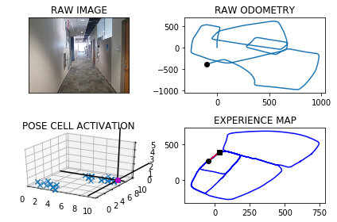

The counter is 4909

The angle is reset to 357.408238836004

Energy injection at [9, 1]

min_delta_val

1.0

e_pc 9 1

current pc 9 0

loop closure

The counter is 4912

The angle is reset to 357.1357671852028

Energy injection at [9, 2]

min_delta_val

0.0

e_pc 9 2

current pc 9 2

loop closure

The counter is 4913

The angle is reset to 357.99503702964194

Energy injection at [9, 2]

The counter is 4914

The angle is reset to 358.59652592074934

Energy injection at [9, 2]

The counter is 4915

The angle is reset to 359.54256814452447

Energy injection at [9, 2]

min_delta_val

0.0

e_pc 9 2

current pc 9 2

The counter is 4916

The angle is reset to 359.67979770116716

Energy injection at [9, 2]

The counter is 4917

The angle is reset to 0.30085839081699206

Energy injection at [9, 2]

min_delta_val

0.0

e_pc 9 2

current pc 9 2

The counter is 4921

The angle is reset to 0.21060087357189441

Energy injection at [9, 2]

min_delta_val

1.0

e_pc 9 3

current pc 9 2

loop closure

The counter is 4929

The angle is reset to 0.1474206115003261

Energy injection at [9, 5]

min_delta_val

1.0

e_pc 9 5

current pc 9 4

loop closure

The counter is 4930

The angle is reset to 0.10319442805022826

Energy injection at [9, 5]

The counter is 4931

The angle is reset to 0.07223609963515978

Energy injection at [9, 5]

min_delta_val

1.0

e_pc 9 5

current pc 9 6

The counter is 4932

The angle is reset to 0.05056526974461184

Energy injection at [9, 5]

The counter is 4934

The angle is reset to 359.5103956888212

Energy injection at [9, 5]

min_delta_val

0.0

e_pc 9 5

current pc 9 5

loop closure

The counter is 4935

The angle is reset to 359.65727698217484

Energy injection at [9, 5]

The counter is 4939

The angle is reset to 359.7600938875223

Energy injection at [9, 6]

min_delta_val

1.0

e_pc 9 7

current pc 9 6

loop closure

The counter is 4940

The angle is reset to 359.8320657212656

Energy injection at [9, 6]

The counter is 4941

The angle is reset to 0.4074460048859506

Energy injection at [9, 7]

min_delta_val

1.0

e_pc 9 7

current pc 9 6

The counter is 4948

The angle is reset to 359.23521220342013

Energy injection at [9, 7]

min_delta_val

0.0

e_pc 9 7

current pc 9 7

loop closure

The counter is 4949

The angle is reset to 359.4646485423941

Energy injection at [9, 7]

The counter is 4967

The angle is reset to 0.1502539796758562

Energy injection at [9, 1]

min_delta_val

0.0

e_pc 9 1

current pc 9 1

loop closure

The counter is 4970

The angle is reset to 0.10517778577309933

Energy injection at [9, 2]

min_delta_val

0.0

e_pc 9 2

current pc 9 2

loop closure

The counter is 4971

The angle is reset to 0.07362445004116953

Energy injection at [9, 2]

The counter is 4972

The angle is reset to 0.05153711502881867

Energy injection at [9, 2]

The counter is 4975

The angle is reset to 0.036075980520173065

Energy injection at [9, 3]

min_delta_val

0.0

e_pc 9 3

current pc 9 3

loop closure

The counter is 4976

The angle is reset to 0.550253186364121

Energy injection at [9, 3]

The counter is 4977

The angle is reset to 0.3851772304548847

Energy injection at [9, 3]

min_delta_val

0.0

e_pc 9 3

current pc 9 3

The counter is 4978

The angle is reset to 0.26962406131841926

Energy injection at [9, 3]

The counter is 4979

The angle is reset to 0.18873684292289347

Energy injection at [9, 4]

min_delta_val

1.0

e_pc 9 4

current pc 9 3

The counter is 4980

The angle is reset to 0.13211579004602542

Energy injection at [9, 4]

The counter is 4981

The angle is reset to 359.5674810530322

Energy injection at [9, 4]

min_delta_val

2.0

e_pc 9 3

current pc 9 5

new experience map with case 2

The counter is 4982

The angle is reset to 359.6972367371225

Energy injection at [9, 4]

The counter is 4985

The angle is reset to 359.7880657159858

Energy injection at [9, 3]

min_delta_val

1.0

e_pc 9 3

current pc 9 4

loop closure

The counter is 4987

The angle is reset to 0.9016460011900481

Energy injection at [9, 5]

hash collision

The counter is 4988

The angle is reset to 1.1561522008330334

Energy injection at [9, 5]

hash collision

The counter is 4989

The angle is reset to 1.3343065405831231

Energy injection at [9, 6]

The counter is 4990

The angle is reset to 0.9340145784081864

Energy injection at [9, 6]

The counter is 4991

The angle is reset to 0.6538102048857304

Energy injection at [9, 6]

min_delta_val

0.0

e_pc 9 6

current pc 9 6

loop closure

The counter is 4992

The angle is reset to 0.4576671434200113

Energy injection at [9, 6]

The counter is 4993

The angle is reset to 0.32036700039400784

Energy injection at [9, 7]

min_delta_val

1.0

e_pc 9 7

current pc 9 6

The counter is 4994

The angle is reset to 0.22425690027580553

Energy injection at [9, 7]

The counter is 4995

The angle is reset to 0.15697983019306386

Energy injection at [9, 7]

-----------------------------------------------------------

The current number of the iteration is 5000

34.7760000229 seconds are elapsed per 100 frames.

The number of units of the VT is 2111

The number of units of the experience map is 2183

02/20/19 09:11:58

-----------------------------------------------------------

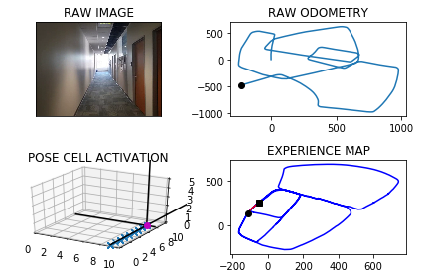

The counter is 5004

The angle is reset to 359.5848858811351

Energy injection at [9, 8]

The counter is 5007

The angle is reset to 359.70942011679455

Energy injection at [9, 9]

min_delta_val

1.0

e_pc 9 0

current pc 9 9

loop closure

The counter is 5008

The angle is reset to 359.79659408175615

Energy injection at [9, 9]

The counter is 5009

The angle is reset to 0.3826158572293173

Energy injection at [9, 9]

The counter is 5010

The angle is reset to 0.7928311000605219

Energy injection at [9, 9]

The counter is 5011

The angle is reset to 0.5549817700423653

Energy injection at [9, 0]

min_delta_val

0.0

e_pc 9 0

current pc 9 0

The counter is 5012

The angle is reset to 0.3884872390296557

Energy injection at [9, 0]

The counter is 5013

The angle is reset to 0.27194106732075896

Energy injection at [9, 0]

The counter is 5014

The angle is reset to 0.19035874712453124

Energy injection at [9, 0]

min_delta_val

0.0

e_pc 9 0

current pc 9 0

The counter is 5015

The angle is reset to 0.13325112298717187

Energy injection at [9, 0]

The counter is 5016

The angle is reset to 0.0932757860910203

Energy injection at [9, 0]

The counter is 5017

The angle is reset to 0.06529305026371421

Energy injection at [9, 0]

The counter is 5018

The angle is reset to 0.04570513518459994

Energy injection at [9, 0]

The counter is 5019

The angle is reset to 0.03199359462921996

Energy injection at [9, 1]

min_delta_val

0.0

e_pc 9 1

current pc 9 1

The counter is 5020

The angle is reset to 0.5473955162404539

Energy injection at [9, 1]

The counter is 5021

The angle is reset to 0.3831768613683177

Energy injection at [9, 0]

min_delta_val

1.0

e_pc 9 0

current pc 9 1

loop closure

The counter is 5022

The angle is reset to 0.2682238029578224

Energy injection at [9, 0]

The counter is 5027

The angle is reset to 359.6627566620705

Energy injection at [9, 2]

The counter is 5028

The angle is reset to 359.2389296634493

Energy injection at [9, 3]

min_delta_val

1.0

e_pc 9 3

current pc 9 2

loop closure

The counter is 5029

The angle is reset to 359.4672507644145

Energy injection at [9, 2]

hash collision

The counter is 5032

The angle is reset to 0.6770755350901605

Energy injection at [9, 3]

The counter is 5035

The angle is reset to 2.048952874563112

Energy injection at [9, 3]

min_delta_val

1.0

e_pc 9 4

current pc 9 3

loop closure

The counter is 5036

The angle is reset to 1.959267012194178

Energy injection at [9, 4]

min_delta_val

0.0

e_pc 9 4

current pc 9 4

The counter is 5037

The angle is reset to 1.3714869085359247

Energy injection at [9, 4]

The counter is 5040

The angle is reset to 0.960040835975147

Energy injection at [9, 4]

min_delta_val

1.0

e_pc 9 5

current pc 9 4

loop closure

The counter is 5041

The angle is reset to 0.6720285851826028

Energy injection at [9, 4]

The counter is 5042

The angle is reset to 0.47042000962782193

Energy injection at [9, 5]

min_delta_val

1.0

e_pc 9 5

current pc 9 4

The counter is 5059

The angle is reset to 0.3292940067394753

Energy injection at [9, 8]

The counter is 5060

The angle is reset to 0.23050580471763266

Energy injection at [9, 8]

min_delta_val

0.0

e_pc 9 8

current pc 9 8

loop closure

The counter is 5061

The angle is reset to 0.16135406330234286

Energy injection at [9, 8]

The counter is 5062

The angle is reset to 359.58794784431166

Energy injection at [9, 8]

The counter is 5063

The angle is reset to 359.71156349101807

Energy injection at [9, 9]

min_delta_val

1.0

e_pc 9 8

current pc 9 9

loop closure

The counter is 5064

The angle is reset to 359.79809444371267

Energy injection at [9, 9]

The counter is 5065

The angle is reset to 359.8586661105989

Energy injection at [9, 0]

The counter is 5066

The angle is reset to 359.90106627741915

Energy injection at [9, 0]

The counter is 5067

The angle is reset to 359.9307463941934

Energy injection at [9, 0]

The counter is 5068

The angle is reset to 0.4765224759353973

Energy injection at [9, 0]

The counter is 5069

The angle is reset to 0.3335657331547781

Energy injection at [9, 0]

The counter is 5070

The angle is reset to 0.23349601320834465

Energy injection at [9, 0]

min_delta_val

0.0

e_pc 9 0

current pc 9 0

loop closure

The counter is 5071

The angle is reset to 0.16344720924584125

Energy injection at [9, 0]

The counter is 5072

The angle is reset to 0.11441304647208887

Energy injection at [9, 0]

The counter is 5073

The angle is reset to 0.08008913253046221

Energy injection at [9, 0]

The counter is 5074

The angle is reset to 0.05606239277132354

Energy injection at [9, 1]

min_delta_val

1.0

e_pc 9 1

current pc 9 0

The counter is 5079

The angle is reset to 0.039243674939926476

Energy injection at [9, 1]

min_delta_val

1.0

e_pc 9 1

current pc 9 2

loop closure

The counter is 5080

The angle is reset to 0.02747057245794853

Energy injection at [9, 2]

min_delta_val

0.0

e_pc 9 2

current pc 9 2

The counter is 5081

The angle is reset to 0.01922940072056397

Energy injection at [9, 2]

min_delta_val

1.0

e_pc 9 3

current pc 9 2

The counter is 5082

The angle is reset to 0.01346058050439478

Energy injection at [9, 2]

The counter is 5087

The angle is reset to 0.009422406353076344

Energy injection at [9, 4]

min_delta_val

0.0

e_pc 9 4

current pc 9 4

loop closure

The counter is 5088

The angle is reset to 0.006595684447153441

Energy injection at [9, 4]

The counter is 5089

The angle is reset to 0.0046169791130074075

Energy injection at [9, 4]

The counter is 5090

The angle is reset to 0.003231885379105185

Energy injection at [9, 4]

min_delta_val

1.0

e_pc 9 4

current pc 9 5

The counter is 5091

The angle is reset to 0.0022623197653736295

Energy injection at [9, 4]

-----------------------------------------------------------

The current number of the iteration is 5100

32.1050000191 seconds are elapsed per 100 frames.

The number of units of the VT is 2132

The number of units of the experience map is 2209

02/20/19 09:12:30

-----------------------------------------------------------

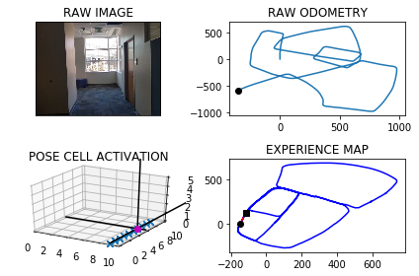

The counter is 5120

The angle is reset to 359.4765836238358

Energy injection at [9, 9]

min_delta_val

1.0

e_pc 9 9

current pc 9 0

loop closure

The counter is 5121

The angle is reset to 359.10860853668504

Energy injection at [9, 9]

The counter is 5131

The angle is reset to 0.4260259756795145

Energy injection at [9, 2]

The counter is 5132

The angle is reset to 0.29821818297566016

Energy injection at [9, 1]

min_delta_val

0.0

e_pc 9 1

current pc 9 1

loop closure

The counter is 5133

The angle is reset to 0.2087527280829621

Energy injection at [9, 1]

The counter is 5134

The angle is reset to 0.14612690965807346

Energy injection at [9, 1]

The counter is 5139

The angle is reset to 1.1522888367606512

Energy injection at [9, 3]

min_delta_val

1.0

e_pc 9 4

current pc 9 3

loop closure

The counter is 5140

The angle is reset to 1.3316021857324558

Energy injection at [9, 4]

min_delta_val

1.0

e_pc 9 4

current pc 9 3

The counter is 5141

The angle is reset to 1.457121530012719

Energy injection at [9, 4]

The counter is 5142

The angle is reset to 2.0699850710089027

Energy injection at [9, 4]

min_delta_val

1.0

e_pc 9 4

current pc 9 5

The counter is 5150

The angle is reset to 35.42398954970623

Energy injection at [9, 5]

min_delta_val

0.0

e_pc 9 6

current pc 9 6

loop closure

The counter is 5151

The angle is reset to 31.996792684794357

Energy injection at [9, 5]

min_delta_val

1.0

e_pc 9 5

current pc 9 6

The counter is 5152

The angle is reset to 35.89775487935605

Energy injection at [9, 5]

min_delta_val

0.0

e_pc 9 5

current pc 9 5

The counter is 5170

The angle is reset to 45.453428415549226

Energy injection at [2, 8]

min_delta_val

0.0

e_pc 2 8

current pc 2 8

loop closure

The counter is 5179

The angle is reset to 44.26739989088446

Energy injection at [3, 9]

min_delta_val

0.0

e_pc 3 9

current pc 3 9

loop closure

The counter is 5182

The angle is reset to 45.01217992361912

Energy injection at [3, 9]

min_delta_val

0.0

e_pc 3 9

current pc 3 9

loop closure

The counter is 5183

The angle is reset to 45.00852594653338

Energy injection at [3, 9]

The counter is 5191

The angle is reset to 44.48096816257336

Energy injection at [4, 0]

min_delta_val

0.0

e_pc 4 0

current pc 4 0

loop closure

The counter is 5192

The angle is reset to 44.63667771380135

Energy injection at [4, 0]

The counter is 5193

The angle is reset to 44.74567439966094

Energy injection at [4, 0]

The counter is 5194

The angle is reset to 44.82197207976266

Energy injection at [4, 0]

The counter is 5195

The angle is reset to 44.350380455833864

Energy injection at [5, 1]

min_delta_val

0.0

e_pc 5 1

current pc 5 1

The counter is 5196

The angle is reset to 44.5452663190837

Energy injection at [5, 1]

The counter is 5197

The angle is reset to 44.68168642335859

Energy injection at [5, 1]

The counter is 5198

The angle is reset to 44.777180496351015

Energy injection at [5, 1]

The counter is 5199

The angle is reset to 44.844026347445705

Energy injection at [5, 1]

The counter is 5200

The angle is reset to 45.41581844321199

Energy injection at [5, 1]

min_delta_val

1.4142135623730951

e_pc 6 2

current pc 5 1

-----------------------------------------------------------

The current number of the iteration is 5200

22.7969999313 seconds are elapsed per 100 frames.

The number of units of the VT is 2179

The number of units of the experience map is 2258

02/20/19 09:12:53

-----------------------------------------------------------

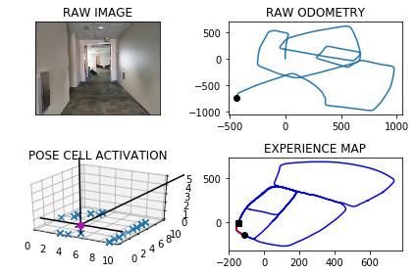

The counter is 5207

The angle is reset to 45.29107291024839

Energy injection at [6, 2]

min_delta_val

0.0

e_pc 6 2

current pc 6 2

loop closure

The counter is 5208

The angle is reset to 44.678751037173875

Energy injection at [6, 2]

The counter is 5209

The angle is reset to 44.77512572602171

Energy injection at [6, 2]

min_delta_val

0.0

e_pc 6 2

current pc 6 2

The counter is 5210

The angle is reset to 44.842588008215195

Energy injection at [6, 2]

The counter is 5211

The angle is reset to 44.88981160575064

Energy injection at [6, 2]

The counter is 5212

The angle is reset to 44.92286812402544

Energy injection at [6, 2]

min_delta_val

0.0

e_pc 6 2

current pc 6 2

The counter is 5216

The angle is reset to 44.946007686817815

Energy injection at [7, 3]

The counter is 5217

The angle is reset to 44.96220538077246

Energy injection at [7, 3]

The counter is 5218

The angle is reset to 44.97354376654072

Energy injection at [7, 3]

The counter is 5219

The angle is reset to 44.9814806365785

Energy injection at [7, 3]

min_delta_val

1.4142135623730951

e_pc 8 4

current pc 7 3

loop closure

The counter is 5220

The angle is reset to 44.98703644560495

Energy injection at [7, 3]

The counter is 5260

The angle is reset to 43.41592551192347

Energy injection at [3, 9]

min_delta_val

0.0

e_pc 3 9

current pc 3 9

loop closure

The counter is 5264

The angle is reset to 44.41614785834643

Energy injection at [3, 9]

min_delta_val

0.0

e_pc 3 9

current pc 3 9

loop closure

The counter is 5265

The angle is reset to 44.59130350084249

Energy injection at [3, 9]

The counter is 5266

The angle is reset to 44.71391245058974

Energy injection at [3, 9]

min_delta_val

0.0

e_pc 3 9

current pc 3 9

The counter is 5267

The angle is reset to 44.79973871541282

Energy injection at [3, 9]

The counter is 5268

The angle is reset to 44.85981710078897

Energy injection at [3, 9]

The counter is 5269

The angle is reset to 44.90187197055227

Energy injection at [3, 9]

min_delta_val

1.4142135623730951

e_pc 4 0

current pc 3 9

The counter is 5270

The angle is reset to 44.93131037938659

Energy injection at [3, 9]

The counter is 5277

The angle is reset to 43.37691726557061

Energy injection at [4, 0]

min_delta_val

0.0

e_pc 4 0

current pc 4 0

loop closure

The counter is 5278

The angle is reset to 43.86384208589943

Energy injection at [4, 0]

min_delta_val

0.0

e_pc 4 0

current pc 4 0

The counter is 5279

The angle is reset to 43.679689460129595

Energy injection at [4, 0]

The counter is 5280

The angle is reset to 44.07578262209072

Energy injection at [4, 0]

The counter is 5281

The angle is reset to 43.8280478354635

Energy injection at [4, 0]

The counter is 5282

The angle is reset to 44.17963348482445

Energy injection at [4, 0]

-----------------------------------------------------------

The current number of the iteration is 5300

17.9259998798 seconds are elapsed per 100 frames.

The number of units of the VT is 2210

The number of units of the experience map is 2290

02/20/19 09:13:11

-----------------------------------------------------------

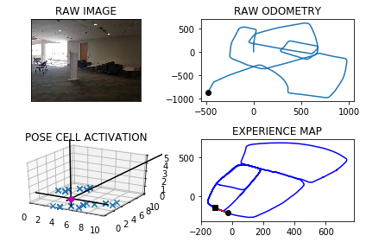

The counter is 5306

The angle is reset to 52.300743439377115

Energy injection at [5, 2]

min_delta_val

0.0

e_pc 5 2

current pc 5 2

loop closure

The counter is 5322

The angle is reset to 56.41052040756399

Energy injection at [7, 3]

min_delta_val

0.0

e_pc 7 3

current pc 7 3

loop closure

The counter is 5323

The angle is reset to 52.98736428529479

Energy injection at [7, 3]

The counter is 5324

The angle is reset to 50.066154999706356

Energy injection at [5, 3]

min_delta_val

1.0

e_pc 6 4

current pc 6 3

loop closure

The counter is 5325

The angle is reset to 48.02130849979445

Energy injection at [5, 3]

The counter is 5326

The angle is reset to 46.58991594985611

Energy injection at [7, 3]

min_delta_val

1.0

e_pc 7 3

current pc 6 3

loop closure

The counter is 5327

The angle is reset to 45.587941164899284

Energy injection at [7, 3]

The counter is 5328

The angle is reset to 45.41155881542949

Energy injection at [7, 3]

The counter is 5329

The angle is reset to 45.28809117080065

Energy injection at [8, 4]

min_delta_val

1.0

e_pc 8 4

current pc 8 3

The counter is 5330

The angle is reset to 45.20166381956045

Energy injection at [7, 3]

min_delta_val

1.0

e_pc 7 3

current pc 8 3

loop closure

The counter is 5331

The angle is reset to 45.666164673692315

Energy injection at [7, 3]

The counter is 5332

The angle is reset to 45.46631527158462

Energy injection at [7, 3]

The counter is 5333

The angle is reset to 45.32642069010923

Energy injection at [7, 3]

The counter is 5334

The angle is reset to 45.22849448307646

Energy injection at [7, 3]

The counter is 5335

The angle is reset to 45.159946138153515

Energy injection at [7, 3]

The counter is 5336

The angle is reset to 45.11196229670746

Energy injection at [7, 3]

The counter is 5339

The angle is reset to 44.02837360769523

Energy injection at [8, 4]

min_delta_val

0.0

e_pc 8 4

current pc 8 4

loop closure

The counter is 5340

The angle is reset to 44.319861525386656

Energy injection at [8, 4]

The counter is 5341

The angle is reset to 44.52390306777066

Energy injection at [8, 4]

The counter is 5342

The angle is reset to 44.66673214743946

Energy injection at [8, 4]

min_delta_val

1.4142135623730951

e_pc 8 4

current pc 9 5

The counter is 5351

The angle is reset to 44.24171250320762

Energy injection at [9, 5]

min_delta_val

0.0

e_pc 9 5

current pc 9 5

loop closure

The counter is 5352

The angle is reset to 44.46919875224533

Energy injection at [9, 5]

The counter is 5353

The angle is reset to 44.62843912657173

Energy injection at [9, 5]

The counter is 5354

The angle is reset to 44.73990738860021

Energy injection at [9, 5]

-----------------------------------------------------------

The current number of the iteration is 5400

16.5499999523 seconds are elapsed per 100 frames.

The number of units of the VT is 2242

The number of units of the experience map is 2322

02/20/19 09:13:27

-----------------------------------------------------------

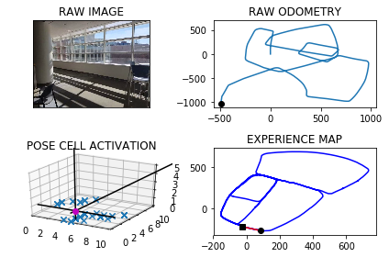

The counter is 5405

The angle is reset to 43.767935172020145

Energy injection at [6, 2]

min_delta_val

0.0

e_pc 6 2

current pc 6 2

loop closure

The counter is 5414

The angle is reset to 44.6625546204141

Energy injection at [7, 3]

The counter is 5417

The angle is reset to 45.813788234289866

Energy injection at [7, 3]

hash collision

The counter is 5418

The angle is reset to 45.5696517640029

Energy injection at [7, 3]

hash collision

The counter is 5419

The angle is reset to 45.398756234802036

Energy injection at [7, 3]

hash collision

The counter is 5420

The angle is reset to 44.75412936436142

Energy injection at [7, 3]

min_delta_val

0.0

e_pc 7 3

current pc 7 3

loop closure

The counter is 5430

The angle is reset to 57.80289055505299

Energy injection at [8, 3]

min_delta_val

0.0

e_pc 8 3

current pc 8 3

loop closure

The counter is 5431

The angle is reset to 67.46202338853709

Energy injection at [8, 3]

min_delta_val

0.0

e_pc 8 3

current pc 8 3

The counter is 5432

The angle is reset to 73.69841637197597

Energy injection at [8, 3]

The counter is 5447

The angle is reset to 94.86389146038317

Energy injection at [1, 3]

The counter is 5457

The angle is reset to 124.22972402226821

Energy injection at [3, 2]

The counter is 5458

The angle is reset to 127.46080681558774

Energy injection at [3, 2]

The counter is 5459

The angle is reset to 129.72256477091142

Energy injection at [4, 2]

min_delta_val

0.0

e_pc 4 2

current pc 4 2

loop closure

The counter is 5463

The angle is reset to 131.30579533963797

Energy injection at [5, 1]

min_delta_val

1.0

e_pc 5 1

current pc 4 1

loop closure

The counter is 5464

The angle is reset to 132.93905673774657

Energy injection at [5, 1]

The counter is 5465

The angle is reset to 133.55733971642258

Energy injection at [5, 1]

min_delta_val

1.0

e_pc 5 0

current pc 5 1

The counter is 5466

The angle is reset to 133.9901378014958

Energy injection at [5, 0]

min_delta_val

0.0

e_pc 5 0

current pc 5 0

The counter is 5467

The angle is reset to 134.29309646104704

Energy injection at [5, 0]

The counter is 5468

The angle is reset to 134.5051675227329

Energy injection at [5, 0]

The counter is 5471

The angle is reset to 134.12861726591302

Energy injection at [5, 0]

min_delta_val

1.0

e_pc 6 0

current pc 5 0

loop closure

The counter is 5499

The angle is reset to 133.34003208613908

Energy injection at [1, 5]

min_delta_val

0.0

e_pc 1 5

current pc 1 5

loop closure

The counter is 5500

The angle is reset to 133.83802246029734

Energy injection at [1, 5]

min_delta_val

0.0

e_pc 1 5

current pc 1 5

-----------------------------------------------------------

The current number of the iteration is 5500

25.0750000477 seconds are elapsed per 100 frames.

The number of units of the VT is 2279

The number of units of the experience map is 2362

02/20/19 09:13:52

-----------------------------------------------------------

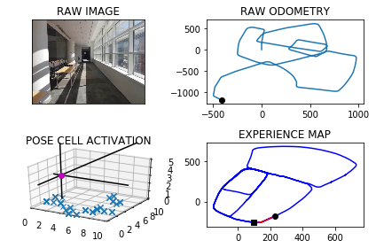

The counter is 5505

The angle is reset to 133.66161572220813

Energy injection at [2, 4]

The counter is 5506

The angle is reset to 133.53813100554567

Energy injection at [2, 4]

The counter is 5507

The angle is reset to 133.97669170388193

Energy injection at [2, 4]

The counter is 5510

The angle is reset to 134.28368419271735

Energy injection at [2, 3]

min_delta_val

1.0

e_pc 3 3

current pc 2 3

loop closure

The counter is 5511

The angle is reset to 135.02357893490216

Energy injection at [2, 3]

The counter is 5512

The angle is reset to 135.0165052544315

Energy injection at [4, 2]

counter 5512

multiple peak # >2

[4L, 4L, 5L] [1L, 2L, 1L]

The counter is 5513

The angle is reset to 135.01155367810202

Energy injection at [4, 2]

The counter is 5514

The angle is reset to 135.00808757467144

Energy injection at [4, 2]

The counter is 5515

The angle is reset to 135.00566130226997

Energy injection at [4, 2]

The counter is 5516

The angle is reset to 135.00396291158896

Energy injection at [4, 2]

min_delta_val

0.0

e_pc 4 2

current pc 4 2

loop closure

The counter is 5526

The angle is reset to 134.47777403811227

Energy injection at [6, 0]

min_delta_val

0.0

e_pc 6 0

current pc 6 0

loop closure

The counter is 5527

The angle is reset to 135.15944182667857

Energy injection at [6, 0]

The counter is 5528

The angle is reset to 135.111609278675

Energy injection at [6, 0]

The counter is 5535

The angle is reset to 136.12812649507248

Energy injection at [7, 9]

min_delta_val

1.0

e_pc 7 8

current pc 7 9

loop closure

The counter is 5536

The angle is reset to 135.78968854655074

Energy injection at [7, 9]

The counter is 5539

The angle is reset to 135.0277819825855

Energy injection at [8, 8]

min_delta_val

1.0

e_pc 8 8

current pc 8 7

loop closure

The counter is 5545

The angle is reset to 135.01944738780983

Energy injection at [9, 7]

min_delta_val

0.0

e_pc 9 7

current pc 9 7

loop closure

The counter is 5546

The angle is reset to 135.5386131714669

Energy injection at [9, 7]

The counter is 5551

The angle is reset to 135.9020292200268

Energy injection at [9, 6]

min_delta_val

1.4142135623730951

e_pc 0 5

current pc 9 6

loop closure

The counter is 5552

The angle is reset to 135.10642045401875

Energy injection at [9, 6]

The counter is 5583

The angle is reset to 138.74949431781315

Energy injection at [4, 2]

The counter is 5584

The angle is reset to 137.62464602246916

Energy injection at [4, 2]

The counter is 5585

The angle is reset to 136.8372522157284

Energy injection at [4, 1]

min_delta_val

0.0

e_pc 4 1

current pc 4 1

loop closure

The counter is 5586

The angle is reset to 136.28607655100987

Energy injection at [4, 1]

The counter is 5587

The angle is reset to 135.9002535857069

Energy injection at [4, 1]

The counter is 5599

The angle is reset to 136.15517750999484

Energy injection at [7, 8]

min_delta_val

0.0

e_pc 7 8

current pc 7 8

loop closure

The counter is 5600

The angle is reset to 135.28362425699638

Energy injection at [7, 8]

-----------------------------------------------------------

The current number of the iteration is 5600

17.0580000877 seconds are elapsed per 100 frames.

The number of units of the VT is 2316

The number of units of the experience map is 2402

02/20/19 09:14:10

-----------------------------------------------------------

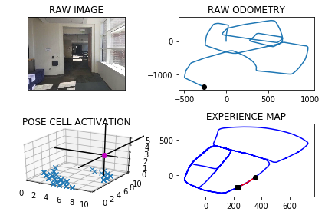

The counter is 5601

The angle is reset to 135.19853697989745

Energy injection at [7, 8]

The counter is 5602

The angle is reset to 135.1389758859282

Energy injection at [7, 8]

The counter is 5609

The angle is reset to 136.67228312014976

Energy injection at [9, 6]

min_delta_val

0.0

e_pc 9 6

current pc 9 6

loop closure

The counter is 5610

The angle is reset to 136.1705981841048

Energy injection at [9, 6]

The counter is 5611

The angle is reset to 135.29441872887335

Energy injection at [9, 6]

The counter is 5612

The angle is reset to 135.20609311021133

Energy injection at [9, 6]

over

over

over

over

The counter is 5660

The angle is reset to 125.6942651771479

Energy injection at [8, 8]

The counter is 5698

The angle is reset to 130.58598562400354

Energy injection at [3, 2]

min_delta_val

0.0

e_pc 3 2

current pc 3 2

loop closure

The counter is 5699

The angle is reset to 133.48518993680244

Energy injection at [3, 2]

min_delta_val

1.4142135623730951

e_pc 3 2

current pc 4 1

-----------------------------------------------------------

The current number of the iteration is 5700

8.0680000782 seconds are elapsed per 100 frames.

The number of units of the VT is 2356

The number of units of the experience map is 2445

02/20/19 09:14:18

-----------------------------------------------------------

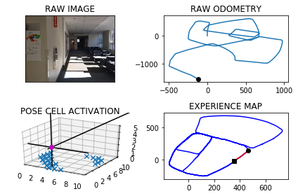

The counter is 5701

The angle is reset to 136.56463295576174

Energy injection at [3, 2]

min_delta_val

1.4142135623730951

e_pc 4 1

current pc 3 2

loop closure

The counter is 5702

The angle is reset to 137.6702430690332

Energy injection at [4, 1]

min_delta_val

0.0

e_pc 4 1

current pc 4 1

The counter is 5704

The angle is reset to 141.59417014832323

Energy injection at [4, 1]

min_delta_val

0.0

e_pc 4 1

current pc 4 1

loop closure

The counter is 5705

The angle is reset to 142.24091910382623

Energy injection at [4, 1]

min_delta_val

1.4142135623730951

e_pc 4 1

current pc 5 0

The counter is 5706

The angle is reset to 143.74364337267835

Energy injection at [4, 1]

min_delta_val

1.4142135623730951

e_pc 4 1

current pc 5 0

The counter is 5707

The angle is reset to 144.7955503608748

Energy injection at [4, 1]

min_delta_val

1.0

e_pc 5 1

current pc 4 1

The counter is 5708

The angle is reset to 134.50688525261236

Energy injection at [5, 1]

min_delta_val

1.4142135623730951

e_pc 5 1

current pc 4 0

The counter is 5709

The angle is reset to 134.65481967682865

Energy injection at [5, 1]

The counter is 5710

The angle is reset to 135.80837377378006

Energy injection at [5, 1]

min_delta_val

0.0

e_pc 5 1

current pc 5 1

The counter is 5711

The angle is reset to 137.140861641646

Energy injection at [5, 1]

min_delta_val

0.0

e_pc 5 1

current pc 5 1

The counter is 5712

The angle is reset to 138.5986031491522

Energy injection at [6, 0]

min_delta_val

1.4142135623730951

e_pc 6 0

current pc 5 1

loop closure

The counter is 5714

The angle is reset to 142.76902220440655

Energy injection at [6, 9]

min_delta_val

1.0

e_pc 6 9

current pc 7 9

loop closure

The counter is 5717

The angle is reset to 175.31331554308457

Energy injection at [2, 8]

The counter is 5724

The angle is reset to 179.3443208801592

Energy injection at [6, 4]

The counter is 5731

The angle is reset to 181.64102461611142

Energy injection at [6, 3]

min_delta_val

1.0

e_pc 6 2

current pc 6 3

loop closure

The counter is 5732

The angle is reset to 181.148717231278

Energy injection at [6, 2]

min_delta_val

0.0

e_pc 6 2

current pc 6 2

The counter is 5738

The angle is reset to 180.27910206189458

Energy injection at [6, 2]

min_delta_val

0.0

e_pc 6 2

current pc 6 2

loop closure

The counter is 5740

The angle is reset to 180.1953714433262

Energy injection at [6, 2]

min_delta_val

0.0

e_pc 6 2

current pc 6 2

loop closure

The counter is 5741

The angle is reset to 180.13676001032835

Energy injection at [6, 2]

min_delta_val

0.0

e_pc 6 2

current pc 6 2

The counter is 5742

The angle is reset to 180.09573200722983

Energy injection at [6, 2]

The counter is 5743

The angle is reset to 180.0670124050609

Energy injection at [6, 1]

min_delta_val

1.0

e_pc 6 1

current pc 6 2

The counter is 5744

The angle is reset to 180.04690868354263

Energy injection at [6, 1]

The counter is 5746

The angle is reset to 180.03283607847982

Energy injection at [6, 1]

min_delta_val

1.0

e_pc 6 1

current pc 6 0

loop closure

The counter is 5747

The angle is reset to 179.49798525493586

Energy injection at [6, 1]

min_delta_val

0.0

e_pc 6 1

current pc 6 1

The counter is 5748

The angle is reset to 179.6485896784551

Energy injection at [6, 1]

The counter is 5749

The angle is reset to 179.75401277491858

Energy injection at [6, 1]

The counter is 5750

The angle is reset to 179.82780894244297

Energy injection at [6, 1]

The counter is 5751

The angle is reset to 180.4044662597101

Energy injection at [6, 0]

min_delta_val

0.0

e_pc 6 0

current pc 6 0

The counter is 5752

The angle is reset to 180.80812638179705

Energy injection at [6, 0]

The counter is 5753

The angle is reset to 180.5656884672579

Energy injection at [6, 0]

The counter is 5754

The angle is reset to 180.39598192708053

Energy injection at [6, 0]

The counter is 5755

The angle is reset to 180.27718734895635

Energy injection at [6, 0]

min_delta_val

1.0

e_pc 6 9

current pc 6 0

The counter is 5756

The angle is reset to 180.71903114426942

Energy injection at [6, 0]

min_delta_val

0.0

e_pc 6 0

current pc 6 0

loop closure

The counter is 5762

The angle is reset to 181.55332180098858

Energy injection at [6, 9]

min_delta_val

0.0

e_pc 6 9

current pc 6 9

loop closure

The counter is 5763

The angle is reset to 181.08732526069204

Energy injection at [6, 9]

The counter is 5764

The angle is reset to 181.28612768248442

Energy injection at [6, 9]

min_delta_val

0.0

e_pc 6 9

current pc 6 9

The counter is 5765

The angle is reset to 180.90028937773909

Energy injection at [6, 9]

The counter is 5766

The angle is reset to 180.63020256441732

Energy injection at [6, 9]

min_delta_val

0.0

e_pc 6 9

current pc 6 9

The counter is 5767

The angle is reset to 180.44114179509214

Energy injection at [6, 8]

min_delta_val

1.0

e_pc 6 8

current pc 6 9

The counter is 5769

The angle is reset to 179.78379925656446

Energy injection at [6, 0]

The counter is 5770

The angle is reset to 179.32365947959514

Energy injection at [6, 0]

The counter is 5771

The angle is reset to 179.52656163571658

Energy injection at [6, 0]

min_delta_val

0.0

e_pc 6 4

current pc 6 0

loop closure

The counter is 5772

The angle is reset to 179.66859314500158

Energy injection at [6, 0]

The counter is 5773

The angle is reset to 179.7680152015011

Energy injection at [6, 0]

The counter is 5774

The angle is reset to 180.3626106410508

Energy injection at [6, 4]

The counter is 5775

The angle is reset to 180.77882744873554

Energy injection at [6, 4]

The counter is 5776

The angle is reset to 181.07017921411486

Energy injection at [6, 4]

The counter is 5777

The angle is reset to 181.27412544988042

Energy injection at [6, 7]

min_delta_val

3.0

e_pc 6 8

current pc 6 4

new experience map with case 2

The counter is 5778

The angle is reset to 181.4168878149163

Energy injection at [6, 7]

The counter is 5779

The angle is reset to 180.99182147044138

Energy injection at [6, 7]

The counter is 5780

The angle is reset to 180.69427502930895

Energy injection at [6, 4]

counter 5782

multiple peak # >2

[6L, 6L, 6L, 6L] [3L, 4L, 7L, 8L]

counter 5783

multiple peak # >2

[6L, 6L, 6L, 6L] [2L, 3L, 6L, 7L]

counter 5784

multiple peak # >2

[6L, 6L, 6L, 6L] [2L, 3L, 6L, 7L]

counter 5785

multiple peak # >2

[6L, 6L, 6L, 6L] [2L, 3L, 6L, 7L]

counter 5786

multiple peak # >2

[6L, 6L, 6L, 6L] [2L, 3L, 6L, 7L]

counter 5787

multiple peak # >2

[6L, 6L, 6L, 6L] [2L, 3L, 6L, 7L]

counter 5788

multiple peak # >2

[6L, 6L, 6L, 6L] [2L, 3L, 6L, 7L]

counter 5789

multiple peak # >2

[6L, 6L, 6L, 6L] [2L, 3L, 6L, 7L]

counter 5790

multiple peak # >2

[6L, 6L, 6L, 6L] [2L, 3L, 6L, 7L]

counter 5791

multiple peak # >2

[6L, 6L, 6L, 6L] [2L, 3L, 6L, 7L]

The counter is 5792

The angle is reset to 181.01099252051625

Energy injection at [6, 5]

The counter is 5793

The angle is reset to 180.18269476436137

Energy injection at [6, 5]

min_delta_val

0.0

e_pc 6 5

current pc 6 5

loop closure

The counter is 5794

The angle is reset to 180.12788633505292

Energy injection at [6, 5]

The counter is 5795

The angle is reset to 180.08952043453706

Energy injection at [6, 5]

min_delta_val

1.0

e_pc 6 5

current pc 6 4

The counter is 5796

The angle is reset to 180.06266430417594

Energy injection at [6, 5]

min_delta_val

1.0

e_pc 6 5

current pc 6 4

The counter is 5797

The angle is reset to 180.04386501292313

Energy injection at [6, 5]

The counter is 5798

The angle is reset to 180.03070550904621

Energy injection at [6, 4]

min_delta_val

0.0

e_pc 6 4

current pc 6 4

The counter is 5799

The angle is reset to 180.0214938563323

Energy injection at [6, 4]

The counter is 5800

The angle is reset to 180.0150456994326

Energy injection at [6, 4]

-----------------------------------------------------------

The current number of the iteration is 5800

55.6899998188 seconds are elapsed per 100 frames.

The number of units of the VT is 2384

The number of units of the experience map is 2482

02/20/19 09:15:13

-----------------------------------------------------------

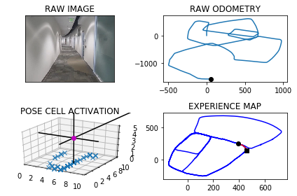

The counter is 5804

The angle is reset to 179.48553198960283

Energy injection at [6, 4]

hash collision

The counter is 5825

The angle is reset to 180.16487239272197

Energy injection at [6, 1]

min_delta_val

0.0

e_pc 6 1

current pc 6 1

loop closure

The counter is 5826

The angle is reset to 180.11541067490538

Energy injection at [6, 1]

The counter is 5827

The angle is reset to 180.08078747243374

Energy injection at [6, 1]

The counter is 5828

The angle is reset to 180.05655123070363

Energy injection at [6, 0]

min_delta_val

1.0

e_pc 6 0

current pc 6 1

The counter is 5829

The angle is reset to 180.03958586149253

Energy injection at [6, 0]

The counter is 5830

The angle is reset to 180.02771010304477

Energy injection at [6, 4]

The counter is 5831

The angle is reset to 180.0193970721313

Energy injection at [6, 4]

The counter is 5832

The angle is reset to 180.0135779504919

Energy injection at [6, 4]

The counter is 5833

The angle is reset to 180.00950456534434

Energy injection at [6, 4]

min_delta_val

0.0

e_pc 6 4

current pc 6 4

loop closure

The counter is 5834

The angle is reset to 180.00665319574102

Energy injection at [6, 4]

The counter is 5835

The angle is reset to 180.0046572370187

Energy injection at [6, 4]

min_delta_val

0.0

e_pc 6 4

current pc 6 4

The counter is 5836

The angle is reset to 180.0032600659131

Energy injection at [6, 4]

The counter is 5837

The angle is reset to 180.00228204613916

Energy injection at [6, 4]

hash collision

The counter is 5839

The angle is reset to 180.00159743229742

Energy injection at [6, 3]

min_delta_val

0.0

e_pc 6 3

current pc 6 3

loop closure

The counter is 5840

The angle is reset to 179.47611820260815

Energy injection at [6, 3]

The counter is 5841

The angle is reset to 179.63328274182572

Energy injection at [6, 3]

min_delta_val

0.0

e_pc 6 3

current pc 6 3

The counter is 5842

The angle is reset to 179.743297919278

Energy injection at [6, 3]

The counter is 5843

The angle is reset to 179.82030854349458

Energy injection at [6, 3]

The counter is 5844

The angle is reset to 179.8742159804462

Energy injection at [6, 3]

The counter is 5845

The angle is reset to 179.91195118631236

Energy injection at [6, 3]

min_delta_val

0.0

e_pc 6 3

current pc 6 3

The counter is 5846

The angle is reset to 179.93836583041863

Energy injection at [6, 3]

The counter is 5847

The angle is reset to 179.95685608129304

Energy injection at [6, 3]

min_delta_val

0.0

e_pc 6 3

current pc 6 3

loop closure

The counter is 5848

The angle is reset to 180.49479925690514

Energy injection at [6, 3]

The counter is 5849

The angle is reset to 180.34635947983358

Energy injection at [6, 3]

The counter is 5854

The angle is reset to 179.7174516358835

Energy injection at [6, 2]

min_delta_val

0.0

e_pc 6 2

current pc 6 2

loop closure

The counter is 5855

The angle is reset to 179.80221614511845

Energy injection at [6, 2]

The counter is 5856

The angle is reset to 179.86155130158292

Energy injection at [6, 2]

The counter is 5857

The angle is reset to 179.903085911108

Energy injection at [6, 2]

min_delta_val

0.0

e_pc 6 2

current pc 6 2

The counter is 5858

The angle is reset to 179.93216013777558

Energy injection at [6, 2]

The counter is 5859

The angle is reset to 180.4775120964429

Energy injection at [6, 1]

min_delta_val

1.0

e_pc 6 1

current pc 6 2

The counter is 5860

The angle is reset to 180.33425846751

Energy injection at [6, 1]

min_delta_val

0.0

e_pc 6 1

current pc 6 1

loop closure

The counter is 5861

The angle is reset to 180.23398092725705

Energy injection at [6, 1]

The counter is 5862

The angle is reset to 180.16378664907992

Energy injection at [6, 1]

The counter is 5863

The angle is reset to 180.11465065435593

Energy injection at [6, 1]

min_delta_val

1.0

e_pc 6 1

current pc 6 0

The counter is 5866

The angle is reset to 180.08025545804915

Energy injection at [6, 0]

min_delta_val

0.0

e_pc 6 0

current pc 6 0

loop closure

The counter is 5867

The angle is reset to 180.58117882063442

Energy injection at [6, 0]

min_delta_val

0.0

e_pc 6 0

current pc 6 0

The counter is 5874

The angle is reset to 182.5068251744441

Energy injection at [6, 0]

min_delta_val

0.0

e_pc 6 8

current pc 6 0

loop closure

The counter is 5875

The angle is reset to 181.75477762211082

Energy injection at [6, 8]

The counter is 5878

The angle is reset to 180.70334433547757

Energy injection at [6, 8]

min_delta_val

1.0

e_pc 6 7

current pc 6 8

loop closure

The counter is 5879

The angle is reset to 180.49234103483428

Energy injection at [6, 8]

-----------------------------------------------------------

The current number of the iteration is 5900

34.8949999809 seconds are elapsed per 100 frames.

The number of units of the VT is 2415

The number of units of the experience map is 2515

02/20/19 09:15:48

-----------------------------------------------------------

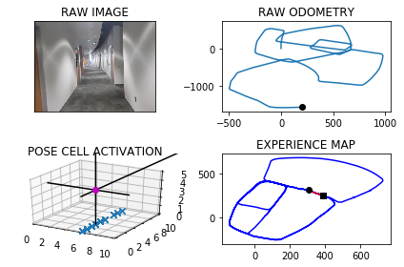

The counter is 5901

The angle is reset to 181.91963872438401

Energy injection at [6, 4]

min_delta_val

0.0

e_pc 6 4

current pc 6 4

loop closure

The counter is 5902

The angle is reset to 181.3437471070688

Energy injection at [6, 4]

The counter is 5909

The angle is reset to 180.94062297494818

Energy injection at [6, 2]

min_delta_val

0.0

e_pc 6 2

current pc 6 2

loop closure

The counter is 5915

The angle is reset to 180.13343608246373

Energy injection at [6, 2]

min_delta_val

1.0

e_pc 6 1

current pc 6 2

loop closure

The counter is 5916

The angle is reset to 180.09340525772458

Energy injection at [6, 1]

min_delta_val

0.0

e_pc 6 1

current pc 6 1

loop closure

The counter is 5917

The angle is reset to 180.06538368040722

Energy injection at [6, 1]

The counter is 5918

The angle is reset to 180.045768576285

Energy injection at [6, 0]

min_delta_val

0.0

e_pc 6 0

current pc 6 0

loop closure

The counter is 5919

The angle is reset to 180.03203800339952

Energy injection at [6, 0]

The counter is 5920

The angle is reset to 180.02242660237962

Energy injection at [6, 0]

min_delta_val

1.0

e_pc 6 0

current pc 6 9

The counter is 5923

The angle is reset to 179.49069862166576

Energy injection at [6, 0]

min_delta_val

0.0

e_pc 6 0

current pc 6 0

loop closure

The counter is 5924

The angle is reset to 179.64348903516603

Energy injection at [6, 0]

The counter is 5930

The angle is reset to 181.3254423246162

Energy injection at [6, 9]

hash collision

The counter is 5931

The angle is reset to 180.92780962723134

Energy injection at [6, 9]

hash collision

The counter is 5933

The angle is reset to 180.64946673906195

Energy injection at [6, 8]

min_delta_val

0.0

e_pc 6 8

current pc 6 8

loop closure

The counter is 5935

The angle is reset to 179.92962671734335

Energy injection at [6, 8]

min_delta_val

0.0

e_pc 6 8

current pc 6 8

loop closure

The counter is 5937

The angle is reset to 179.95073870214034

Energy injection at [6, 8]

min_delta_val

0.0

e_pc 6 8

current pc 6 8

loop closure

The counter is 5939

The angle is reset to 179.9655170914982

Energy injection at [6, 8]

min_delta_val

1.0

e_pc 6 8

current pc 6 7

loop closure

The counter is 5941

The angle is reset to 179.97586196404876

Energy injection at [6, 8]

min_delta_val

0.0

e_pc 6 7

current pc 6 7

loop closure

The counter is 5942

The angle is reset to 179.98310337483412

Energy injection at [6, 8]

The counter is 5943

The angle is reset to 179.98817236238386

Energy injection at [6, 8]

The counter is 5944

The angle is reset to 179.9917206536687

Energy injection at [6, 7]

min_delta_val

1.0

e_pc 6 7

current pc 6 8

The counter is 5945

The angle is reset to 179.99420445756812

Energy injection at [6, 7]

The counter is 5946

The angle is reset to 179.47094312029765

Energy injection at [6, 7]

The counter is 5947

The angle is reset to 179.62966018420832

Energy injection at [6, 7]

The counter is 5951

The angle is reset to 180.26576212894585

Energy injection at [6, 7]

min_delta_val

0.0

e_pc 6 7

current pc 6 7

loop closure

The counter is 5952

The angle is reset to 180.18603349026208

Energy injection at [6, 7]

The counter is 5953

The angle is reset to 180.13022344318344

Energy injection at [6, 7]

The counter is 5954

The angle is reset to 180.09115641022836

Energy injection at [6, 7]

The counter is 5955

The angle is reset to 180.06380948715986

Energy injection at [6, 7]

The counter is 5956

The angle is reset to 180.04466664101187

Energy injection at [6, 6]

min_delta_val

1.0

e_pc 6 5

current pc 6 7

The counter is 5957

The angle is reset to 180.03126664870834

Energy injection at [6, 6]

The counter is 5958

The angle is reset to 180.0218866540958

Energy injection at [6, 6]

The counter is 5961

The angle is reset to 180.54032065786706

Energy injection at [6, 6]

min_delta_val

0.0

e_pc 6 6

current pc 6 6

loop closure

The counter is 5964

The angle is reset to 180.90322446050695

Energy injection at [6, 6]

min_delta_val

1.0

e_pc 6 6

current pc 6 5

loop closure

The counter is 5965

The angle is reset to 181.15725712235482

Energy injection at [6, 5]

min_delta_val

0.0

e_pc 6 5

current pc 6 5

The counter is 5966

The angle is reset to 180.81007998564837

Energy injection at [6, 5]

The counter is 5967

The angle is reset to 180.56705598995387

Energy injection at [6, 5]

min_delta_val

0.0

e_pc 6 5

current pc 6 5

The counter is 5968

The angle is reset to 180.3969391929677

Energy injection at [6, 5]

The counter is 5969

The angle is reset to 179.7528574350774

Energy injection at [6, 5]

The counter is 5972

The angle is reset to 179.82700020455414

Energy injection at [6, 3]

The counter is 5973

The angle is reset to 179.8789001431879

Energy injection at [6, 3]

The counter is 5974

The angle is reset to 179.91523010023153

Energy injection at [6, 3]

The counter is 5975

The angle is reset to 180.46566107016204

Energy injection at [6, 4]

min_delta_val

1.0

e_pc 6 4

current pc 6 3

loop closure

The counter is 5976

The angle is reset to 180.85096274911342

Energy injection at [6, 4]

The counter is 5977

The angle is reset to 181.12067392437936

Energy injection at [6, 4]

The counter is 5978

The angle is reset to 181.30947174706557

Energy injection at [6, 4]

The counter is 5979

The angle is reset to 180.9166302229459

Energy injection at [6, 4]

min_delta_val

1.0

e_pc 6 4

current pc 6 3

The counter is 5980

The angle is reset to 180.6416411560621

Energy injection at [6, 4]

The counter is 5981

The angle is reset to 180.4491488092435

Energy injection at [6, 4]

The counter is 5982

The angle is reset to 179.7894041664704

Energy injection at [6, 4]

The counter is 5986

The angle is reset to 180.37758291652932

Energy injection at [6, 2]

The counter is 5987

The angle is reset to 180.2643080415705

Energy injection at [6, 2]

The counter is 5988

The angle is reset to 180.18501562909935

Energy injection at [6, 2]

The counter is 5989

The angle is reset to 180.12951094036953

Energy injection at [6, 2]

min_delta_val

0.0

e_pc 6 2

current pc 6 2

loop closure

The counter is 5990

The angle is reset to 180.09065765825866

Energy injection at [6, 2]

The counter is 5993

The angle is reset to 179.01346036078107

Energy injection at [6, 0]

min_delta_val

0.0

e_pc 6 0

current pc 6 0

loop closure

-----------------------------------------------------------

The current number of the iteration is 6000

46.4260001183 seconds are elapsed per 100 frames.

The number of units of the VT is 2441

The number of units of the experience map is 2543

02/20/19 09:16:35

-----------------------------------------------------------

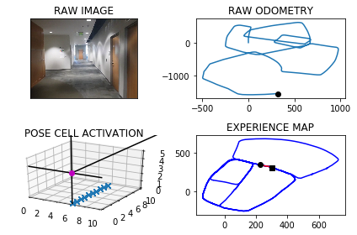

The counter is 6002

The angle is reset to 180.88442225254673

Energy injection at [6, 8]

The counter is 6003

The angle is reset to 180.61909557678268

Energy injection at [6, 8]

The counter is 6004

The angle is reset to 180.4333669037479

Energy injection at [6, 8]

The counter is 6026

The angle is reset to 180.82835683262348

Energy injection at [6, 9]

The counter is 6027

The angle is reset to 180.57984978283645

Energy injection at [6, 9]

min_delta_val

0.0

e_pc 6 9

current pc 6 9

loop closure

The counter is 6030

The angle is reset to 179.35589484798547

Energy injection at [6, 9]

min_delta_val

1.0

e_pc 6 9

current pc 6 8

loop closure

The counter is 6031

The angle is reset to 179.54912639358983

Energy injection at [6, 8]

min_delta_val

0.0

e_pc 6 8

current pc 6 8

The counter is 6032

The angle is reset to 179.68438847551286

Energy injection at [6, 8]

The counter is 6033

The angle is reset to 179.779071932859

Energy injection at [6, 8]

The counter is 6034

The angle is reset to 179.84535035300127

Energy injection at [6, 8]

The counter is 6035

The angle is reset to 179.89174524710089

Energy injection at [6, 8]

min_delta_val

0.0

e_pc 6 8

current pc 6 8

The counter is 6038

The angle is reset to 179.92422167297062

Energy injection at [6, 8]

min_delta_val

1.0

e_pc 6 8

current pc 6 7

loop closure

The counter is 6050

The angle is reset to 179.94695517107942

Energy injection at [6, 4]

The counter is 6051

The angle is reset to 179.96286861975557

Energy injection at [6, 4]

min_delta_val

0.0

e_pc 6 4

current pc 6 4

loop closure

The counter is 6052

The angle is reset to 179.97400803382888

Energy injection at [6, 4]

The counter is 6053

The angle is reset to 179.98180562368023

Energy injection at [6, 4]

The counter is 6054

The angle is reset to 179.98726393657614

Energy injection at [6, 4]

The counter is 6055

The angle is reset to 179.99108475560328

Energy injection at [6, 3]

min_delta_val

1.0

e_pc 6 3

current pc 6 4

The counter is 6056

The angle is reset to 179.99375932892232

Energy injection at [6, 3]

The counter is 6057

The angle is reset to 179.99563153024562

Energy injection at [6, 3]

min_delta_val

0.0

e_pc 6 3

current pc 6 3

The counter is 6058

The angle is reset to 180.5219420711719

Energy injection at [6, 3]

min_delta_val

0.0

e_pc 6 3

current pc 6 3

The counter is 6059

The angle is reset to 180.36535944982032

Energy injection at [6, 3]

The counter is 6060

The angle is reset to 180.2557516148742

Energy injection at [6, 3]

The counter is 6061

The angle is reset to 180.17902613041196

Energy injection at [6, 3]

The counter is 6062

The angle is reset to 179.60031829128835

Energy injection at [6, 3]

The counter is 6063

The angle is reset to 179.19522280390186

Energy injection at [6, 3]

min_delta_val

0.0

e_pc 6 3

current pc 6 3

The counter is 6064

The angle is reset to 206.43665596273127

Energy injection at [5, 7]

The counter is 6065

The angle is reset to 198.50565917391185

Energy injection at [6, 2]

The counter is 6066

The angle is reset to 192.9539614217383

Energy injection at [6, 2]

The counter is 6067

The angle is reset to 189.0677729952168

Energy injection at [6, 2]

The counter is 6068

The angle is reset to 186.34744109665175

Energy injection at [6, 2]

min_delta_val

1.0

e_pc 4 7

current pc 6 1

loop closure

The counter is 6069

The angle is reset to 184.44320876765624

Energy injection at [6, 2]

The counter is 6070

The angle is reset to 183.11024613735933

Energy injection at [6, 2]

hash collision

The counter is 6071

The angle is reset to 182.17717229615153

Energy injection at [6, 2]

hash collision

The counter is 6072

The angle is reset to 181.52402060730606

Energy injection at [6, 2]

hash collision

The counter is 6073

The angle is reset to 208.06681442511422

Energy injection at [4, 7]

The counter is 6079

The angle is reset to 227.1717700975799

Energy injection at [4, 7]

min_delta_val

1.0

e_pc 3 7

current pc 4 7

loop closure

The counter is 6080

The angle is reset to 240.5452390683059

Energy injection at [4, 7]

min_delta_val

0.0

e_pc 4 7

current pc 4 7

The counter is 6081

The angle is reset to 249.38166734781413

Energy injection at [4, 7]

The counter is 6082

The angle is reset to 242.06716714346987

Energy injection at [3, 4]

The counter is 6083

The angle is reset to 236.94701700042887

Energy injection at [3, 4]

The counter is 6084

The angle is reset to 233.36291190030022

Energy injection at [3, 4]

The counter is 6085

The angle is reset to 230.85403833021016

Energy injection at [3, 4]

The counter is 6086

The angle is reset to 229.0978268311471

Energy injection at [3, 4]

The counter is 6087

The angle is reset to 227.86847878180296

Energy injection at [3, 4]

The counter is 6092

The angle is reset to 227.0079351472621

Energy injection at [3, 6]

min_delta_val

1.0

e_pc 3 6

current pc 3 5

loop closure

-----------------------------------------------------------

The current number of the iteration is 6100

32.5690000057 seconds are elapsed per 100 frames.

The number of units of the VT is 2464

The number of units of the experience map is 2573

02/20/19 09:17:07

-----------------------------------------------------------

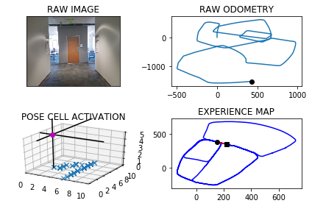

The counter is 6101

The angle is reset to 224.8305546030834

Energy injection at [2, 5]

min_delta_val

0.0

e_pc 2 5

current pc 2 5

loop closure

The counter is 6102

The angle is reset to 224.8813882221584

Energy injection at [2, 5]

The counter is 6111

The angle is reset to 224.91697175551087

Energy injection at [1, 4]

min_delta_val

0.0

e_pc 1 4

current pc 1 4

loop closure

The counter is 6120

The angle is reset to 226.51688022885756

Energy injection at [9, 2]

min_delta_val

1.4142135623730951

e_pc 8 1

current pc 9 2

loop closure

The counter is 6121

The angle is reset to 225.53681616020032

Energy injection at [0, 1]

counter 6121

multiple peak # >2

[0L, 0L, 9L] [1L, 2L, 2L]

The counter is 6122

The angle is reset to 225.3757713121402

Energy injection at [9, 0]

counter 6122

multiple peak # >2

[0L, 9L, 9L] [1L, 0L, 1L]

min_delta_val

1.4142135623730951

e_pc 9 0

current pc 0 1

loop closure

The counter is 6123

The angle is reset to 225.26303991849815

Energy injection at [9, 0]

The counter is 6124

The angle is reset to 225.18412794294866

Energy injection at [0, 1]

min_delta_val

0.0

e_pc 0 1

current pc 0 1

loop closure

The counter is 6125

The angle is reset to 225.1288895600641

Energy injection at [9, 0]

min_delta_val

0.0

e_pc 9 0

current pc 9 0

loop closure

The counter is 6126

The angle is reset to 225.09022269204482

Energy injection at [8, 1]

hash collision

The counter is 6130

The angle is reset to 225.58815588443142

Energy injection at [8, 1]

min_delta_val

1.0

e_pc 7 1

current pc 8 1

loop closure

The counter is 6131

The angle is reset to 225.41170911910197

Energy injection at [8, 1]

The counter is 6134

The angle is reset to 224.76319638337137

Energy injection at [7, 0]

The counter is 6135

The angle is reset to 224.83423746835996

Energy injection at [7, 0]

The counter is 6138

The angle is reset to 225.40896622785195

Energy injection at [6, 8]

The counter is 6139

The angle is reset to 225.28627635949638

Energy injection at [6, 8]

min_delta_val

1.4142135623730951

e_pc 5 7

current pc 6 8

loop closure

The counter is 6143

The angle is reset to 218.37539345164745

Energy injection at [5, 7]

min_delta_val

0.0

e_pc 5 7

current pc 5 7

loop closure

The counter is 6169

The angle is reset to 146.1127754161532

Energy injection at [5, 2]

min_delta_val

0.0

e_pc 5 2

current pc 5 2

loop closure

The counter is 6170

The angle is reset to 142.7789427913072

Energy injection at [5, 2]

The counter is 6184

The angle is reset to 142.54525995391504

Energy injection at [7, 0]

min_delta_val

0.0

e_pc 7 0

current pc 7 0

loop closure

The counter is 6185

The angle is reset to 140.28168196774052

Energy injection at [7, 0]

The counter is 6186

The angle is reset to 138.17217737741834

Energy injection at [7, 0]

The counter is 6187

The angle is reset to 137.22052416419282

Energy injection at [8, 9]

min_delta_val

1.4142135623730951

e_pc 8 9

current pc 7 0

The counter is 6188

The angle is reset to 136.55436691493497

Energy injection at [8, 9]

The counter is 6189

The angle is reset to 136.61305684045448

Energy injection at [8, 9]

min_delta_val

0.0

e_pc 8 9

current pc 8 9

The counter is 6197

The angle is reset to 136.12913978831813

Energy injection at [8, 9]

min_delta_val

0.0

e_pc 8 9

current pc 8 9

loop closure

The counter is 6198

The angle is reset to 135.26539785182268

Energy injection at [8, 9]

The counter is 6199

The angle is reset to 134.66077849627587

Energy injection at [8, 9]

The counter is 6200

The angle is reset to 134.7625449473931

Energy injection at [8, 9]

-----------------------------------------------------------

The current number of the iteration is 6200

29.746999979 seconds are elapsed per 100 frames.

The number of units of the VT is 2508

The number of units of the experience map is 2621

02/20/19 09:17:37

-----------------------------------------------------------

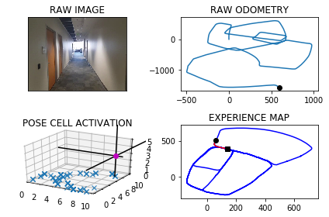

The counter is 6201

The angle is reset to 134.83378146317514

Energy injection at [9, 8]

min_delta_val

0.0

e_pc 9 8

current pc 9 8

The counter is 6202

The angle is reset to 134.8836470242226

Energy injection at [9, 8]

The counter is 6203

The angle is reset to 134.9185529169558

Energy injection at [9, 8]

min_delta_val

0.0

e_pc 9 8

current pc 9 8

The counter is 6205

The angle is reset to 134.94298704186906

Energy injection at [9, 8]

min_delta_val

1.4142135623730951

e_pc 0 7

current pc 9 8

loop closure

The counter is 6206

The angle is reset to 134.96009092930834

Energy injection at [9, 8]

The counter is 6207

The angle is reset to 134.44706365051582

Energy injection at [0, 7]

min_delta_val

1.0

e_pc 0 7

current pc 0 8

The counter is 6209

The angle is reset to 133.56294455536104

Energy injection at [0, 7]

min_delta_val

0.0

e_pc 0 7

current pc 0 7

loop closure

The counter is 6210

The angle is reset to 133.99406118875274

Energy injection at [0, 7]

The counter is 6211

The angle is reset to 134.2958428321269

Energy injection at [0, 7]

min_delta_val

0.0

e_pc 0 7

current pc 0 7

The counter is 6212

The angle is reset to 134.50708998248885

Energy injection at [0, 7]

The counter is 6213

The angle is reset to 134.65496298774218

Energy injection at [0, 7]

min_delta_val

0.0

e_pc 0 7

current pc 0 7

The counter is 6214

The angle is reset to 135.2834740914195

Energy injection at [0, 7]

The counter is 6215

The angle is reset to 135.19843186399365

Energy injection at [0, 7]

min_delta_val

0.0

e_pc 0 7

current pc 0 7

The counter is 6216

The angle is reset to 135.13890230479555

Energy injection at [0, 7]

The counter is 6217

The angle is reset to 135.09723161335685

Energy injection at [0, 7]

min_delta_val

1.0

e_pc 0 7

current pc 0 6

The counter is 6218

The angle is reset to 135.06806212934978

Energy injection at [0, 7]

The counter is 6219

The angle is reset to 135.04764349054486

Energy injection at [0, 7]

The counter is 6220

The angle is reset to 135.0333504433814

Energy injection at [0, 7]

min_delta_val

0.0

e_pc 0 7

current pc 0 7

The counter is 6221

The angle is reset to 135.02334531036698

Energy injection at [0, 7]

The counter is 6222

The angle is reset to 135.01634171725686

Energy injection at [0, 7]

min_delta_val

0.0

e_pc 0 7

current pc 0 7

The counter is 6223

The angle is reset to 135.0114392020798

Energy injection at [0, 7]

The counter is 6224

The angle is reset to 135.00800744145585

Energy injection at [0, 7]

The counter is 6225

The angle is reset to 135.5306052090191

Energy injection at [1, 6]

min_delta_val

0.0

e_pc 1 6

current pc 1 6

The counter is 6226

The angle is reset to 135.89642364631334

Energy injection at [1, 6]

The counter is 6235

The angle is reset to 135.62749655241933

Energy injection at [2, 5]

min_delta_val

1.4142135623730951

e_pc 3 4

current pc 2 5

loop closure

The counter is 6236

The angle is reset to 135.4392475866935

Energy injection at [2, 5]

The counter is 6237

The angle is reset to 135.83247331068543

Energy injection at [3, 4]

min_delta_val

1.4142135623730951

e_pc 3 4

current pc 2 5

The counter is 6238

The angle is reset to 136.1077313174798

Energy injection at [3, 4]

min_delta_val

1.4142135623730951

e_pc 3 4

current pc 4 3

The counter is 6239

The angle is reset to 136.30041192223587

Energy injection at [3, 4]

The counter is 6240

The angle is reset to 136.4352883455651

Energy injection at [3, 4]

min_delta_val

0.0

e_pc 3 4

current pc 3 4

The counter is 6243

The angle is reset to 136.52970184189556

Energy injection at [3, 4]

min_delta_val

1.4142135623730951

e_pc 3 4

current pc 4 3

loop closure

The counter is 6244

The angle is reset to 136.07079128932688

Energy injection at [3, 4]

The counter is 6245

The angle is reset to 135.7495539025288

Energy injection at [3, 4]

min_delta_val

0.0

e_pc 3 4

current pc 3 4

The counter is 6246

The angle is reset to 135.52468773177014

Energy injection at [3, 4]

The counter is 6247

The angle is reset to 135.3672814122391

Energy injection at [3, 4]

min_delta_val

0.0

e_pc 3 4

current pc 3 4

The counter is 6248

The angle is reset to 135.78209698856736

Energy injection at [3, 4]

The counter is 6249

The angle is reset to 135.54746789199714

Energy injection at [3, 4]

min_delta_val

0.0

e_pc 3 4

current pc 3 4

The counter is 6250

The angle is reset to 135.908227524398

Energy injection at [3, 4]

The counter is 6251

The angle is reset to 135.63575926707858

Energy injection at [3, 4]

The counter is 6254

The angle is reset to 134.920031486955

Energy injection at [3, 4]

min_delta_val

0.0

e_pc 3 4

current pc 3 4

loop closure

The counter is 6255

The angle is reset to 134.9440220408685

Energy injection at [4, 3]

min_delta_val

0.0

e_pc 4 3

current pc 4 3

The counter is 6256

The angle is reset to 134.96081542860793

Energy injection at [4, 3]

The counter is 6257

The angle is reset to 134.97257080002555

Energy injection at [4, 3]

The counter is 6258

The angle is reset to 135.50579956001786

Energy injection at [4, 3]

min_delta_val

0.0

e_pc 4 3

current pc 4 3

The counter is 6259

The angle is reset to 135.3540596920125

Energy injection at [4, 3]

The counter is 6260

The angle is reset to 135.24784178440873

Energy injection at [5, 2]

min_delta_val

1.4142135623730951

e_pc 5 2

current pc 4 3

The counter is 6261

The angle is reset to 135.6984892490861

Energy injection at [5, 2]

The counter is 6262

The angle is reset to 135.48894247436024

Energy injection at [5, 2]

min_delta_val

0.0

e_pc 5 2

current pc 5 2

The counter is 6263

The angle is reset to 135.34225973205216

Energy injection at [5, 2]

The counter is 6264

The angle is reset to 135.2395818124365

Energy injection at [5, 2]

The counter is 6265

The angle is reset to 135.16770726870556

Energy injection at [5, 2]

min_delta_val

0.0

e_pc 5 2

current pc 5 2

The counter is 6266

The angle is reset to 135.11739508809387

Energy injection at [5, 2]

The counter is 6267

The angle is reset to 135.0821765616657

Energy injection at [5, 2]

The counter is 6268

The angle is reset to 135.057523593166

Energy injection at [5, 2]

min_delta_val

0.0

e_pc 5 2

current pc 5 2

The counter is 6269

The angle is reset to 135.0402665152162

Energy injection at [5, 2]

The counter is 6270

The angle is reset to 135.0281865606513

Energy injection at [5, 2]

The counter is 6271

The angle is reset to 135.5447305924559

Energy injection at [6, 1]

min_delta_val

1.4142135623730951

e_pc 6 1

current pc 5 2

The counter is 6272

The angle is reset to 135.90631141471914

Energy injection at [6, 1]

The counter is 6273

The angle is reset to 136.15941799030338

Energy injection at [6, 1]

The counter is 6281

The angle is reset to 135.28659259321236

Energy injection at [7, 0]

min_delta_val

0.0

e_pc 7 0

current pc 7 0

loop closure

The counter is 6282

The angle is reset to 135.20061481524863

Energy injection at [7, 0]

min_delta_val

1.0

e_pc 8 0

current pc 7 0

The counter is 6283

The angle is reset to 135.140430370674

Energy injection at [7, 0]

The counter is 6293

The angle is reset to 134.57330125947178

Energy injection at [8, 9]

min_delta_val

0.0

e_pc 8 9

current pc 8 9

loop closure

The counter is 6294

The angle is reset to 134.70131088163023

Energy injection at [8, 9]

min_delta_val

0.0

e_pc 8 9

current pc 8 9

The counter is 6296

The angle is reset to 134.79091761714116

Energy injection at [8, 9]

min_delta_val

1.4142135623730951

e_pc 8 9

current pc 9 8

loop closure

The counter is 6297

The angle is reset to 134.8536423319988

Energy injection at [8, 9]

The counter is 6298

The angle is reset to 134.89754963239912

Energy injection at [8, 9]

The counter is 6299

The angle is reset to 134.92828474267938

Energy injection at [8, 9]

min_delta_val

0.0

e_pc 8 9

current pc 8 9

The counter is 6300

The angle is reset to 134.94979931987555

Energy injection at [8, 9]

-----------------------------------------------------------

The current number of the iteration is 6300

63.5519998074 seconds are elapsed per 100 frames.

The number of units of the VT is 2522

The number of units of the experience map is 2635

02/20/19 09:18:41

-----------------------------------------------------------

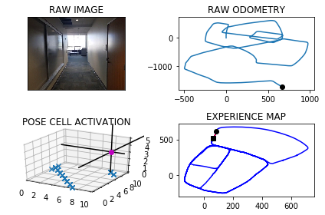

The counter is 6301

The angle is reset to 134.43985952391287

Energy injection at [8, 9]

The counter is 6302

The angle is reset to 134.08290166673902

Energy injection at [8, 9]

min_delta_val

0.0

e_pc 8 9

current pc 8 9

The counter is 6303

The angle is reset to 134.3580311667173

Energy injection at [8, 9]

The counter is 6304

The angle is reset to 134.55062181670212

Energy injection at [8, 9]

The counter is 6305

The angle is reset to 134.68543527169146

Energy injection at [8, 9]

The counter is 6306

The angle is reset to 134.779804690184

Energy injection at [8, 9]

The counter is 6307

The angle is reset to 134.8458632831288

Energy injection at [8, 9]

The counter is 6308

The angle is reset to 134.89210429819013

Energy injection at [9, 8]

min_delta_val

1.4142135623730951

e_pc 9 8

current pc 8 9

The counter is 6309

The angle is reset to 134.92447300873306

Energy injection at [9, 8]

The counter is 6310

The angle is reset to 134.94713110611312

Energy injection at [9, 8]

The counter is 6311

The angle is reset to 134.96299177427917

Energy injection at [9, 8]

The counter is 6312

The angle is reset to 134.9740942419954

Energy injection at [9, 8]

The counter is 6313

The angle is reset to 134.98186596939678

Energy injection at [9, 8]

The counter is 6314

The angle is reset to 134.9873061785777

Energy injection at [9, 8]

min_delta_val

0.0

e_pc 9 8

current pc 9 8

The counter is 6315

The angle is reset to 134.99111432500442

Energy injection at [9, 8]

min_delta_val

0.0

e_pc 9 8

current pc 9 8

loop closure

The counter is 6316

The angle is reset to 134.99378002750305

Energy injection at [0, 7]

min_delta_val

0.0

e_pc 0 7

current pc 0 7

loop closure

The counter is 6317

The angle is reset to 134.99564601925215

Energy injection at [0, 7]

The counter is 6318

The angle is reset to 134.99695221347648

Energy injection at [0, 7]

The counter is 6319

The angle is reset to 135.52286654943353

Energy injection at [0, 7]

The counter is 6320

The angle is reset to 135.89100658460347

Energy injection at [0, 7]

The counter is 6321

The angle is reset to 135.62370460922241

Energy injection at [0, 7]

min_delta_val

0.0

e_pc 0 7

current pc 0 7

The counter is 6322

The angle is reset to 135.43659322645567

Energy injection at [0, 7]

The counter is 6323

The angle is reset to 135.30561525851894

Energy injection at [0, 7]

The counter is 6324

The angle is reset to 135.21393068096324

Energy injection at [0, 7]

The counter is 6325

The angle is reset to 134.62475147667428

Energy injection at [0, 7]

min_delta_val

0.0

e_pc 0 7

current pc 0 7

loop closure

The counter is 6326

The angle is reset to 134.73732603367196

Energy injection at [0, 7]

The counter is 6327

The angle is reset to 134.81612822357036

Energy injection at [0, 7]

The counter is 6328

The angle is reset to 134.87128975649924

Energy injection at [0, 7]

min_delta_val

0.0

e_pc 0 7

current pc 0 7

The counter is 6329

The angle is reset to 134.90990282954948

Energy injection at [0, 7]

The counter is 6330

The angle is reset to 134.93693198068462

Energy injection at [0, 7]

The counter is 6331

The angle is reset to 134.95585238647922

Energy injection at [0, 7]

min_delta_val

1.4142135623730951

e_pc 1 6

current pc 0 7

The counter is 6332

The angle is reset to 134.96909667053544

Energy injection at [0, 7]

The counter is 6333

The angle is reset to 134.9783676693748

Energy injection at [0, 7]

The counter is 6334

The angle is reset to 134.98485736856236

Energy injection at [0, 7]

The counter is 6337

The angle is reset to 134.46440015799362

Energy injection at [1, 6]

min_delta_val

0.0

e_pc 1 6

current pc 1 6

loop closure

The counter is 6338

The angle is reset to 134.62508011059552

Energy injection at [1, 6]

The counter is 6339

The angle is reset to 134.73755607741685

Energy injection at [1, 6]

The counter is 6340

The angle is reset to 134.8162892541918

Energy injection at [1, 6]

The counter is 6343

The angle is reset to 134.87140247793425

Energy injection at [1, 6]

min_delta_val

0.0

e_pc 1 6

current pc 1 6

loop closure

The counter is 6344

The angle is reset to 134.90998173455398

Energy injection at [1, 6]

min_delta_val

1.0

e_pc 1 6

current pc 1 5

loop closure

The counter is 6345

The angle is reset to 134.93698721418775

Energy injection at [1, 6]

The counter is 6346

The angle is reset to 134.9558910499314

Energy injection at [1, 6]

The counter is 6348

The angle is reset to 134.96912373495198

Energy injection at [1, 6]

min_delta_val

1.4142135623730951

e_pc 2 5

current pc 1 6

loop closure

The counter is 6353

The angle is reset to 134.9783866144664

Energy injection at [2, 5]

min_delta_val

0.0

e_pc 2 5

current pc 2 5

loop closure

The counter is 6354

The angle is reset to 135.50987063012644

Energy injection at [2, 5]

The counter is 6355

The angle is reset to 135.3569094410885

Energy injection at [2, 5]

The counter is 6356

The angle is reset to 135.2498366087619

Energy injection at [2, 5]

The counter is 6357

The angle is reset to 135.17488562613335

Energy injection at [2, 5]

min_delta_val

0.0

e_pc 2 5

current pc 2 5

The counter is 6358

The angle is reset to 135.12241993829335

Energy injection at [2, 5]

The counter is 6359

The angle is reset to 134.56069395680532

Energy injection at [2, 5]

The counter is 6360

The angle is reset to 134.69248576976372

Energy injection at [2, 5]

The counter is 6378

The angle is reset to 115.35974003883459

Energy injection at [3, 4]

min_delta_val

1.4142135623730951

e_pc 4 3

current pc 3 4

loop closure

The counter is 6379

The angle is reset to 117.05181802718421

Energy injection at [4, 3]

min_delta_val

1.0

e_pc 5 3

current pc 4 3

The counter is 6380

The angle is reset to 105.78627261902895

Energy injection at [5, 3]

min_delta_val

0.0

e_pc 5 3

current pc 5 3

The counter is 6388

The angle is reset to 73.22539083332026

Energy injection at [1, 3]

The counter is 6394

The angle is reset to 77.73277358332417

Energy injection at [1, 3]

min_delta_val

0.0

e_pc 1 3

current pc 1 3

loop closure

The counter is 6395

The angle is reset to 81.41294150832691

Energy injection at [1, 3]

The counter is 6396

The angle is reset to 83.98905905582883

Energy injection at [1, 3]

-----------------------------------------------------------

The current number of the iteration is 6400

37.5440001488 seconds are elapsed per 100 frames.

The number of units of the VT is 2546

The number of units of the experience map is 2660

02/20/19 09:19:18

-----------------------------------------------------------

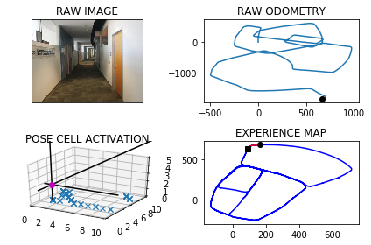

The counter is 6406

The angle is reset to 87.89234133908019

Energy injection at [3, 3]

The counter is 6407

The angle is reset to 88.52463893735612

Energy injection at [3, 3]

The counter is 6416

The angle is reset to 88.96724725614928

Energy injection at [4, 3]

min_delta_val

1.0

e_pc 4 3

current pc 3 3

loop closure

The counter is 6419

The angle is reset to 89.27707307930449

Energy injection at [5, 3]

min_delta_val

0.0

e_pc 5 3

current pc 5 3

loop closure

The counter is 6427

The angle is reset to 88.44395115551313

Energy injection at [6, 3]

min_delta_val

0.0

e_pc 6 3

current pc 6 3

loop closure

The counter is 6437

The angle is reset to 88.9107658088592

Energy injection at [6, 3]

min_delta_val

0.0

e_pc 6 3

current pc 6 3

loop closure

The counter is 6438

The angle is reset to 89.76253606620143

Energy injection at [6, 3]

The counter is 6465

The angle is reset to 91.933775246341

Energy injection at [9, 3]

min_delta_val

0.0

e_pc 9 3

current pc 9 3

loop closure

The counter is 6466

The angle is reset to 91.3536426724387

Energy injection at [9, 3]

The counter is 6467

The angle is reset to 90.94754987070709

Energy injection at [0, 3]

min_delta_val

0.0

e_pc 0 3

current pc 0 3

The counter is 6480

The angle is reset to 91.18828490949497

Energy injection at [3, 3]

min_delta_val

0.0

e_pc 3 3

current pc 3 3

loop closure

The counter is 6489

The angle is reset to 77.33179943664648

Energy injection at [3, 3]

min_delta_val

0.0

e_pc 3 3

current pc 3 3

loop closure

-----------------------------------------------------------

The current number of the iteration is 6500

18.1240000725 seconds are elapsed per 100 frames.

The number of units of the VT is 2591

The number of units of the experience map is 2706

02/20/19 09:19:36

-----------------------------------------------------------

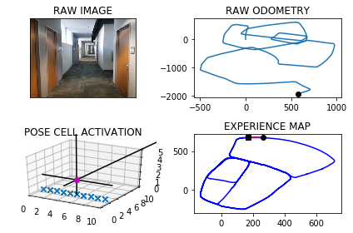

The counter is 6509

The angle is reset to 67.10725960565252

Energy injection at [5, 3]

min_delta_val

0.0

e_pc 5 3

current pc 5 3

loop closure

The counter is 6510

The angle is reset to 60.475081723956755

Energy injection at [5, 3]

The counter is 6511

The angle is reset to 55.83255720676972

Energy injection at [5, 3]

min_delta_val

1.0

e_pc 5 4

current pc 5 3

The counter is 6512

The angle is reset to 52.58279004473881

Energy injection at [5, 3]

The counter is 6513

The angle is reset to 50.30795303131716

Energy injection at [5, 3]

The counter is 6515

The angle is reset to 48.71556712192201

Energy injection at [5, 4]

min_delta_val

1.4142135623730951

e_pc 5 4

current pc 6 3

loop closure

The counter is 6516

The angle is reset to 47.0758969853454

Energy injection at [5, 4]

The counter is 6517

The angle is reset to 46.45312788974178

Energy injection at [5, 4]

min_delta_val

1.0

e_pc 6 4

current pc 5 4

The counter is 6518

The angle is reset to 46.017189522819244

Energy injection at [5, 4]

The counter is 6519

The angle is reset to 45.71203266597347

Energy injection at [6, 4]

min_delta_val

1.0

e_pc 6 4

current pc 5 4

The counter is 6520

The angle is reset to 45.49842286618143

Energy injection at [6, 4]

The counter is 6521

The angle is reset to 45.348896006326996

Energy injection at [6, 4]

min_delta_val

0.0

e_pc 6 4

current pc 6 4

The counter is 6522

The angle is reset to 45.244227204428896

Energy injection at [6, 4]

The counter is 6523

The angle is reset to 45.17095904310022

Energy injection at [6, 4]

The counter is 6524

The angle is reset to 45.11967133017015

Energy injection at [6, 4]

The counter is 6558

The angle is reset to 43.50876993111911

Energy injection at [9, 7]

min_delta_val

0.0

e_pc 9 7

current pc 9 7

loop closure

-----------------------------------------------------------

The current number of the iteration is 6600

17.253000021 seconds are elapsed per 100 frames.

The number of units of the VT is 2635

The number of units of the experience map is 2750

02/20/19 09:19:53

-----------------------------------------------------------

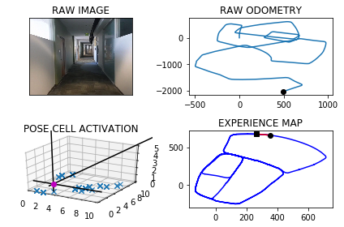

The counter is 6628

The angle is reset to 43.956138951783366

Energy injection at [6, 4]

min_delta_val

0.0

e_pc 6 4

current pc 6 4

loop closure

The counter is 6629

The angle is reset to 44.26929726624836

Energy injection at [5, 3]

min_delta_val

0.0

e_pc 5 3

current pc 5 3

loop closure

The counter is 6630

The angle is reset to 44.48850808637385

Energy injection at [6, 4]

The counter is 6631

The angle is reset to 44.64195566046169

Energy injection at [5, 3]

The counter is 6639

The angle is reset to 44.749368962323175

Energy injection at [7, 5]

min_delta_val

1.0

e_pc 7 6

current pc 7 5

loop closure

The counter is 6640

The angle is reset to 44.824558273626224

Energy injection at [7, 5]

The counter is 6643

The angle is reset to 44.877190791538354

Energy injection at [7, 6]

min_delta_val

0.0

e_pc 7 6

current pc 7 6

loop closure

The counter is 6653

The angle is reset to 43.86403355407685

Energy injection at [9, 7]

min_delta_val

0.0

e_pc 9 7

current pc 9 7

loop closure

The counter is 6654

The angle is reset to 44.204823487853794

Energy injection at [9, 7]

The counter is 6665

The angle is reset to 44.96837644149766

Energy injection at [1, 9]

min_delta_val

0.0

e_pc 1 9

current pc 1 9

loop closure

The counter is 6666

The angle is reset to 44.452863509048356

Energy injection at [0, 8]

min_delta_val

1.4142135623730951

e_pc 0 8

current pc 1 9

loop closure

The counter is 6672

The angle is reset to 44.617004456333845

Energy injection at [2, 0]

The counter is 6678

The angle is reset to 44.2069031194337

Energy injection at [3, 1]

min_delta_val

0.0

e_pc 3 1

current pc 3 1

loop closure

The counter is 6679

The angle is reset to 43.91983218360358

Energy injection at [3, 1]

The counter is 6690

The angle is reset to 43.71888252852251

Energy injection at [4, 2]

-----------------------------------------------------------

The current number of the iteration is 6700

18.5550000668 seconds are elapsed per 100 frames.

The number of units of the VT is 2679

The number of units of the experience map is 2798

02/20/19 09:20:12

-----------------------------------------------------------

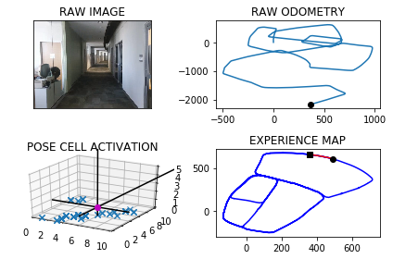

The counter is 6717

The angle is reset to 43.57821776996576

Energy injection at [7, 6]

min_delta_val

0.0

e_pc 7 6

current pc 7 6

loop closure

The counter is 6725

The angle is reset to 44.00475243897603

Energy injection at [8, 6]

min_delta_val

0.0

e_pc 8 6

current pc 8 6

loop closure

The counter is 6726

The angle is reset to 44.30332670728322

Energy injection at [8, 6]

The counter is 6729

The angle is reset to 44.51232869509824

Energy injection at [9, 7]

min_delta_val

0.0

e_pc 9 7

current pc 9 7

loop closure

The counter is 6730

The angle is reset to 44.65863008656876

Energy injection at [9, 7]

The counter is 6748

The angle is reset to 43.18604106059814

Energy injection at [1, 0]

min_delta_val

0.0

e_pc 1 0

current pc 1 0

loop closure

The counter is 6751

The angle is reset to 43.73022874241869

Energy injection at [2, 0]

min_delta_val

0.0

e_pc 2 0

current pc 2 0

loop closure

The counter is 6752

The angle is reset to 44.111160119693075

Energy injection at [2, 0]

The counter is 6753

The angle is reset to 44.37781208378515

Energy injection at [2, 0]

min_delta_val

0.0

e_pc 2 0

current pc 2 0

The counter is 6754

The angle is reset to 44.56446845864961

Energy injection at [2, 0]

The counter is 6755

The angle is reset to 44.69512792105472

Energy injection at [2, 0]

min_delta_val

0.0

e_pc 2 0

current pc 2 0

The counter is 6756

The angle is reset to 44.786589544738305

Energy injection at [2, 0]

The counter is 6757

The angle is reset to 44.85061268131681

Energy injection at [3, 1]

min_delta_val

1.4142135623730951

e_pc 3 1

current pc 2 0

The counter is 6758

The angle is reset to 44.89542887692177

Energy injection at [3, 1]

The counter is 6782

The angle is reset to 45.45180021384523

Energy injection at [5, 3]

min_delta_val

1.4142135623730951

e_pc 6 4

current pc 5 3

loop closure

The counter is 6789

The angle is reset to 45.316260149691665

Energy injection at [6, 5]

min_delta_val

0.0

e_pc 6 5

current pc 6 5

loop closure

The counter is 6790

The angle is reset to 45.22138210478416

Energy injection at [6, 5]

The counter is 6791

The angle is reset to 45.15496747334891

Energy injection at [6, 5]

The counter is 6796

The angle is reset to 44.058477231344234

Energy injection at [7, 5]

min_delta_val

0.0

e_pc 7 5

current pc 7 5

loop closure

The counter is 6797

The angle is reset to 44.34093406194097

Energy injection at [7, 5]

The counter is 6798

The angle is reset to 44.53865384335868

Energy injection at [7, 5]

The counter is 6799

The angle is reset to 44.67705769035108

Energy injection at [7, 5]

The counter is 6800

The angle is reset to 44.773940383245744

Energy injection at [7, 5]

min_delta_val

0.0

e_pc 7 5

current pc 7 5

-----------------------------------------------------------

The current number of the iteration is 6800

27.8819999695 seconds are elapsed per 100 frames.

The number of units of the VT is 2720

The number of units of the experience map is 2839

02/20/19 09:20:40

-----------------------------------------------------------

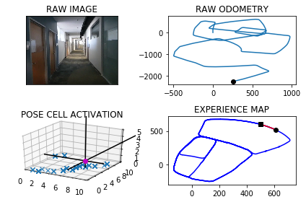

The counter is 6801

The angle is reset to 44.84175826827202

Energy injection at [7, 5]

The counter is 6809

The angle is reset to 44.88923078779042

Energy injection at [8, 6]

min_delta_val

0.0

e_pc 8 6

current pc 8 6

loop closure

The counter is 6812

The angle is reset to 44.92246155145329

Energy injection at [8, 6]

min_delta_val

1.4142135623730951

e_pc 8 6

current pc 9 7

loop closure

The counter is 6813

The angle is reset to 44.9457230860173

Energy injection at [8, 6]

The counter is 6814

The angle is reset to 44.962006160212105

Energy injection at [9, 7]

min_delta_val

0.0

e_pc 9 7

current pc 9 7

The counter is 6815

The angle is reset to 44.973404312148475

Energy injection at [9, 7]

The counter is 6827

The angle is reset to 46.55638301850392

Energy injection at [9, 8]

min_delta_val

0.0

e_pc 9 8

current pc 9 8

loop closure

The counter is 6849

The angle is reset to 45.564468112952746

Energy injection at [2, 0]

The counter is 6856

The angle is reset to 44.870127679066925

Energy injection at [3, 1]

min_delta_val

0.0

e_pc 3 1

current pc 3 1

loop closure

The counter is 6857

The angle is reset to 44.90908937534684

Energy injection at [3, 1]

The counter is 6867

The angle is reset to 45.461362562742785

Energy injection at [3, 2]

min_delta_val

0.0

e_pc 3 2

current pc 3 2

loop closure

The counter is 6868

The angle is reset to 45.32295379391995

Energy injection at [3, 2]

The counter is 6871

The angle is reset to 45.22606765574396

Energy injection at [3, 2]

min_delta_val

0.0

e_pc 3 2

current pc 3 2

loop closure

The counter is 6872

The angle is reset to 45.15824735902076

Energy injection at [4, 2]

min_delta_val

1.0

e_pc 4 2

current pc 3 2

The counter is 6873

The angle is reset to 45.11077315131453

Energy injection at [4, 2]

The counter is 6876

The angle is reset to 44.02754120592018

Energy injection at [5, 3]

min_delta_val

1.0

e_pc 5 3

current pc 4 3

loop closure

The counter is 6877

The angle is reset to 44.319278844144115

Energy injection at [5, 3]

The counter is 6878

The angle is reset to 44.523495190900874

Energy injection at [5, 3]

The counter is 6886

The angle is reset to 44.141446633630615

Energy injection at [6, 4]

min_delta_val

0.0

e_pc 6 4

current pc 6 4

loop closure

The counter is 6887

The angle is reset to 44.39901264354143

Energy injection at [6, 4]

The counter is 6888

The angle is reset to 44.579308850479

Energy injection at [6, 4]

min_delta_val

0.0

e_pc 6 4

current pc 6 4

The counter is 6897

The angle is reset to 44.180516195335294

Energy injection at [6, 5]

min_delta_val

0.0

e_pc 6 5

current pc 6 5

loop closure

The counter is 6898

The angle is reset to 43.9013613367347

Energy injection at [6, 5]

The counter is 6899

The angle is reset to 44.230952935714285

Energy injection at [6, 5]

The counter is 6900

The angle is reset to 44.461667055

Energy injection at [6, 5]

-----------------------------------------------------------

The current number of the iteration is 6900

27.1679999828 seconds are elapsed per 100 frames.

The number of units of the VT is 2756

The number of units of the experience map is 2876

02/20/19 09:21:07

-----------------------------------------------------------

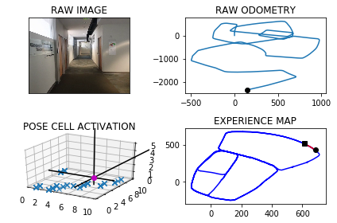

The counter is 6903

The angle is reset to 44.6231669385

Energy injection at [6, 5]

min_delta_val

1.0

e_pc 7 5

current pc 6 5

loop closure

The counter is 6904

The angle is reset to 44.736216856949994

Energy injection at [8, 6]

counter 6904

multiple peak # >2

[8L, 8L, 9L] [6L, 7L, 7L]

min_delta_val

0.0

e_pc 8 6

current pc 8 6

loop closure

The counter is 6905

The angle is reset to 44.81535179986499

Energy injection at [8, 6]

The counter is 6906

The angle is reset to 44.870746259905495

Energy injection at [8, 6]

The counter is 6907

The angle is reset to 44.90952238193384

Energy injection at [8, 6]

The counter is 6908

The angle is reset to 44.93666566735369

Energy injection at [8, 6]

min_delta_val

0.0

e_pc 8 6

current pc 8 6

The counter is 6909

The angle is reset to 44.43066596714758

Energy injection at [8, 6]

The counter is 6910

The angle is reset to 44.60146617700331

Energy injection at [8, 6]

The counter is 6911

The angle is reset to 44.72102632390231

Energy injection at [8, 6]

min_delta_val

0.0

e_pc 8 6

current pc 8 6

The counter is 6914

The angle is reset to 44.80471842673162

Energy injection at [8, 7]

min_delta_val

0.0

e_pc 8 7

current pc 8 7

loop closure

The counter is 6915

The angle is reset to 44.86330289871213

Energy injection at [8, 7]

The counter is 6916

The angle is reset to 44.90431202909849

Energy injection at [9, 7]

min_delta_val

1.0

e_pc 9 7

current pc 9 8

loop closure

The counter is 6917

The angle is reset to 44.40801842036895

Energy injection at [9, 7]

The counter is 6929

The angle is reset to 2.2106128942582575

Energy injection at [1, 0]

The counter is 6931

The angle is reset to 354.7224290259808

Energy injection at [1, 1]

min_delta_val

1.0

e_pc 1 2

current pc 1 1

loop closure

The counter is 6956

The angle is reset to 328.6307003181866

Energy injection at [8, 6]

The counter is 6957

The angle is reset to 324.54149022273054

Energy injection at [8, 6]

The counter is 6958

The angle is reset to 321.67904315591136

Energy injection at [8, 6]

The counter is 6980

The angle is reset to 319.67533020913794

Energy injection at [7, 7]

min_delta_val

0.0

e_pc 7 7

current pc 7 7

loop closure

The counter is 6981

The angle is reset to 318.27273114639655

Energy injection at [7, 7]

The counter is 6982

The angle is reset to 317.2909118024776

Energy injection at [7, 7]

The counter is 6983

The angle is reset to 316.60363826173426

Energy injection at [7, 8]

min_delta_val

0.0

e_pc 7 8

current pc 7 8

The counter is 6984

The angle is reset to 316.122546783214

Energy injection at [7, 8]

The counter is 6985

The angle is reset to 315.78578274824974

Energy injection at [7, 8]

The counter is 6995

The angle is reset to 315.55004792377486

Energy injection at [7, 7]

min_delta_val

0.0

e_pc 7 7

current pc 7 7

loop closure

The counter is 6996

The angle is reset to 315.3850335466423

Energy injection at [6, 9]

The counter is 6997

The angle is reset to 315.2695234826496

Energy injection at [6, 9]

The counter is 6998

The angle is reset to 315.18866643785475

Energy injection at [6, 9]

The counter is 6999

The angle is reset to 315.1320665064983

Energy injection at [6, 9]

The counter is 7000

The angle is reset to 315.0924465545488

Energy injection at [6, 9]

-----------------------------------------------------------

The current number of the iteration is 7000

22.8740000725 seconds are elapsed per 100 frames.

The number of units of the VT is 2788

The number of units of the experience map is 2911

02/20/19 09:21:30

-----------------------------------------------------------

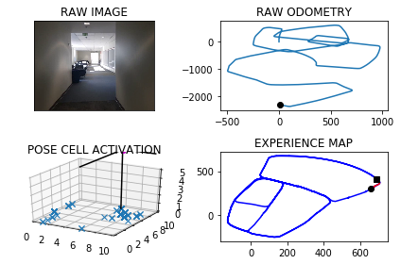

The counter is 7001

The angle is reset to 315.06471258818414

Energy injection at [6, 9]

The counter is 7002

The angle is reset to 315.04529881172886

Energy injection at [6, 9]

The counter is 7003

The angle is reset to 315.0317091682102

Energy injection at [6, 9]

The counter is 7004

The angle is reset to 315.0221964177471

Energy injection at [5, 9]

min_delta_val

1.0

e_pc 5 9

current pc 6 9

loop closure

The counter is 7005

The angle is reset to 315.015537492423

Energy injection at [5, 9]

The counter is 7033

The angle is reset to 315.5358762446961

Energy injection at [4, 1]

The counter is 7034

The angle is reset to 315.3751133712873

Energy injection at [4, 1]

The counter is 7061

The angle is reset to 317.8875793599011

Energy injection at [9, 5]

min_delta_val

0.0

e_pc 9 5

current pc 9 5

loop closure

The counter is 7062

The angle is reset to 317.02130555193077

Energy injection at [9, 5]

The counter is 7066

The angle is reset to 316.4149138863516

Energy injection at [9, 5]

min_delta_val

1.0

e_pc 8 5

current pc 8 6

loop closure

The counter is 7071

The angle is reset to 316.51543972044607

Energy injection at [7, 6]

min_delta_val

0.0

e_pc 7 6

current pc 7 6

loop closure

The counter is 7072

The angle is reset to 316.0608078043123

Energy injection at [7, 6]

The counter is 7073

The angle is reset to 315.7425654630186

Energy injection at [7, 6]

The counter is 7074

The angle is reset to 315.51979582411303

Energy injection at [7, 6]

The counter is 7075

The angle is reset to 315.36385707687907

Energy injection at [7, 6]

The counter is 7076

The angle is reset to 315.2546999538153

Energy injection at [6, 7]

min_delta_val

0.0

e_pc 6 7

current pc 6 7

loop closure

The counter is 7077

The angle is reset to 315.17828996767076

Energy injection at [6, 7]

The counter is 7078

The angle is reset to 315.6498029773695

Energy injection at [6, 7]

The counter is 7084

The angle is reset to 315.45486208415866

Energy injection at [5, 0]

The counter is 7085

The angle is reset to 315.318403458911

Energy injection at [5, 0]

The counter is 7086

The angle is reset to 315.2228824212377

Energy injection at [5, 0]

The counter is 7087

The angle is reset to 315.6810176948664

Energy injection at [4, 0]

min_delta_val

0.0

e_pc 4 0

current pc 4 0

loop closure

The counter is 7088

The angle is reset to 316.5267123864065

Energy injection at [4, 0]

The counter is 7096

The angle is reset to 316.06869867048454

Energy injection at [2, 1]

min_delta_val

1.0

e_pc 2 2

current pc 2 1

loop closure

The counter is 7097

The angle is reset to 315.74808906933913

Energy injection at [2, 1]

The counter is 7098

The angle is reset to 315.5236623485374

Energy injection at [2, 1]

The counter is 7099

The angle is reset to 315.3665636439762

Energy injection at [2, 2]

min_delta_val

1.0

e_pc 2 2

current pc 1 2

The counter is 7100

The angle is reset to 315.7815945507833

Energy injection at [2, 2]

-----------------------------------------------------------

The current number of the iteration is 7100

19.4789998531 seconds are elapsed per 100 frames.

The number of units of the VT is 2812

The number of units of the experience map is 2937

02/20/19 09:21:49

-----------------------------------------------------------

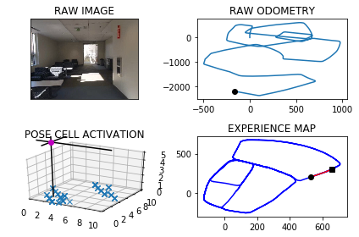

The counter is 7101

The angle is reset to 315.54711618554836

Energy injection at [2, 2]

The counter is 7107

The angle is reset to 315.3829813298838

Energy injection at [2, 2]

min_delta_val

0.0

e_pc 2 2

current pc 2 2

loop closure

The counter is 7108

The angle is reset to 315.2680869309186

Energy injection at [2, 2]

The counter is 7109

The angle is reset to 315.18766085164305

Energy injection at [2, 2]

The counter is 7110

The angle is reset to 315.13136259615004

Energy injection at [2, 2]

The counter is 7111

The angle is reset to 315.091953817305

Energy injection at [2, 2]

The counter is 7112

The angle is reset to 315.06436767211346

Energy injection at [2, 2]

The counter is 7113

The angle is reset to 315.0450573704794

Energy injection at [2, 2]

The counter is 7114

The angle is reset to 315.0315401593356

Energy injection at [2, 3]

min_delta_val

1.0

e_pc 1 3

current pc 2 3

The counter is 7127

The angle is reset to 315.0220781115349

Energy injection at [9, 6]

The counter is 7128

The angle is reset to 315.01545467807443

Energy injection at [9, 6]

The counter is 7141

The angle is reset to 311.8608182746521

Energy injection at [7, 7]

min_delta_val

0.0

e_pc 7 7

current pc 7 7

loop closure

The counter is 7146

The angle is reset to 301.2525727922564

Energy injection at [6, 8]

The counter is 7147

The angle is reset to 302.22680095457946

Energy injection at [6, 8]

min_delta_val

0.0

e_pc 6 8

current pc 6 8

loop closure

The counter is 7150

The angle is reset to 277.33376066820557

Energy injection at [5, 8]

The counter is 7151

The angle is reset to 270.93363246774396

Energy injection at [4, 8]

min_delta_val

1.0

e_pc 4 8

current pc 3 8

loop closure

The counter is 7152

The angle is reset to 266.4535427274207

Energy injection at [4, 8]

min_delta_val

1.0

e_pc 4 8

current pc 3 8

The counter is 7155

The angle is reset to 257.54247990919447

Energy injection at [3, 8]

min_delta_val

1.0

e_pc 3 8

current pc 2 8

loop closure

The counter is 7170

The angle is reset to 245.15473593643608

Energy injection at [8, 4]

The counter is 7172

The angle is reset to 239.1083151555052

Energy injection at [8, 4]

min_delta_val

1.0

e_pc 7 4

current pc 8 4

loop closure

The counter is 7174

The angle is reset to 235.92582060885366

Energy injection at [7, 4]

min_delta_val

0.0

e_pc 7 4

current pc 7 4

loop closure

The counter is 7175

The angle is reset to 233.17307442619753

Energy injection at [7, 4]

min_delta_val

1.0

e_pc 7 3

current pc 7 4

loop closure

The counter is 7176

The angle is reset to 231.24615209833823

Energy injection at [7, 3]

min_delta_val

1.4142135623730951

e_pc 7 3

current pc 6 2

The counter is 7177

The angle is reset to 229.8973064688368

Energy injection at [7, 3]

min_delta_val

1.0

e_pc 7 3

current pc 6 3

The counter is 7179

The angle is reset to 228.95311452818575

Energy injection at [7, 3]

min_delta_val

0.0

e_pc 7 3

current pc 7 3

loop closure

The counter is 7187

The angle is reset to 215.84218016972997

Energy injection at [6, 1]

The counter is 7190

The angle is reset to 205.61452611881097

Energy injection at [6, 1]

min_delta_val

0.0

e_pc 6 1

current pc 6 1

loop closure

The counter is 7197

The angle is reset to 199.5051682831677

Energy injection at [6, 9]

The counter is 7198

The angle is reset to 194.17861779821737

Energy injection at [6, 0]

min_delta_val

2.0

e_pc 6 0

current pc 6 8

new experience map with case 2

The counter is 7199

The angle is reset to 190.45003245875213

Energy injection at [6, 9]

hash collision

The counter is 7200

The angle is reset to 187.31502272112647

Energy injection at [6, 9]

min_delta_val

0.0

e_pc 6 9

current pc 6 9

loop closure

-----------------------------------------------------------

The current number of the iteration is 7200

38.3740000725 seconds are elapsed per 100 frames.

The number of units of the VT is 2847

The number of units of the experience map is 2980

02/20/19 09:22:28

-----------------------------------------------------------

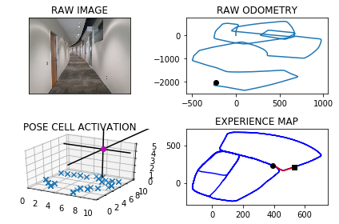

The counter is 7201

The angle is reset to 185.12051590478856

Energy injection at [6, 9]

The counter is 7203

The angle is reset to 183.58436113335193

Energy injection at [6, 0]

min_delta_val

0.0

e_pc 6 0

current pc 6 0

loop closure

The counter is 7204

The angle is reset to 182.50905279334637

Energy injection at [6, 0]

The counter is 7208

The angle is reset to 182.28133695534245

Energy injection at [6, 0]

hash collision

The counter is 7209

The angle is reset to 182.1219358687397

Energy injection at [6, 0]

hash collision

The counter is 7210

The angle is reset to 182.01035510811778

Energy injection at [6, 0]

min_delta_val

0.0

e_pc 6 4

current pc 6 0

loop closure

The counter is 7211

The angle is reset to 181.40724857568242

Energy injection at [6, 0]

The counter is 7212

The angle is reset to 180.98507400297768

Energy injection at [6, 0]

The counter is 7215

The angle is reset to 194.1895518020844

Energy injection at [6, 1]

min_delta_val

1.0

e_pc 6 1

current pc 6 0

loop closure

The counter is 7216

The angle is reset to 203.43268626145905

Energy injection at [6, 1]

The counter is 7222

The angle is reset to 197.97788038302133

Energy injection at [6, 6]

The counter is 7223

The angle is reset to 192.58451626811492

Energy injection at [6, 6]

The counter is 7224

The angle is reset to 188.80916138768043

Energy injection at [6, 6]

min_delta_val

0.0

e_pc 6 6

current pc 6 6

loop closure

The counter is 7225

The angle is reset to 186.1664129713763

Energy injection at [6, 6]

The counter is 7231

The angle is reset to 184.84148907996342

Energy injection at [6, 6]

min_delta_val

1.0

e_pc 6 5

current pc 6 6

loop closure

The counter is 7232

The angle is reset to 183.91404235597437

Energy injection at [6, 6]

The counter is 7233

The angle is reset to 183.26482964918205

Energy injection at [6, 5]

min_delta_val

0.0

e_pc 6 5

current pc 6 5

loop closure

The counter is 7234

The angle is reset to 182.28538075442742

Energy injection at [6, 5]

min_delta_val

0.0

e_pc 6 5

current pc 6 5

The counter is 7235

The angle is reset to 181.5997665280992

Energy injection at [6, 4]

min_delta_val

1.0

e_pc 6 4

current pc 6 5

loop closure

The counter is 7236

The angle is reset to 181.11983656966942

Energy injection at [6, 4]

The counter is 7237

The angle is reset to 180.7838855987686

Energy injection at [6, 4]

The counter is 7238

The angle is reset to 180.54871991913802

Energy injection at [6, 4]

The counter is 7239

The angle is reset to 180.3841039433966

Energy injection at [6, 4]

The counter is 7240

The angle is reset to 180.26887276037763

Energy injection at [6, 4]

min_delta_val

0.0

e_pc 6 4

current pc 6 4

The counter is 7241

The angle is reset to 180.18821093226433

Energy injection at [6, 4]

The counter is 7242

The angle is reset to 180.65674765258504

Energy injection at [6, 4]

min_delta_val

1.0

e_pc 6 4

current pc 6 3

loop closure

The counter is 7243

The angle is reset to 180.9847233568095

Energy injection at [6, 4]

hash collision

The counter is 7244

The angle is reset to 180.68930634976664

Energy injection at [6, 4]

hash collision

The counter is 7245

The angle is reset to 180.48251444483665

Energy injection at [6, 4]

min_delta_val

1.0

e_pc 6 3

current pc 6 4

The counter is 7248

The angle is reset to 180.33776011138568

Energy injection at [6, 3]

The counter is 7249

The angle is reset to 180.23643207796994

Energy injection at [6, 1]

min_delta_val

1.0

e_pc 6 1

current pc 6 2

loop closure

The counter is 7250

The angle is reset to 180.16550245457896

Energy injection at [6, 3]

min_delta_val

1.0

e_pc 6 3

current pc 6 2

loop closure

The counter is 7251

The angle is reset to 180.11585171820528

Energy injection at [6, 2]

min_delta_val

0.0

e_pc 6 2

current pc 6 2

The counter is 7252

The angle is reset to 180.08109620274368

Energy injection at [6, 2]

The counter is 7253

The angle is reset to 180.05676734192056

Energy injection at [6, 4]

min_delta_val

3.0

e_pc 6 4

current pc 6 1

new experience map with case 2

The counter is 7254

The angle is reset to 180.03973713934437

Energy injection at [6, 0]

min_delta_val

0.0

e_pc 6 0

current pc 6 0

loop closure

The counter is 7256

The angle is reset to 181.07781599754105

Energy injection at [6, 1]

min_delta_val

0.0

e_pc 6 1

current pc 6 1

loop closure

The counter is 7257

The angle is reset to 181.2794711982787

Energy injection at [6, 1]

The counter is 7258

The angle is reset to 180.8956298387951

Energy injection at [6, 1]

The counter is 7259

The angle is reset to 180.6269408871566

Energy injection at [6, 1]

The counter is 7260

The angle is reset to 180.4388586210096

Energy injection at [6, 0]

min_delta_val

0.0

e_pc 6 0

current pc 6 0

The counter is 7261

The angle is reset to 180.30720103470668

Energy injection at [6, 0]

min_delta_val

0.0

e_pc 6 0

current pc 6 0

loop closure

The counter is 7262

The angle is reset to 180.2150407242947

Energy injection at [6, 0]

The counter is 7263

The angle is reset to 180.15052850700624

Energy injection at [6, 0]

The counter is 7266

The angle is reset to 180.10536995490435

Energy injection at [6, 0]

min_delta_val

0.0

e_pc 6 0

current pc 6 0

loop closure

The counter is 7267

The angle is reset to 180.07375896843305

Energy injection at [6, 0]

The counter is 7268

The angle is reset to 180.05163127790314

Energy injection at [6, 0]

The counter is 7269

The angle is reset to 180.0361418945322

Energy injection at [6, 0]

min_delta_val

0.0

e_pc 6 0

current pc 6 0

The counter is 7270

The angle is reset to 180.02529932617253

Energy injection at [6, 0]

The counter is 7278

The angle is reset to 180.01770952832072

Energy injection at [6, 4]

The counter is 7279

The angle is reset to 180.53739666982452

Energy injection at [6, 4]

min_delta_val

0.0

e_pc 6 4

current pc 6 4

loop closure

The counter is 7280

The angle is reset to 180.37617766887715

Energy injection at [6, 4]

The counter is 7281

The angle is reset to 180.26332436821397

Energy injection at [6, 3]

min_delta_val

1.0

e_pc 6 3

current pc 6 4

loop closure

The counter is 7282

The angle is reset to 180.1843270577498

Energy injection at [6, 3]

The counter is 7285

The angle is reset to 180.12902894042486

Energy injection at [6, 2]

min_delta_val

0.0

e_pc 6 2

current pc 6 2

loop closure

The counter is 7286

The angle is reset to 180.0903202582974

Energy injection at [6, 2]

The counter is 7297

The angle is reset to 181.63822418080818

Energy injection at [6, 0]

min_delta_val

0.0

e_pc 6 0

current pc 6 0

loop closure

The counter is 7298

The angle is reset to 181.1467569265657

Energy injection at [6, 1]

min_delta_val

0.0

e_pc 6 1

current pc 6 1

loop closure

The counter is 7300

The angle is reset to 180.802729848596

Energy injection at [6, 0]

-----------------------------------------------------------

The current number of the iteration is 7300

69.4210000038 seconds are elapsed per 100 frames.

The number of units of the VT is 2867

The number of units of the experience map is 3005

02/20/19 09:23:37

-----------------------------------------------------------

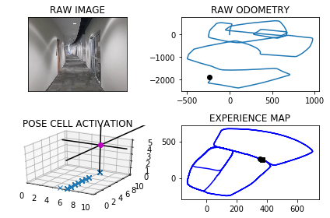

The counter is 7301

The angle is reset to 180.5619108940172

Energy injection at [6, 0]

The counter is 7302

The angle is reset to 180.91833762581203

Energy injection at [6, 9]

min_delta_val

0.0

e_pc 6 9

current pc 6 9

loop closure

The counter is 7303

The angle is reset to 181.1678363380684

Energy injection at [6, 9]

The counter is 7304

The angle is reset to 180.81748543664787

Energy injection at [6, 9]

The counter is 7305

The angle is reset to 180.5722398056535

Energy injection at [6, 9]

min_delta_val

1.0

e_pc 6 9

current pc 6 8

The counter is 7310

The angle is reset to 180.4005678639574

Energy injection at [6, 8]

min_delta_val

0.0

e_pc 6 8

current pc 6 8

loop closure

The counter is 7311

The angle is reset to 180.2803975047702

Energy injection at [6, 8]

The counter is 7313

The angle is reset to 181.24627825333914

Energy injection at [6, 7]

min_delta_val

0.0

e_pc 6 7

current pc 6 7

loop closure

The counter is 7314

The angle is reset to 180.87239477733738

Energy injection at [6, 7]

min_delta_val

1.0

e_pc 6 7

current pc 6 6

The counter is 7315

The angle is reset to 180.61067634413618

Energy injection at [6, 6]

min_delta_val

0.0

e_pc 6 6

current pc 6 6

The counter is 7316

The angle is reset to 180.42747344089528

Energy injection at [6, 6]

The counter is 7317

The angle is reset to 180.2992314086267

Energy injection at [6, 6]

min_delta_val

0.0

e_pc 6 6

current pc 6 6

The counter is 7318

The angle is reset to 180.2094619860387

Energy injection at [6, 6]

The counter is 7319

The angle is reset to 180.14662339022706

Energy injection at [6, 6]

min_delta_val

0.0

e_pc 6 5

current pc 6 5

The counter is 7320

The angle is reset to 180.10263637315896

Energy injection at [6, 5]

min_delta_val

0.0

e_pc 6 5

current pc 6 5

The counter is 7321

The angle is reset to 180.07184546121124

Energy injection at [6, 5]

The counter is 7322

The angle is reset to 180.05029182284787

Energy injection at [6, 5]

The counter is 7323

The angle is reset to 180.03520427599346

Energy injection at [6, 5]

min_delta_val

0.0

e_pc 6 5

current pc 6 5

The counter is 7324

The angle is reset to 180.02464299319544

Energy injection at [6, 5]

The counter is 7325

The angle is reset to 180.54225009523682

Energy injection at [6, 5]

min_delta_val

0.0

e_pc 6 4

current pc 6 4

The counter is 7335

The angle is reset to 181.42957506666576

Energy injection at [6, 3]

min_delta_val

1.0

e_pc 6 3

current pc 6 2

loop closure

The counter is 7336

The angle is reset to 181.00070254666602

Energy injection at [6, 3]

The counter is 7348

The angle is reset to 181.75049178266622

Energy injection at [6, 0]

min_delta_val

0.0

e_pc 6 0

current pc 6 0

loop closure

The counter is 7349

The angle is reset to 181.22534424786633

Energy injection at [6, 0]

The counter is 7350

The angle is reset to 180.85774097350645

Energy injection at [6, 0]

min_delta_val

0.0

e_pc 6 0

current pc 6 0

The counter is 7351

The angle is reset to 180.6004186814545

Energy injection at [6, 0]

The counter is 7352

The angle is reset to 180.42029307701813

Energy injection at [6, 9]

min_delta_val

1.0

e_pc 6 9

current pc 6 0

The counter is 7353

The angle is reset to 180.29420515391269

Energy injection at [6, 9]

The counter is 7361

The angle is reset to 180.73094360773888

Energy injection at [6, 8]

min_delta_val

0.0

e_pc 6 8

current pc 6 8

loop closure

The counter is 7370

The angle is reset to 181.03666052541723

Energy injection at [6, 8]

min_delta_val

1.0

e_pc 6 7

current pc 6 8

loop closure

The counter is 7371

The angle is reset to 180.72566236779204

Energy injection at [6, 7]

min_delta_val

0.0

e_pc 6 7

current pc 6 7

The counter is 7372

The angle is reset to 180.50796365745444

Energy injection at [6, 7]

The counter is 7373

The angle is reset to 180.3555745602181

Energy injection at [6, 7]

The counter is 7378

The angle is reset to 180.77390219215263

Energy injection at [6, 7]

min_delta_val

0.0

e_pc 6 7

current pc 6 7

loop closure

The counter is 7379

The angle is reset to 181.06673153450683

Energy injection at [6, 7]

The counter is 7380

The angle is reset to 181.27171207415478

Energy injection at [6, 7]

min_delta_val

0.0

e_pc 6 7

current pc 6 7

loop closure

The counter is 7381

The angle is reset to 180.89019845190836

Energy injection at [6, 7]

The counter is 7384

The angle is reset to 180.6231389163358

Energy injection at [6, 6]

min_delta_val

0.0

e_pc 6 6

current pc 6 6

loop closure

The counter is 7385

The angle is reset to 180.43619724143508

Energy injection at [6, 6]

The counter is 7386

The angle is reset to 179.78033806900453

Energy injection at [6, 6]

The counter is 7387

The angle is reset to 179.84623664830318

Energy injection at [6, 6]

min_delta_val

1.0

e_pc 6 6

current pc 6 5

-----------------------------------------------------------

The current number of the iteration is 7400

54.2599999905 seconds are elapsed per 100 frames.

The number of units of the VT is 2899

The number of units of the experience map is 3037

02/20/19 09:24:31

-----------------------------------------------------------

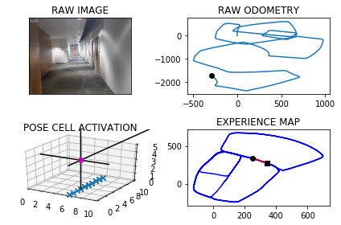

The counter is 7408

The angle is reset to 181.99236565381224

Energy injection at [6, 4]

min_delta_val

1.0

e_pc 6 4

current pc 6 3

loop closure

The counter is 7409

The angle is reset to 181.39465595766853

Energy injection at [6, 1]

The counter is 7410

The angle is reset to 180.97625917036797

Energy injection at [6, 1]

The counter is 7411

The angle is reset to 180.68338141925759

Energy injection at [6, 0]

min_delta_val

1.0

e_pc 6 0

current pc 6 1

loop closure

The counter is 7415

The angle is reset to 181.00336699348028

Energy injection at [6, 0]

min_delta_val

0.0

e_pc 6 0

current pc 6 0

loop closure

The counter is 7416

The angle is reset to 180.70235689543622

Energy injection at [6, 0]

min_delta_val

0.0

e_pc 6 0

current pc 6 0

The counter is 7417

The angle is reset to 180.49164982680537

Energy injection at [6, 0]

The counter is 7418

The angle is reset to 180.8691548787637

Energy injection at [6, 0]

min_delta_val

0.0

e_pc 6 0

current pc 6 0

The counter is 7419

The angle is reset to 180.60840841513462

Energy injection at [6, 0]

The counter is 7420

The angle is reset to 180.4258858905942

Energy injection at [6, 0]

The counter is 7421

The angle is reset to 180.29812012341594

Energy injection at [6, 0]

min_delta_val

0.0

e_pc 6 8

current pc 6 0

The counter is 7422

The angle is reset to 180.20868408639114

Energy injection at [6, 0]

The counter is 7423

The angle is reset to 180.14607886047378

Energy injection at [6, 8]

hash collision

The counter is 7424

The angle is reset to 180.62725520233164

Energy injection at [6, 8]

The counter is 7425

The angle is reset to 180.43907864163216

Energy injection at [6, 8]

The counter is 7426

The angle is reset to 180.3073550491425

Energy injection at [6, 8]

min_delta_val

0.0

e_pc 6 8

current pc 6 8

loop closure

The counter is 7427

The angle is reset to 180.21514853439973

Energy injection at [6, 8]

The counter is 7428

The angle is reset to 180.15060397407984

Energy injection at [6, 8]

The counter is 7431

The angle is reset to 180.10542278185585

Energy injection at [6, 0]

The counter is 7432

The angle is reset to 179.5487959472991

Energy injection at [6, 0]

min_delta_val

1.0

e_pc 6 0

current pc 6 9

loop closure

The counter is 7433

The angle is reset to 179.68415716310935

Energy injection at [6, 7]

The counter is 7434

The angle is reset to 179.77891001417655

Energy injection at [6, 7]

The counter is 7435

The angle is reset to 179.84523700992358

Energy injection at [6, 7]

The counter is 7436

The angle is reset to 179.89166590694649

Energy injection at [6, 7]

min_delta_val

0.0

e_pc 6 7

current pc 6 7

loop closure

The counter is 7440

The angle is reset to 180.44916613486257

Energy injection at [6, 0]

The counter is 7441

The angle is reset to 180.31441629440377

Energy injection at [6, 0]

The counter is 7442

The angle is reset to 180.22009140608262

Energy injection at [6, 0]

The counter is 7443

The angle is reset to 180.15406398425785

Energy injection at [6, 6]

The counter is 7444

The angle is reset to 180.1078447889805

Energy injection at [6, 6]

The counter is 7445

The angle is reset to 180.07549135228632

Energy injection at [6, 6]

The counter is 7446

The angle is reset to 180.0528439466004

Energy injection at [6, 6]

The counter is 7447

The angle is reset to 180.0369907626203

Energy injection at [6, 9]

min_delta_val

2.0

e_pc 6 8

current pc 6 6

new experience map with case 2

The counter is 7448

The angle is reset to 180.0258935338342

Energy injection at [6, 9]

The counter is 7449

The angle is reset to 180.01812547368394

Energy injection at [6, 9]

min_delta_val

1.0

e_pc 6 9

current pc 6 8

loop closure

The counter is 7450

The angle is reset to 180.01268783157872

Energy injection at [6, 9]

The counter is 7453

The angle is reset to 180.0088814821051

Energy injection at [6, 8]

min_delta_val

0.0

e_pc 6 8

current pc 6 8

loop closure

The counter is 7454

The angle is reset to 180.00621703747356

Energy injection at [6, 8]

The counter is 7455

The angle is reset to 180.00435192623146

Energy injection at [6, 8]

The counter is 7456

The angle is reset to 180.003046348362

Energy injection at [6, 8]

min_delta_val

0.0

e_pc 6 8

current pc 6 8

The counter is 7457

The angle is reset to 180.0021324438534

Energy injection at [6, 7]

min_delta_val

1.0

e_pc 6 8

current pc 6 7

The counter is 7458

The angle is reset to 180.0014927106974

Energy injection at [6, 7]

The counter is 7466

The angle is reset to 172.65104489748816

Energy injection at [6, 6]

min_delta_val

1.0

e_pc 6 6

current pc 6 5

loop closure

The counter is 7467

The angle is reset to 174.8557314282417

Energy injection at [6, 6]

The counter is 7471

The angle is reset to 177.4490119997692

Energy injection at [6, 4]

The counter is 7472

The angle is reset to 178.21430839983842

Energy injection at [6, 4]

The counter is 7473

The angle is reset to 178.7500158798869

Energy injection at [6, 3]

min_delta_val

0.0

e_pc 6 3

current pc 6 3

loop closure

The counter is 7474

The angle is reset to 179.12501111592078

Energy injection at [6, 3]

min_delta_val

1.0

e_pc 6 3

current pc 6 2

loop closure

The counter is 7475

The angle is reset to 179.38750778114456

Energy injection at [6, 3]

The counter is 7476

The angle is reset to 179.5712554468012

Energy injection at [6, 3]

The counter is 7477

The angle is reset to 179.69987881276083

Energy injection at [6, 3]

The counter is 7478

The angle is reset to 179.78991516893257

Energy injection at [6, 3]

The counter is 7479

The angle is reset to 179.8529406182528

Energy injection at [6, 3]

The counter is 7480

The angle is reset to 179.89705843277696

Energy injection at [6, 2]

hash collision

The counter is 7481

The angle is reset to 179.92794090294385

Energy injection at [6, 2]

hash collision

The counter is 7482

The angle is reset to 193.9745586320607

Energy injection at [4, 7]

The counter is 7483

The angle is reset to 190.30719104244247

Energy injection at [6, 2]

The counter is 7484

The angle is reset to 187.74003372970975

Energy injection at [6, 2]

hash collision

max_exp 4

The counter is 7485

The angle is reset to 212.41802361079678

Energy injection at [4, 7]

The counter is 7486

The angle is reset to 202.16761652755775

Energy injection at [6, 2]

The counter is 7487

The angle is reset to 195.5173315692904

Energy injection at [6, 2]

The counter is 7493

The angle is reset to 203.83713209850328

Energy injection at [4, 7]

The counter is 7494

The angle is reset to 210.71099246895227

Energy injection at [4, 7]

The counter is 7495

The angle is reset to 214.9976947282666

Energy injection at [3, 6]

counter 7495

multiple peak # >2

[3L, 3L, 4L, 4L] [6L, 7L, 6L, 7L]

min_delta_val

0.0

e_pc 3 6

current pc 3 6

loop closure

The counter is 7496

The angle is reset to 217.9983863097866

Energy injection at [3, 6]

The counter is 7497

The angle is reset to 233.59887041685062

Energy injection at [4, 7]

min_delta_val

1.0

e_pc 3 7

current pc 3 6

loop closure

The counter is 7498

The angle is reset to 244.5192092917954

Energy injection at [4, 7]

-----------------------------------------------------------

The current number of the iteration is 7500

53.2039999962 seconds are elapsed per 100 frames.

The number of units of the VT is 2915

The number of units of the experience map is 3067

02/20/19 09:25:25

-----------------------------------------------------------

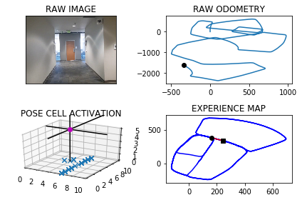

The counter is 7502

The angle is reset to 225.16344650425677

Energy injection at [3, 5]

hash collision

The counter is 7503

The angle is reset to 211.6144125529797

Energy injection at [3, 5]

hash collision

The counter is 7504

The angle is reset to 216.1550887870858

Energy injection at [3, 6]

min_delta_val

1.0

e_pc 3 6

current pc 3 5

loop closure

The counter is 7505

The angle is reset to 218.80856215096006

Energy injection at [3, 6]

The counter is 7506

The angle is reset to 221.19099350567205

Energy injection at [3, 6]

min_delta_val

1.0

e_pc 3 6

current pc 2 6

The counter is 7507

The angle is reset to 222.8586954539704

Energy injection at [3, 6]

min_delta_val

1.0

e_pc 3 6

current pc 2 6

The counter is 7508

The angle is reset to 223.50108681777928

Energy injection at [3, 6]

The counter is 7509

The angle is reset to 223.95076077244548

Energy injection at [3, 6]

The counter is 7510

The angle is reset to 224.26553254071186

Energy injection at [3, 6]

The counter is 7511

The angle is reset to 224.4858727784983

Energy injection at [3, 5]

min_delta_val

2.23606797749979

e_pc 2 4

current pc 3 6

new experience map with case 2

The counter is 7512

The angle is reset to 224.64011094494882

Energy injection at [2, 5]

hash collision

The counter is 7513

The angle is reset to 224.74807766146415

Energy injection at [2, 5]

hash collision

The counter is 7514

The angle is reset to 224.8236543630249

Energy injection at [2, 5]

The counter is 7518

The angle is reset to 225.4015580541174

Energy injection at [1, 4]

min_delta_val

0.0

e_pc 1 4

current pc 1 4

loop closure

The counter is 7519

The angle is reset to 225.2810906378822

Energy injection at [1, 4]

The counter is 7523

The angle is reset to 224.67176344651753

Energy injection at [1, 4]

min_delta_val

0.0

e_pc 1 3

current pc 1 3

loop closure

The counter is 7524

The angle is reset to 224.77023441256227

Energy injection at [1, 4]

The counter is 7525

The angle is reset to 224.83916408879358

Energy injection at [1, 2]

min_delta_val

1.4142135623730951

e_pc 1 2

current pc 0 3

loop closure

The counter is 7528

The angle is reset to 225.9374148621555

Energy injection at [1, 2]

hash collision

The counter is 7529

The angle is reset to 226.18119040350882

Energy injection at [1, 2]

hash collision

The counter is 7530

The angle is reset to 226.35183328245614

Energy injection at [0, 3]

min_delta_val

1.0

e_pc 0 3

current pc 0 2

loop closure

The counter is 7531

The angle is reset to 225.9462832977193

Energy injection at [0, 3]

The counter is 7532

The angle is reset to 226.18739830840352

Energy injection at [9, 2]

counter 7532

multiple peak # >2

[0L, 0L, 9L] [2L, 3L, 2L]

hash collision

The counter is 7534

The angle is reset to 225.83117881588245

Energy injection at [0, 1]

The counter is 7535

The angle is reset to 225.58182517111774

Energy injection at [0, 1]

The counter is 7540

The angle is reset to 225.4072776197824

Energy injection at [9, 0]

min_delta_val

0.0

e_pc 9 0

current pc 9 0

loop closure

The counter is 7541

The angle is reset to 225.28509433384767

Energy injection at [8, 0]

min_delta_val

1.0

e_pc 7 0

current pc 8 0

The counter is 7542

The angle is reset to 225.19956603369337

Energy injection at [8, 0]

The counter is 7543

The angle is reset to 225.13969622358536

Energy injection at [7, 0]

min_delta_val

1.0

e_pc 7 0

current pc 8 0

The counter is 7545

The angle is reset to 224.5727873565097

Energy injection at [8, 1]

The counter is 7546

The angle is reset to 224.7009511495568

Energy injection at [7, 0]

The counter is 7547

The angle is reset to 224.79066580468975

Energy injection at [7, 0]

min_delta_val

0.0

e_pc 7 0

current pc 7 0

loop closure

The counter is 7549

The angle is reset to 225.90346606328282

Energy injection at [7, 0]

hash collision

The counter is 7550

The angle is reset to 226.157426244298

Energy injection at [6, 9]

The counter is 7551

The angle is reset to 226.33519837100857

Energy injection at [6, 9]

The counter is 7552

The angle is reset to 226.459638859706

Energy injection at [6, 8]

hash collision

The counter is 7556

The angle is reset to 235.9967472017942

Energy injection at [4, 8]

min_delta_val

0.0

e_pc 4 8

current pc 4 8

loop closure

The counter is 7557

The angle is reset to 234.27272304125597

Energy injection at [4, 8]

min_delta_val

1.0

e_pc 3 8

current pc 4 8

loop closure

The counter is 7559

The angle is reset to 237.26590612887912

Energy injection at [3, 8]

min_delta_val

0.0

e_pc 3 8

current pc 3 8

loop closure

The counter is 7560

The angle is reset to 237.78613429021533

Energy injection at [3, 8]

min_delta_val

0.0

e_pc 3 8

current pc 3 8

over

The counter is 7562

The angle is reset to 256.9002940031507

Energy injection at [3, 8]

min_delta_val

1.0

e_pc 2 8

current pc 3 8

loop closure

The counter is 7568

The angle is reset to 297.95520580220546

Energy injection at [9, 8]

min_delta_val

0.0

e_pc 9 8

current pc 9 8

loop closure

The counter is 7575

The angle is reset to 307.79364406154383

Energy injection at [9, 8]

min_delta_val

0.0

e_pc 9 8

current pc 9 8

loop closure

The counter is 7578

The angle is reset to 311.0055508430807

Energy injection at [8, 8]

min_delta_val

0.0

e_pc 8 8

current pc 8 8

loop closure

The counter is 7579

The angle is reset to 312.72888559015644

Energy injection at [8, 8]

min_delta_val

0.0

e_pc 8 8

current pc 8 8

loop closure

The counter is 7580

The angle is reset to 313.93521991310945

Energy injection at [8, 8]

The counter is 7581

The angle is reset to 314.7796539391766

Energy injection at [8, 8]

min_delta_val

0.0

e_pc 8 8

current pc 8 8

The counter is 7582

The angle is reset to 314.8457577574236

Energy injection at [8, 8]

The counter is 7583

The angle is reset to 314.36703043019645

Energy injection at [8, 8]

min_delta_val

0.0

e_pc 8 8

current pc 8 8

The counter is 7586

The angle is reset to 314.55692130113755

Energy injection at [8, 8]

min_delta_val

0.0

e_pc 8 8

current pc 8 8

loop closure

The counter is 7587

The angle is reset to 314.6898449107963

Energy injection at [8, 8]

The counter is 7588

The angle is reset to 314.7828914375574

Energy injection at [8, 7]

hash collision

The counter is 7589

The angle is reset to 314.84802400629013

Energy injection at [8, 8]

min_delta_val

0.0

e_pc 8 8

current pc 8 8

The counter is 7590

The angle is reset to 314.8936168044031

Energy injection at [8, 8]

The counter is 7591

The angle is reset to 315.45053176308215

Energy injection at [8, 8]

The counter is 7592

The angle is reset to 315.8403722341575

Energy injection at [8, 8]

min_delta_val

0.0

e_pc 8 8

current pc 8 8

The counter is 7596

The angle is reset to 313.4882605639102

Energy injection at [7, 7]

min_delta_val

0.0

e_pc 7 7

current pc 7 7

loop closure

The counter is 7597

The angle is reset to 313.41678239473714

Energy injection at [7, 7]

The counter is 7598

The angle is reset to 313.89174767631596

Energy injection at [6, 6]

min_delta_val

1.4142135623730951

e_pc 6 6

current pc 7 7

The counter is 7599

The angle is reset to 314.2242233734212

Energy injection at [6, 6]

-----------------------------------------------------------

The current number of the iteration is 7600

85.9769999981 seconds are elapsed per 100 frames.

The number of units of the VT is 2946

The number of units of the experience map is 3104

02/20/19 09:26:51

-----------------------------------------------------------

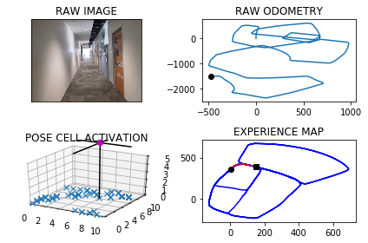

The counter is 7602

The angle is reset to 314.4569563613949

Energy injection at [5, 7]

min_delta_val

0.0

e_pc 5 7

current pc 5 7

loop closure

The counter is 7603

The angle is reset to 315.14486945297637

Energy injection at [5, 7]

The counter is 7604

The angle is reset to 315.10140861708345

Energy injection at [5, 7]

min_delta_val

0.0

e_pc 5 7

current pc 5 7

The counter is 7605

The angle is reset to 315.0709860319584

Energy injection at [5, 7]

The counter is 7606

The angle is reset to 328.5496902223709

Energy injection at [9, 7]

min_delta_val

7.874007874011811

e_pc 9 7

current pc 4 8

new experience map with case 2

The counter is 7607

The angle is reset to 324.48478315565956

Energy injection at [5, 8]

min_delta_val

1.0

e_pc 5 8

current pc 4 8

loop closure

The counter is 7608

The angle is reset to 321.1143482089617

Energy injection at [5, 9]

min_delta_val

1.0

e_pc 5 9

current pc 5 8

loop closure

The counter is 7609

The angle is reset to 318.75504374627315

Energy injection at [5, 9]

The counter is 7610

The angle is reset to 317.62853062239117

Energy injection at [5, 9]

min_delta_val

0.0

e_pc 5 9

current pc 5 9

The counter is 7611

The angle is reset to 316.8399714356738

Energy injection at [5, 9]

The counter is 7612

The angle is reset to 316.28798000497164

Energy injection at [5, 9]

The counter is 7613

The angle is reset to 315.90158600348013

Energy injection at [5, 9]

The counter is 7614

The angle is reset to 316.1561102024361

Energy injection at [4, 0]

hash collision

The counter is 7615

The angle is reset to 316.33427714170523

Energy injection at [4, 0]

hash collision

The counter is 7616

The angle is reset to 315.9339939991936

Energy injection at [4, 0]

min_delta_val

1.4142135623730951

e_pc 3 1

current pc 4 0

loop closure

The counter is 7617

The angle is reset to 315.65379579943556

Energy injection at [4, 0]

The counter is 7618

The angle is reset to 315.45765705960486

Energy injection at [4, 0]

The counter is 7619

The angle is reset to 315.32035994172344

Energy injection at [4, 0]

min_delta_val

0.0

e_pc 4 0

current pc 4 0

The counter is 7620

The angle is reset to 314.6992519592064

Energy injection at [4, 0]

min_delta_val

0.0

e_pc 4 0

current pc 4 0

The counter is 7621

The angle is reset to 314.78947637144444

Energy injection at [4, 0]

min_delta_val

1.4142135623730951

e_pc 4 0

current pc 3 1

The counter is 7622

The angle is reset to 314.85263346001113

Energy injection at [4, 0]

The counter is 7625

The angle is reset to 314.89684342200775

Energy injection at [3, 1]

The counter is 7626

The angle is reset to 314.9277903954054

Energy injection at [3, 1]

min_delta_val

0.0

e_pc 3 1

current pc 3 1

loop closure

The counter is 7627

The angle is reset to 314.9494532767838

Energy injection at [3, 1]

hash collision

The counter is 7628

The angle is reset to 314.43961729374865

Energy injection at [3, 1]

min_delta_val

0.0

e_pc 3 1

current pc 3 1

The counter is 7629

The angle is reset to 314.0827321056241

Energy injection at [3, 2]

min_delta_val

1.0

e_pc 3 2

current pc 3 1

The counter is 7630

The angle is reset to 314.35791247393684

Energy injection at [3, 2]

The counter is 7637

The angle is reset to 316.65053873175583

Energy injection at [2, 2]

min_delta_val

0.0

e_pc 2 2

current pc 2 2

loop closure

The counter is 7638

The angle is reset to 316.68037711222905

Energy injection at [1, 1]

counter 7638

multiple peak # >2

[1L, 1L, 2L] [1L, 2L, 2L]

min_delta_val

0.0

e_pc 1 1

current pc 1 1

loop closure

The counter is 7639

The angle is reset to 316.7012639785603

Energy injection at [1, 1]

The counter is 7642

The angle is reset to 316.1908847849922

Energy injection at [2, 2]

min_delta_val

1.0

e_pc 1 3

current pc 1 2

loop closure

The counter is 7643

The angle is reset to 329.33361934949454

Energy injection at [9, 6]

The counter is 7644

The angle is reset to 325.0335335446461

Energy injection at [9, 6]

min_delta_val

0.0

e_pc 8 7

current pc 8 7

loop closure

The counter is 7645

The angle is reset to 322.02347348125227

Energy injection at [9, 6]

The counter is 7646

The angle is reset to 319.91643143687656

Energy injection at [8, 7]

hash collision

The counter is 7647

The angle is reset to 318.44150200581356

Energy injection at [8, 7]

min_delta_val

0.0

e_pc 8 7

current pc 8 7

loop closure

The counter is 7648

The angle is reset to 317.93405140406946

Energy injection at [8, 7]

min_delta_val

0.0

e_pc 8 7

current pc 8 7

The counter is 7649

The angle is reset to 317.0538359828486

Energy injection at [8, 7]

The counter is 7651

The angle is reset to 329.937685187994

Energy injection at [9, 7]

min_delta_val

6.082762530298219

e_pc 9 7

current pc 8 7

new experience map with case 2

The counter is 7652

The angle is reset to 338.95637963159584

Energy injection at [9, 7]

The counter is 7653

The angle is reset to 344.74446574211703

Energy injection at [9, 7]

min_delta_val

0.0

e_pc 9 7

current pc 9 7

loop closure

The counter is 7657

The angle is reset to 348.2711260194819

Energy injection at [9, 8]

min_delta_val

0.0

e_pc 9 8

current pc 9 8

loop closure

The counter is 7658

The angle is reset to 351.78978821363734

Energy injection at [9, 8]

The counter is 7662

The angle is reset to 354.2528517495461

Energy injection at [9, 0]

min_delta_val

0.0

e_pc 9 0

current pc 9 0

loop closure

The counter is 7672

The angle is reset to 354.9269962246823

Energy injection at [9, 1]

min_delta_val

1.0

e_pc 9 2

current pc 9 1

loop closure

The counter is 7673

The angle is reset to 356.97389735727756

Energy injection at [9, 1]

The counter is 7696

The angle is reset to 359.9817281500943

Energy injection at [9, 5]

min_delta_val

1.0

e_pc 9 6

current pc 9 5

loop closure

The counter is 7697

The angle is reset to 359.987209705066

Energy injection at [9, 5]

The counter is 7698

The angle is reset to 359.99104679354616

Energy injection at [9, 6]

min_delta_val

1.0

e_pc 9 6

current pc 9 5

The counter is 7699

The angle is reset to 359.4687327554823

Energy injection at [9, 6]

min_delta_val

1.0

e_pc 9 6

current pc 9 7

loop closure

-----------------------------------------------------------

The current number of the iteration is 7700

74.2170000076 seconds are elapsed per 100 frames.

The number of units of the VT is 2972

The number of units of the experience map is 3135

02/20/19 09:28:05

-----------------------------------------------------------

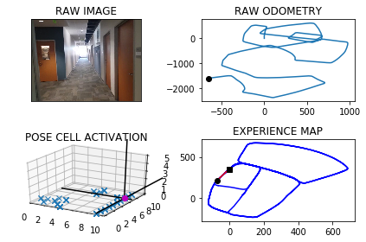

The counter is 7703

The angle is reset to 359.1031129288376

Energy injection at [9, 7]

min_delta_val

0.0

e_pc 9 7

current pc 9 7

loop closure

The counter is 7718

The angle is reset to 3.047179050186316

Energy injection at [9, 0]

hash collision

The counter is 7719

The angle is reset to 2.133025335130421

Energy injection at [9, 0]

hash collision

The counter is 7732

The angle is reset to 0.9681177345912827

Energy injection at [9, 2]

min_delta_val

1.0

e_pc 9 1

current pc 9 2

loop closure

The counter is 7735

The angle is reset to 0.677682414213898

Energy injection at [9, 3]

The counter is 7737

The angle is reset to 0.47437768994972856

Energy injection at [9, 3]

min_delta_val

0.0

e_pc 9 3

current pc 9 3

loop closure

The counter is 7738

The angle is reset to 0.33206438296480995

Energy injection at [9, 4]

min_delta_val

0.0

e_pc 9 4

current pc 9 4

The counter is 7739

The angle is reset to 0.7574450680753668

Energy injection at [9, 4]

hash collision

The counter is 7740

The angle is reset to 1.0552115476527568

Energy injection at [9, 5]

min_delta_val

1.0

e_pc 9 4

current pc 9 5

loop closure

The counter is 7741

The angle is reset to 1.2636480833569295

Energy injection at [9, 3]

min_delta_val

0.0

e_pc 9 3

current pc 9 3

The counter is 7742

The angle is reset to 1.4095536583498507

Energy injection at [9, 5]

The counter is 7743

The angle is reset to 1.5116875608448954

Energy injection at [9, 5]

hash collision

The counter is 7744

The angle is reset to 1.0581812925914267

Energy injection at [9, 5]

hash collision

The counter is 7745

The angle is reset to 0.2157269048139987

Energy injection at [9, 5]

hash collision

The counter is 7746

The angle is reset to 359.6260088333698

Energy injection at [9, 5]

hash collision

The counter is 7747

The angle is reset to 359.73820618335884

Energy injection at [9, 5]

min_delta_val

1.0

e_pc 9 6

current pc 9 5

loop closure

The counter is 7748

The angle is reset to 359.8167443283512

Energy injection at [9, 6]

min_delta_val

1.0

e_pc 9 6

current pc 9 5

The counter is 7749

The angle is reset to 0.39672102984581814

Energy injection at [9, 6]

The counter is 7750

The angle is reset to 0.8027047208920726

Energy injection at [9, 7]

min_delta_val

0.0

e_pc 9 7

current pc 9 7

loop closure

The counter is 7751

The angle is reset to 1.0868933046244507

Energy injection at [9, 7]

The counter is 7752

The angle is reset to 1.2858253132371154

Energy injection at [9, 8]

min_delta_val

1.0

e_pc 9 8

current pc 9 7

The counter is 7756

The angle is reset to 0.3750777192659808

Energy injection at [9, 7]

The counter is 7757

The angle is reset to 359.7375544034861

Energy injection at [9, 7]

The counter is 7758

The angle is reset to 359.8162880824403

Energy injection at [9, 7]

The counter is 7759

The angle is reset to 359.87140165770813

Energy injection at [9, 9]

The counter is 7760

The angle is reset to 359.90998116039566

Energy injection at [9, 9]

The counter is 7768

The angle is reset to 359.41198681227695

Energy injection at [9, 0]

min_delta_val

0.0

e_pc 9 0

current pc 9 0

loop closure

The counter is 7769

The angle is reset to 359.58839076859385

Energy injection at [9, 0]

The counter is 7770

The angle is reset to 359.71187353801565

Energy injection at [9, 0]

The counter is 7771

The angle is reset to 359.798311476611

Energy injection at [9, 1]

min_delta_val

1.0

e_pc 9 1

current pc 9 0

The counter is 7772

The angle is reset to 359.8588180336277

Energy injection at [9, 1]

The counter is 7773

The angle is reset to 359.90117262353937

Energy injection at [9, 1]

The counter is 7774

The angle is reset to 359.9308208364775

Energy injection at [9, 1]

The counter is 7775

The angle is reset to 0.4765745855342705

Energy injection at [9, 0]

min_delta_val

1.0

e_pc 9 0

current pc 9 1

The counter is 7776

The angle is reset to 0.3336022098739893

Energy injection at [9, 0]

The counter is 7777

The angle is reset to 0.23352154691179253

Energy injection at [9, 0]

min_delta_val

0.0

e_pc 9 0

current pc 9 0

The counter is 7778

The angle is reset to 0.16346508283825475

Energy injection at [9, 0]

The counter is 7779

The angle is reset to 0.11442555798677831

Energy injection at [9, 2]

min_delta_val

1.0

e_pc 9 2

current pc 9 1

loop closure

The counter is 7780

The angle is reset to 0.0800978905907448

Energy injection at [9, 2]

hash collision

The counter is 7781

The angle is reset to 0.056068523413521365

Energy injection at [9, 2]

hash collision

The counter is 7782

The angle is reset to 0.03924796638946495

Energy injection at [9, 2]

min_delta_val

0.0

e_pc 9 2

current pc 9 2

loop closure

The counter is 7783

The angle is reset to 0.02747357647262546

Energy injection at [9, 2]

The counter is 7784

The angle is reset to 0.019231503530837822

Energy injection at [9, 3]

hash collision

The counter is 7785

The angle is reset to 0.5384620524715865

Energy injection at [9, 4]

The counter is 7786

The angle is reset to 0.37692343673011053

Energy injection at [9, 3]

min_delta_val

0.0

e_pc 9 3

current pc 9 3

loop closure

The counter is 7787

The angle is reset to 0.7888464057110772

Energy injection at [9, 3]

min_delta_val

1.0

e_pc 9 4

current pc 9 3

The counter is 7788

The angle is reset to 0.5521924839977541

Energy injection at [9, 4]

min_delta_val

0.0

e_pc 9 4

current pc 9 4

The counter is 7789

The angle is reset to 0.38653473879842787

Energy injection at [9, 4]

The counter is 7790

The angle is reset to 0.27057431715889946

Energy injection at [9, 5]

min_delta_val

0.0

e_pc 9 5

current pc 9 5

The counter is 7791

The angle is reset to 0.18940202201122963

Energy injection at [9, 9]

The counter is 7794

The angle is reset to 0.13258141540786073

Energy injection at [9, 5]

The counter is 7795

The angle is reset to 0.0928069907855025

Energy injection at [9, 5]

The counter is 7796

The angle is reset to 0.06496489354985174

Energy injection at [9, 5]

min_delta_val

1.0

e_pc 9 6

current pc 9 5

loop closure

The counter is 7797

The angle is reset to 0.04547542548489622

Energy injection at [9, 5]

The counter is 7798

The angle is reset to 0.5568327978394273

Energy injection at [9, 5]

The counter is 7799

The angle is reset to 0.38978295848759914

Energy injection at [9, 6]

min_delta_val

0.0

e_pc 9 6

current pc 9 6

The counter is 7800

The angle is reset to 0.27284807094131935

Energy injection at [9, 6]

-----------------------------------------------------------

The current number of the iteration is 7800

83.0120000839 seconds are elapsed per 100 frames.

The number of units of the VT is 2995

The number of units of the experience map is 3165

02/20/19 09:29:28

-----------------------------------------------------------

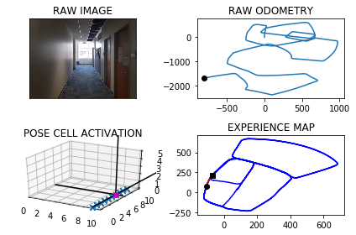

The counter is 7801

The angle is reset to 0.19099364965892354

Energy injection at [9, 6]

The counter is 7809

The angle is reset to 1.1836955547612649

Energy injection at [9, 7]

min_delta_val

0.0

e_pc 9 7

current pc 9 7

loop closure

The counter is 7814

The angle is reset to 0.8285868883328854

Energy injection at [9, 9]

min_delta_val

1.0

e_pc 9 0

current pc 9 9

loop closure

The counter is 7815

The angle is reset to 0.055010821833019814

Energy injection at [9, 9]

min_delta_val

2.0

e_pc 9 8

current pc 9 0

new experience map with case 2

The counter is 7816

The angle is reset to 0.038507575283113875

Energy injection at [9, 0]

hash collision

The counter is 7817

The angle is reset to 0.02695530269817971

Energy injection at [9, 0]

hash collision

The counter is 7818

The angle is reset to 0.018868711888725794

Energy injection at [9, 0]

min_delta_val

0.0

e_pc 9 0

current pc 9 0

loop closure

The counter is 7819

The angle is reset to 0.5382080983221079

Energy injection at [9, 0]

The counter is 7820

The angle is reset to 0.37674566882547555

Energy injection at [9, 0]

The counter is 7825

The angle is reset to 359.7387219681778

Energy injection at [9, 0]

min_delta_val

0.0

e_pc 9 1

current pc 9 1

loop closure

The counter is 7826

The angle is reset to 359.81710537772443

Energy injection at [9, 1]

min_delta_val

0.0

e_pc 9 1

current pc 9 1

The counter is 7828

The angle is reset to 359.8719737644071

Energy injection at [9, 2]

min_delta_val

1.0

e_pc 9 2

current pc 9 1

loop closure

The counter is 7829

The angle is reset to 359.91038163508495

Energy injection at [9, 2]

min_delta_val

1.0

e_pc 9 3

current pc 9 2

The counter is 7830

The angle is reset to 359.9372671445594

Energy injection at [9, 2]

The counter is 7835

The angle is reset to 359.9560870011916

Energy injection at [9, 4]

min_delta_val

0.0

e_pc 9 4

current pc 9 4

loop closure

The counter is 7836

The angle is reset to 359.4442609008341

Energy injection at [9, 3]

min_delta_val

1.0

e_pc 9 4

current pc 9 3

loop closure

The counter is 7837

The angle is reset to 359.0859826305839

Energy injection at [9, 4]

min_delta_val

0.0

e_pc 9 4

current pc 9 4

The counter is 7840

The angle is reset to 359.3601878414087

Energy injection at [9, 4]

min_delta_val

0.0

e_pc 9 4

current pc 9 4

loop closure

The counter is 7841

The angle is reset to 359.55213148898605

Energy injection at [9, 4]

The counter is 7842

The angle is reset to 0.21149204229023108

Energy injection at [9, 4]

The counter is 7845

The angle is reset to 0.6730444296031617

Energy injection at [9, 5]

min_delta_val

1.0

e_pc 9 6

current pc 9 5

loop closure

The counter is 7846

The angle is reset to 0.4711311007222132

Energy injection at [9, 5]

The counter is 7847

The angle is reset to 0.3297917705055492

Energy injection at [9, 6]

min_delta_val

0.0

e_pc 9 6

current pc 9 6

loop closure

The counter is 7849

The angle is reset to 359.7058542393538

Energy injection at [9, 5]

min_delta_val

0.0

e_pc 9 5

current pc 9 5

loop closure

The counter is 7851

The angle is reset to 359.7940979675477

Energy injection at [9, 6]

min_delta_val

1.0

e_pc 9 7

current pc 9 6

loop closure

The counter is 7852

The angle is reset to 0.38086857728338563

Energy injection at [9, 6]

The counter is 7858

The angle is reset to 1.8416080040983698

Energy injection at [9, 7]

min_delta_val

1.0

e_pc 9 8

current pc 9 7

loop closure

The counter is 7859

The angle is reset to 1.289125602868859

Energy injection at [9, 8]

min_delta_val

0.0

e_pc 9 8

current pc 9 8

The counter is 7868

The angle is reset to 0.9023879220082013

Energy injection at [9, 9]

min_delta_val

1.0

e_pc 9 9

current pc 9 0

loop closure

The counter is 7869

The angle is reset to 0.6316715454057409

Energy injection at [9, 0]

min_delta_val

0.0

e_pc 9 0

current pc 9 0

loop closure

The counter is 7870

The angle is reset to 0.44217008178401856

Energy injection at [9, 0]

min_delta_val

0.0

e_pc 9 0

current pc 9 0

The counter is 7871

The angle is reset to 359.7845190572488

Energy injection at [9, 1]

min_delta_val

1.0

e_pc 9 1

current pc 9 0

loop closure

The counter is 7872

The angle is reset to 359.32416334007416

Energy injection at [9, 0]

min_delta_val

0.0

e_pc 9 0

current pc 9 0

loop closure

The counter is 7873

The angle is reset to 359.5269143380519

Energy injection at [9, 0]

min_delta_val

0.0

e_pc 9 0

current pc 9 0

loop closure

The counter is 7878

The angle is reset to 359.6688400366363

Energy injection at [9, 2]

min_delta_val

0.0

e_pc 9 2

current pc 9 2

loop closure

The counter is 7879

The angle is reset to 0.2931880256454052

Energy injection at [9, 2]

The counter is 7880

The angle is reset to 0.7302316179517836

Energy injection at [9, 2]

The counter is 7881

The angle is reset to 0.5111621325662484

Energy injection at [9, 2]

The counter is 7882

The angle is reset to 0.8828134927963738

Energy injection at [9, 3]

min_delta_val

0.0

e_pc 9 3

current pc 9 3

loop closure

The counter is 7883

The angle is reset to 0.6179694449574616

Energy injection at [9, 3]

The counter is 7884

The angle is reset to 0.9575786114702229

Energy injection at [9, 3]

min_delta_val

1.0

e_pc 9 4

current pc 9 3

The counter is 7885

The angle is reset to 1.720305028029156

Energy injection at [9, 4]

min_delta_val

0.0

e_pc 9 4

current pc 9 4

The counter is 7886

The angle is reset to 2.7792135196204084

Energy injection at [9, 4]

min_delta_val

0.0

e_pc 9 4

current pc 9 4

The counter is 7887

The angle is reset to 4.045449463734286

Energy injection at [9, 4]

min_delta_val

0.0

e_pc 9 4

current pc 9 4

The counter is 7888

The angle is reset to 5.456814624613999

Energy injection at [9, 4]

min_delta_val

1.0

e_pc 9 4

current pc 9 5

The counter is 7893

The angle is reset to 35.1697702372298

Energy injection at [9, 6]

The counter is 7894

The angle is reset to 38.11883916606086

Energy injection at [9, 5]

min_delta_val

0.0

e_pc 9 6

current pc 9 6

loop closure

The counter is 7895

The angle is reset to 40.183187416242596

Energy injection at [9, 5]

min_delta_val

0.0

e_pc 9 5

current pc 9 5

The counter is 7896

The angle is reset to 38.478231191369815

Energy injection at [9, 5]

min_delta_val

1.0

e_pc 9 5

current pc 9 6

The counter is 7897

The angle is reset to 34.65976183395887

Energy injection at [9, 5]

-----------------------------------------------------------

The current number of the iteration is 7900

89.385999918 seconds are elapsed per 100 frames.

The number of units of the VT is 3030

The number of units of the experience map is 3202

02/20/19 09:30:57

-----------------------------------------------------------

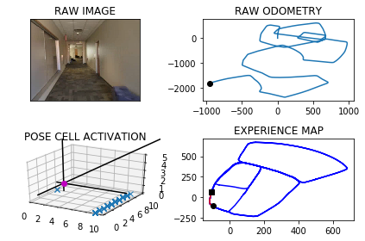

The counter is 7902

The angle is reset to 46.1618332837712

Energy injection at [1, 6]

min_delta_val

0.0

e_pc 1 6

current pc 1 6

loop closure

The counter is 7903

The angle is reset to 46.86328329863984

Energy injection at [1, 6]

min_delta_val

0.0

e_pc 1 6

current pc 1 6

loop closure

The counter is 7926

The angle is reset to 44.2042983090479

Energy injection at [3, 9]

min_delta_val

0.0

e_pc 3 9

current pc 3 9

loop closure

The counter is 7927

The angle is reset to 44.443008816333524

Energy injection at [3, 9]

min_delta_val

0.0

e_pc 3 9

current pc 3 9

The counter is 7928

The angle is reset to 44.61010617143347

Energy injection at [3, 9]

min_delta_val

0.0

e_pc 3 9

current pc 3 9

The counter is 7929

The angle is reset to 44.727074320003425

Energy injection at [3, 9]

min_delta_val

0.0

e_pc 3 9

current pc 3 9

The counter is 7930

The angle is reset to 44.808952024002394

Energy injection at [3, 9]

The counter is 7933

The angle is reset to 44.86626641680168

Energy injection at [4, 0]

min_delta_val

0.0

e_pc 4 0

current pc 4 0

loop closure

The counter is 7934

The angle is reset to 44.906386491761175

Energy injection at [4, 0]

The counter is 7935

The angle is reset to 44.934470544232816

Energy injection at [4, 0]

The counter is 7936

The angle is reset to 44.95412938096297

Energy injection at [4, 0]

The counter is 7937

The angle is reset to 44.96789056667407

Energy injection at [4, 0]

The counter is 7938

The angle is reset to 44.97752339667185

Energy injection at [4, 0]

The counter is 7945

The angle is reset to 44.98426637767029

Energy injection at [6, 1]

min_delta_val

1.0

e_pc 6 1

current pc 5 1

loop closure

The counter is 7946

The angle is reset to 44.463986464369206

Energy injection at [6, 1]

The counter is 7947

The angle is reset to 44.624790525058444

Energy injection at [6, 2]

min_delta_val

0.0

e_pc 6 2

current pc 6 2

The counter is 7948

The angle is reset to 44.737353367540905

Energy injection at [6, 2]

The counter is 7960

The angle is reset to 45.34114735727863

Energy injection at [8, 4]

The counter is 7961

The angle is reset to 45.238803150095045

Energy injection at [8, 4]

The counter is 7962

The angle is reset to 45.167162205066525

Energy injection at [8, 4]

min_delta_val

0.0

e_pc 8 4

current pc 8 4

loop closure

The counter is 7963

The angle is reset to 45.11701354354657

Energy injection at [8, 4]

The counter is 7964

The angle is reset to 45.0819094804826

Energy injection at [8, 4]

The counter is 7965

The angle is reset to 45.05733663633781

Energy injection at [9, 4]

min_delta_val

1.0

e_pc 9 4

current pc 9 5

The counter is 7973

The angle is reset to 45.56513564543646

Energy injection at [0, 6]

The counter is 7974

The angle is reset to 46.445594951805525

Energy injection at [0, 6]

The counter is 7982

The angle is reset to 78.41191646626386

Energy injection at [1, 7]

min_delta_val

0.0

e_pc 1 7

current pc 1 7

loop closure

The counter is 7984

The angle is reset to 91.8633415263847

Energy injection at [2, 7]

min_delta_val

0.0

e_pc 2 7

current pc 2 7

loop closure

The counter is 7985

The angle is reset to 96.0293390684693

Energy injection at [2, 7]

min_delta_val

0.0

e_pc 2 7

current pc 2 7

The counter is 7986

The angle is reset to 98.9455373479285

Energy injection at [2, 7]

min_delta_val

0.0

e_pc 2 7

current pc 2 7

The counter is 7999

The angle is reset to 126.56187614354994

Energy injection at [4, 7]

min_delta_val

0.0

e_pc 4 7

current pc 4 7

loop closure

The counter is 8000

The angle is reset to 129.09331330048494

Energy injection at [4, 7]

min_delta_val

0.0

e_pc 4 7

current pc 4 7

-----------------------------------------------------------

The current number of the iteration is 8000

43.9620001316 seconds are elapsed per 100 frames.

The number of units of the VT is 3069

The number of units of the experience map is 3244

02/20/19 09:31:41

-----------------------------------------------------------

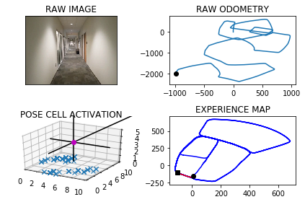

The counter is 8001

The angle is reset to 131.39031931033946

Energy injection at [4, 7]

The counter is 8006

The angle is reset to 131.9482235172376

Energy injection at [4, 6]

min_delta_val

1.0

e_pc 5 5

current pc 5 6

loop closure

The counter is 8007

The angle is reset to 132.8637564620663

Energy injection at [5, 5]

min_delta_val

0.0

e_pc 5 5

current pc 5 5

The counter is 8008

The angle is reset to 133.50462952344643

Energy injection at [5, 5]

The counter is 8009

The angle is reset to 133.95324066641248

Energy injection at [5, 5]

The counter is 8010

The angle is reset to 134.26726846648873

Energy injection at [5, 5]

The counter is 8013

The angle is reset to 134.4870879265421

Energy injection at [7, 4]

min_delta_val

1.0

e_pc 7 4

current pc 6 4

loop closure

The counter is 8014

The angle is reset to 134.64096154857944

Energy injection at [7, 4]

The counter is 8016

The angle is reset to 134.7486730840056

Energy injection at [7, 4]

min_delta_val

1.0

e_pc 7 3

current pc 8 3

loop closure

The counter is 8017

The angle is reset to 134.82407115880392

Energy injection at [7, 3]

min_delta_val

0.0

e_pc 7 3

current pc 7 3

The counter is 8018

The angle is reset to 134.8768498111627

Energy injection at [7, 3]

The counter is 8028

The angle is reset to 135.96379486781387

Energy injection at [9, 1]

min_delta_val

0.0

e_pc 0 0

current pc 0 0

loop closure

The counter is 8029

The angle is reset to 135.6746564074697

Energy injection at [0, 0]

min_delta_val

0.0

e_pc 0 0

current pc 0 0

The counter is 8030

The angle is reset to 135.4722594852288

Energy injection at [0, 0]

min_delta_val

0.0

e_pc 0 0

current pc 0 0

The counter is 8031

The angle is reset to 135.33058163966015

Energy injection at [0, 0]

min_delta_val

1.0

e_pc 0 0

current pc 1 0

The counter is 8049

The angle is reset to 135.2314071477621

Energy injection at [3, 8]

min_delta_val

0.0

e_pc 3 8

current pc 3 8

loop closure

The counter is 8050

The angle is reset to 135.16198500343344

Energy injection at [3, 8]

min_delta_val

1.4142135623730951

e_pc 3 8

current pc 4 7

The counter is 8068

The angle is reset to 136.16338950240342

Energy injection at [7, 4]

The counter is 8069

The angle is reset to 135.8143726516824

Energy injection at [7, 4]

min_delta_val

0.0

e_pc 7 4

current pc 7 4

loop closure

The counter is 8070

The angle is reset to 135.57006085617766

Energy injection at [7, 4]

min_delta_val

1.0

e_pc 7 3

current pc 7 4

The counter is 8073

The angle is reset to 135.39904259932433

Energy injection at [8, 3]

min_delta_val

0.0

e_pc 8 3

current pc 8 3

loop closure

The counter is 8074

The angle is reset to 135.27932981952705

Energy injection at [8, 3]

The counter is 8075

The angle is reset to 135.1955308736689

Energy injection at [8, 3]

The counter is 8076

The angle is reset to 135.1368716115682

Energy injection at [8, 3]

min_delta_val

1.0

e_pc 8 3

current pc 8 2

The counter is 8079

The angle is reset to 135.09581012809772

Energy injection at [8, 3]

min_delta_val

1.0

e_pc 8 3

current pc 8 2

loop closure

The counter is 8080

The angle is reset to 135.0670670896684

Energy injection at [9, 2]

min_delta_val

1.0

e_pc 9 2

current pc 8 2

The counter is 8081

The angle is reset to 135.04694696276786

Energy injection at [9, 2]

The counter is 8082

The angle is reset to 135.03286287393752

Energy injection at [9, 2]

min_delta_val

0.0

e_pc 9 2

current pc 9 2

The counter is 8084

The angle is reset to 135.02300401175623

Energy injection at [9, 2]

min_delta_val

1.4142135623730951

e_pc 9 2

current pc 0 1

loop closure

The counter is 8085

The angle is reset to 135.01610280822936

Energy injection at [9, 2]

min_delta_val

1.4142135623730951

e_pc 9 2

current pc 0 1

The counter is 8090

The angle is reset to 133.96127196576052

Energy injection at [9, 1]

min_delta_val

1.0

e_pc 9 1

current pc 0 1

loop closure

The counter is 8091

The angle is reset to 134.27289037603234

Energy injection at [9, 1]

The counter is 8092

The angle is reset to 134.49102326322264

Energy injection at [0, 0]

min_delta_val

0.0

e_pc 0 0

current pc 0 0

The counter is 8093

The angle is reset to 135.16871628425585

Energy injection at [0, 0]

The counter is 8094

The angle is reset to 135.1181013989791

Energy injection at [0, 0]

min_delta_val

0.0

e_pc 0 0

current pc 0 0

The counter is 8095

The angle is reset to 135.60767097928533

Energy injection at [0, 0]

min_delta_val

1.4142135623730951

e_pc 0 0

current pc 1 9

-----------------------------------------------------------

The current number of the iteration is 8100

59.992000103 seconds are elapsed per 100 frames.

The number of units of the VT is 3112

The number of units of the experience map is 3288

02/20/19 09:32:41

-----------------------------------------------------------

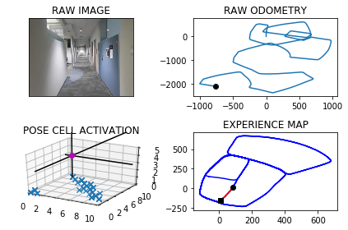

The counter is 8109

The angle is reset to 135.95036968549974

Energy injection at [1, 9]

min_delta_val

1.0

e_pc 2 8

current pc 1 8

loop closure

The counter is 8110

The angle is reset to 135.6652587798498

Energy injection at [1, 9]

The counter is 8111

The angle is reset to 134.94068114589484

Energy injection at [2, 8]

min_delta_val

0.0

e_pc 2 8

current pc 2 8

The counter is 8112

The angle is reset to 134.95847680212637

Energy injection at [2, 8]

min_delta_val

1.0

e_pc 3 8

current pc 2 8

The counter is 8113

The angle is reset to 134.97093376148845

Energy injection at [2, 8]

The counter is 8124

The angle is reset to 149.52965363304193

Energy injection at [5, 3]

The counter is 8128

The angle is reset to 159.19575754312933

Energy injection at [5, 1]

min_delta_val

0.0

e_pc 5 1

current pc 5 1

loop closure

The counter is 8129

The angle is reset to 165.43703028019053

Energy injection at [5, 1]

min_delta_val

0.0

e_pc 5 1

current pc 5 1

The counter is 8130

The angle is reset to 169.80592119613337

Energy injection at [5, 1]

min_delta_val

1.0

e_pc 5 0

current pc 5 1

loop closure

The counter is 8131

The angle is reset to 172.86414483729334

Energy injection at [5, 1]

The counter is 8132

The angle is reset to 175.00490138610533

Energy injection at [5, 0]

min_delta_val

0.0

e_pc 5 0

current pc 5 0

The counter is 8133

The angle is reset to 176.50343097027374

Energy injection at [5, 0]

The counter is 8134

The angle is reset to 177.02740167919163

Energy injection at [5, 0]

min_delta_val

0.0

e_pc 5 8

current pc 5 0

The counter is 8135

The angle is reset to 177.91918117543415

Energy injection at [5, 0]

The counter is 8138

The angle is reset to 179.06842682280387

Energy injection at [5, 8]

min_delta_val

0.0

e_pc 5 8

current pc 5 8

loop closure

The counter is 8139

The angle is reset to 179.8728987759627

Energy injection at [5, 9]

min_delta_val

1.0

e_pc 5 8

current pc 5 9

loop closure

The counter is 8140

The angle is reset to 179.9110291431739

Energy injection at [5, 8]

min_delta_val

0.0

e_pc 5 8

current pc 5 8

loop closure

The counter is 8141

The angle is reset to 179.9377204002217

Energy injection at [5, 8]

min_delta_val

0.0

e_pc 5 8

current pc 5 8

The counter is 8142

The angle is reset to 179.9564042801552

Energy injection at [5, 8]

The counter is 8143

The angle is reset to 179.96948299610864

Energy injection at [5, 8]

min_delta_val

0.0

e_pc 5 7

current pc 5 7

The counter is 8144

The angle is reset to 179.453638097276

Energy injection at [5, 8]

The counter is 8147

The angle is reset to 179.09254666809323

Energy injection at [5, 6]

The counter is 8148

The angle is reset to 179.36478266766525

Energy injection at [5, 6]

min_delta_val

0.0

e_pc 5 6

current pc 5 6

loop closure

The counter is 8149

The angle is reset to 179.55534786736567

Energy injection at [5, 6]

The counter is 8150

The angle is reset to 179.68874350715595

Energy injection at [5, 6]

min_delta_val

1.0

e_pc 5 5

current pc 5 6

The counter is 8151

The angle is reset to 179.78212045500916

Energy injection at [5, 6]

The counter is 8152

The angle is reset to 179.84748431850642

Energy injection at [5, 6]

min_delta_val

0.0

e_pc 5 6

current pc 5 6

The counter is 8153

The angle is reset to 179.89323902295448

Energy injection at [5, 6]

The counter is 8154

The angle is reset to 179.9252673160681

Energy injection at [5, 6]

min_delta_val

1.0

e_pc 5 6

current pc 5 5

The counter is 8171

The angle is reset to 178.89768712124766

Energy injection at [5, 0]

The counter is 8172

The angle is reset to 179.22838098487335

Energy injection at [5, 0]

The counter is 8174

The angle is reset to 179.98486668941132

Energy injection at [5, 6]

The counter is 8175

The angle is reset to 179.9894066825879

Energy injection at [5, 6]

The counter is 8176

The angle is reset to 180.51758467781153

Energy injection at [5, 6]

min_delta_val

1.0

e_pc 5 6

current pc 5 5

loop closure

The counter is 8180

The angle is reset to 179.31230927446808

Energy injection at [5, 4]

min_delta_val

0.0

e_pc 5 4

current pc 5 4

loop closure

The counter is 8184

The angle is reset to 180.56861649212766

Energy injection at [5, 3]

min_delta_val

0.0

e_pc 5 3

current pc 5 3

loop closure

The counter is 8185

The angle is reset to 180.92303154448933

Energy injection at [5, 3]

min_delta_val

0.0

e_pc 5 3

current pc 5 3

loop closure

The counter is 8194

The angle is reset to 180.12112208114254

Energy injection at [5, 0]

min_delta_val

0.0

e_pc 5 0

current pc 5 0

loop closure

The counter is 8195

The angle is reset to 180.08478545679978

Energy injection at [5, 9]

min_delta_val

1.0

e_pc 5 9

current pc 5 0

The counter is 8196

The angle is reset to 180.05934981975983

Energy injection at [5, 0]

min_delta_val

1.0

e_pc 5 0

current pc 5 9

loop closure

The counter is 8197

The angle is reset to 180.04154487383187

Energy injection at [5, 0]

min_delta_val

1.0

e_pc 5 0

current pc 5 9

The counter is 8198

The angle is reset to 180.0290814116823

Energy injection at [5, 0]

-----------------------------------------------------------

The current number of the iteration is 8200

65.5959999561 seconds are elapsed per 100 frames.

The number of units of the VT is 3153

The number of units of the experience map is 3333

02/20/19 09:33:47

-----------------------------------------------------------

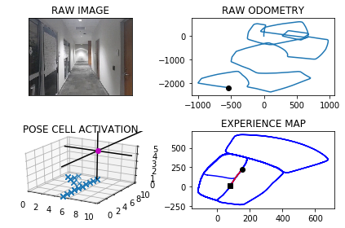

The counter is 8201

The angle is reset to 180.0203569881776

Energy injection at [5, 7]

The counter is 8202

The angle is reset to 179.4892498917243

Energy injection at [5, 7]

The counter is 8203

The angle is reset to 179.64247492420702

Energy injection at [5, 7]

The counter is 8206

The angle is reset to 179.7497324469449

Energy injection at [5, 6]

min_delta_val

0.0

e_pc 5 6

current pc 5 6

loop closure

The counter is 8207

The angle is reset to 179.82481271286142

Energy injection at [5, 6]

min_delta_val

0.0

e_pc 5 6

current pc 5 6

loop closure

The counter is 8208

The angle is reset to 179.87736889900296

Energy injection at [5, 6]

The counter is 8209

The angle is reset to 179.9141582293021

Energy injection at [5, 5]

hash collision

The counter is 8210

The angle is reset to 179.93991076051145

Energy injection at [5, 5]

hash collision

The counter is 8217

The angle is reset to 179.432937532358

Energy injection at [5, 3]

min_delta_val

1.0

e_pc 5 2

current pc 5 3

loop closure

The counter is 8218

The angle is reset to 179.60305627265063

Energy injection at [5, 2]

min_delta_val

1.0

e_pc 5 2

current pc 5 3

The counter is 8219

The angle is reset to 179.7221393908554

Energy injection at [5, 2]

The counter is 8220

The angle is reset to 179.80549757359879

Energy injection at [5, 2]

min_delta_val

1.0

e_pc 5 2

current pc 5 1

The counter is 8221

The angle is reset to 179.8638483015191

Energy injection at [5, 1]

min_delta_val

0.0

e_pc 5 1

current pc 5 1

The counter is 8222

The angle is reset to 179.9046938110634

Energy injection at [5, 1]

The counter is 8223

The angle is reset to 179.93328566774437

Energy injection at [5, 1]

min_delta_val

1.0

e_pc 5 1

current pc 5 0

The counter is 8224

The angle is reset to 179.95329996742106

Energy injection at [5, 1]

The counter is 8225

The angle is reset to 179.44230997719472

Energy injection at [5, 0]

min_delta_val

0.0

e_pc 5 0

current pc 5 0

The counter is 8226

The angle is reset to 179.60961698403628

Energy injection at [5, 0]

The counter is 8227

The angle is reset to 179.7267318888254

Energy injection at [5, 0]

min_delta_val

0.0

e_pc 5 9

current pc 5 9

The counter is 8228

The angle is reset to 179.2837123221778

Energy injection at [5, 0]

min_delta_val

1.0

e_pc 5 9

current pc 5 0

The counter is 8229

The angle is reset to 179.49859862552444

Energy injection at [5, 0]

The counter is 8230

The angle is reset to 179.64901903786708

Energy injection at [5, 9]

min_delta_val

1.0

e_pc 5 9

current pc 5 0

The counter is 8231

The angle is reset to 180.27931332650695

Energy injection at [5, 0]

hash collision

The counter is 8232

The angle is reset to 180.72051932855484

Energy injection at [5, 0]

hash collision

The counter is 8233

The angle is reset to 180.50436352998838

Energy injection at [5, 8]

min_delta_val

1.0

e_pc 5 8

current pc 5 9

loop closure

The counter is 8234

The angle is reset to 180.35305447099188

Energy injection at [5, 8]

The counter is 8235

The angle is reset to 180.24713812969432

Energy injection at [5, 8]

The counter is 8236

The angle is reset to 179.64799669078602

Energy injection at [5, 8]

min_delta_val

1.0

e_pc 5 8

current pc 5 7

loop closure

The counter is 8242

The angle is reset to 180.80359768355024

Energy injection at [5, 7]

min_delta_val

0.0

e_pc 5 7

current pc 5 7

loop closure

The counter is 8243

The angle is reset to 180.56251837848515

Energy injection at [5, 7]

The counter is 8244

The angle is reset to 180.3937628649396

Energy injection at [5, 7]

min_delta_val

0.0

e_pc 5 7

current pc 5 7

The counter is 8245

The angle is reset to 180.2756340054577

Energy injection at [5, 7]

min_delta_val

0.0

e_pc 5 7

current pc 5 7

loop closure

The counter is 8248

The angle is reset to 180.19294380382038

Energy injection at [5, 5]

The counter is 8249

The angle is reset to 180.13506066267425

Energy injection at [5, 5]

The counter is 8250

The angle is reset to 180.094542463872

Energy injection at [5, 6]

min_delta_val

1.0

e_pc 5 6

current pc 5 5

loop closure

The counter is 8251

The angle is reset to 180.0661797247104

Energy injection at [5, 6]

min_delta_val

0.0

e_pc 5 6

current pc 5 6

The counter is 8258

The angle is reset to 182.14632580729725

Energy injection at [5, 3]

min_delta_val

0.0

e_pc 5 3

current pc 5 3

loop closure

The counter is 8259

The angle is reset to 180.97742806510806

Energy injection at [5, 3]

The counter is 8260

The angle is reset to 180.68419964557563

Energy injection at [5, 3]

min_delta_val

0.0

e_pc 5 3

current pc 5 3

The counter is 8261

The angle is reset to 180.47893975190294

Energy injection at [5, 3]

The counter is 8262

The angle is reset to 180.33525782633203

Energy injection at [5, 3]

The counter is 8263

The angle is reset to 180.23468047843244

Energy injection at [5, 2]

min_delta_val

1.0

e_pc 5 2

current pc 5 3

The counter is 8266

The angle is reset to 180.1642763349027

Energy injection at [5, 2]

min_delta_val

0.0

e_pc 5 2

current pc 5 2

loop closure

The counter is 8270

The angle is reset to 179.58999343443188

Energy injection at [5, 3]

The counter is 8271

The angle is reset to 179.18799540410225

Energy injection at [5, 3]

The counter is 8272

The angle is reset to 179.4315967828716

Energy injection at [5, 2]

min_delta_val

0.0

e_pc 5 2

current pc 5 2

loop closure

The counter is 8273

The angle is reset to 179.0771177480101

Energy injection at [5, 2]

The counter is 8280

The angle is reset to 181.45398242360707

Energy injection at [5, 2]

min_delta_val

0.0

e_pc 5 2

current pc 5 2

loop closure

The counter is 8281

The angle is reset to 181.01778769652492

Energy injection at [5, 2]

The counter is 8282

The angle is reset to 180.71245138756743

Energy injection at [5, 2]

The counter is 8283

The angle is reset to 180.4987159712972

Energy injection at [5, 2]

min_delta_val

1.0

e_pc 5 1

current pc 5 2

The counter is 8284

The angle is reset to 180.34910117990805

Energy injection at [5, 2]

The counter is 8285

The angle is reset to 179.7193708259356

Energy injection at [5, 2]

The counter is 8286

The angle is reset to 179.80355957815493

Energy injection at [5, 2]

The counter is 8287

The angle is reset to 180.38749170470848

Energy injection at [5, 2]

The counter is 8288

The angle is reset to 180.7962441932959

Energy injection at [5, 0]

min_delta_val

1.0

e_pc 5 0

current pc 5 1

loop closure

The counter is 8289

The angle is reset to 181.08237093530713

Energy injection at [5, 0]

The counter is 8290

The angle is reset to 180.75765965471496

Energy injection at [5, 0]

The counter is 8291

The angle is reset to 180.53036175830047

Energy injection at [5, 0]

The counter is 8292

The angle is reset to 180.3712532308103

Energy injection at [5, 9]

min_delta_val

0.0

e_pc 5 9

current pc 5 9

loop closure

The counter is 8293

The angle is reset to 180.2598772615672

Energy injection at [5, 9]

The counter is 8294

The angle is reset to 180.18191408309704

Energy injection at [5, 9]

The counter is 8295

The angle is reset to 180.65233985816792

Energy injection at [5, 0]

min_delta_val

1.0

e_pc 5 0

current pc 5 9

loop closure

The counter is 8296

The angle is reset to 180.45663790071757

Energy injection at [5, 0]

The counter is 8297

The angle is reset to 179.79464653050226

Energy injection at [5, 9]

min_delta_val

1.0

e_pc 5 9

current pc 5 0

The counter is 8298

The angle is reset to 179.85625257135158

Energy injection at [5, 9]

The counter is 8299

The angle is reset to 181.4743767999461

Energy injection at [5, 9]

The counter is 8300

The angle is reset to 181.55706375996226

Energy injection at [5, 9]

-----------------------------------------------------------

The current number of the iteration is 8300

84.5329999924 seconds are elapsed per 100 frames.

The number of units of the VT is 3171

The number of units of the experience map is 3355

02/20/19 09:35:11

-----------------------------------------------------------

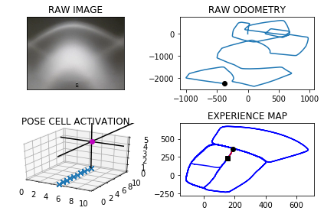

The counter is 8301

The angle is reset to 181.6149446319736

Energy injection at [5, 9]

min_delta_val

0.0

e_pc 5 9

current pc 5 9

The counter is 8302

The angle is reset to 181.13046124238147

Energy injection at [5, 9]

The counter is 8303

The angle is reset to 181.31632286966703

Energy injection at [5, 9]

The counter is 8304

The angle is reset to 181.4464260087669

Energy injection at [5, 9]

The counter is 8305

The angle is reset to 181.01249820613683

Energy injection at [5, 9]

The counter is 8306

The angle is reset to 180.70874874429578

Energy injection at [5, 9]

The counter is 8307

The angle is reset to 180.49612412100703

Energy injection at [5, 9]

The counter is 8308

The angle is reset to 182.4472868847049

Energy injection at [5, 9]

min_delta_val

0.0

e_pc 5 9

current pc 5 9

The counter is 8309

The angle is reset to 184.3381008192934

Energy injection at [5, 9]

min_delta_val

0.0

e_pc 5 9

current pc 5 9

The counter is 8310

The angle is reset to 187.2366705735054

Energy injection at [5, 9]

min_delta_val

0.0

e_pc 5 9

current pc 5 9

loop closure

The counter is 8314

The angle is reset to 217.99066940145377

Energy injection at [5, 8]

min_delta_val

0.0

e_pc 5 8

current pc 5 8

loop closure

The counter is 8315

The angle is reset to 224.29346858101763

Energy injection at [5, 8]

min_delta_val

0.0

e_pc 5 8

current pc 5 8

The counter is 8316

The angle is reset to 228.70542800671234

Energy injection at [5, 8]

min_delta_val

1.0

e_pc 5 8

current pc 5 7

loop closure

The counter is 8317

The angle is reset to 230.74379960469864

Energy injection at [5, 8]

min_delta_val

1.0

e_pc 5 8

current pc 5 7

The counter is 8318

The angle is reset to 231.12065972328904

Energy injection at [5, 7]

min_delta_val

0.0

e_pc 5 7

current pc 5 7

loop closure

The counter is 8319

The angle is reset to 230.85946180630233

Energy injection at [5, 7]

min_delta_val

0.0

e_pc 5 7

current pc 5 7

loop closure

The counter is 8320

The angle is reset to 231.20162326441167

Energy injection at [5, 7]

min_delta_val

0.0

e_pc 5 7

current pc 5 7

loop closure

The counter is 8321

The angle is reset to 230.39113628508818

Energy injection at [5, 8]

min_delta_val

1.0

e_pc 5 8

current pc 5 7

loop closure

The counter is 8322

The angle is reset to 229.8237953995617

Energy injection at [5, 8]

min_delta_val

0.0

e_pc 5 8

current pc 5 8

The counter is 8324

The angle is reset to 242.92665677969322

Energy injection at [5, 7]

min_delta_val

1.0

e_pc 4 7

current pc 5 7

loop closure

The counter is 8325

The angle is reset to 238.07365974578525

Energy injection at [4, 7]

min_delta_val

0.0

e_pc 4 7

current pc 4 7

The counter is 8326

The angle is reset to 235.20156182204968

Energy injection at [4, 7]

min_delta_val

0.0

e_pc 4 7

current pc 4 7

The counter is 8327

The angle is reset to 232.14109327543474

Energy injection at [4, 7]

The counter is 8328

The angle is reset to 230.5237652928043

Energy injection at [4, 7]

min_delta_val

1.0

e_pc 4 7

current pc 4 6

The counter is 8332

The angle is reset to 228.34163570496304

Energy injection at [4, 7]

min_delta_val

1.0

e_pc 4 7

current pc 3 7

loop closure

The counter is 8333

The angle is reset to 227.3391449934741

Energy injection at [4, 7]

The counter is 8334

The angle is reset to 226.63740149543185

Energy injection at [4, 7]

The counter is 8335

The angle is reset to 226.1461810468023

Energy injection at [4, 7]

The counter is 8336

The angle is reset to 225.80232673276157

Energy injection at [3, 6]

min_delta_val

0.0

e_pc 3 6

current pc 3 6

The counter is 8339

The angle is reset to 225.56162871293307

Energy injection at [3, 6]

hash collision

The counter is 8342

The angle is reset to 225.39314009905317

Energy injection at [3, 6]

min_delta_val

0.0

e_pc 3 6

current pc 3 6

loop closure

The counter is 8346

The angle is reset to 224.7501980693372

Energy injection at [3, 6]

min_delta_val

0.0

e_pc 3 6

current pc 3 6

loop closure

The counter is 8347

The angle is reset to 224.82513864853604

Energy injection at [3, 6]

The counter is 8350

The angle is reset to 225.9275970539752

Energy injection at [3, 6]

min_delta_val

0.0

e_pc 3 6

current pc 3 6

loop closure

The counter is 8356

The angle is reset to 225.12431793778265

Energy injection at [2, 5]

hash collision

The counter is 8357

The angle is reset to 225.08702255644783

Energy injection at [1, 4]

counter 8357

multiple peak # >2

[1L, 1L, 2L] [3L, 4L, 4L]

The counter is 8358

The angle is reset to 225.06091578951347

Energy injection at [1, 4]

The counter is 8359

The angle is reset to 225.0426410526594

Energy injection at [2, 3]

counter 8359

multiple peak # >2

[1L, 1L, 2L] [3L, 4L, 3L]

min_delta_val

1.0

e_pc 2 3

current pc 1 3

loop closure

The counter is 8360

The angle is reset to 225.0298487368616

Energy injection at [2, 3]

The counter is 8361

The angle is reset to 225.02089411580312

Energy injection at [1, 4]

The counter is 8362

The angle is reset to 225.53962588106216

Energy injection at [1, 4]

The counter is 8363

The angle is reset to 225.3777381167435

Energy injection at [1, 3]

min_delta_val

0.0

e_pc 1 3

current pc 1 3

loop closure

The counter is 8364

The angle is reset to 225.26441668172046

Energy injection at [2, 5]

counter 8364

multiple peak # >2

[1L, 2L, 2L] [4L, 4L, 5L]

min_delta_val

1.4142135623730951

e_pc 2 5

current pc 1 4

loop closure

The counter is 8366

The angle is reset to 224.66009167720426

Energy injection at [1, 4]

min_delta_val

0.0

e_pc 1 4

current pc 1 4

loop closure

The counter is 8367

The angle is reset to 224.762064174043

Energy injection at [0, 3]

min_delta_val

1.4142135623730951

e_pc 1 2

current pc 0 3

loop closure

The counter is 8368

The angle is reset to 224.83344492183008

Energy injection at [1, 2]

counter 8368

multiple peak # >2

[0L, 0L, 9L] [1L, 2L, 2L]

min_delta_val

1.4142135623730951

e_pc 1 2

current pc 0 1

The counter is 8369

The angle is reset to 224.88341144528107

Energy injection at [1, 2]

hash collision

The counter is 8370

The angle is reset to 225.44338801169673

Energy injection at [1, 2]

min_delta_val

0.0

e_pc 1 2

current pc 1 2

loop closure

The counter is 8371

The angle is reset to 225.31037160818772

Energy injection at [1, 2]

The counter is 8372

The angle is reset to 225.74226012573138

Energy injection at [9, 2]

hash collision

The counter is 8373

The angle is reset to 226.04458208801196

Energy injection at [9, 2]

The counter is 8374

The angle is reset to 226.25620746160837

Energy injection at [0, 2]

min_delta_val

0.0

e_pc 0 2

current pc 0 2

loop closure

The counter is 8375

The angle is reset to 226.40434522312586

Energy injection at [0, 1]

hash collision

The counter is 8376

The angle is reset to 225.98304165618808

Energy injection at [0, 1]

hash collision

The counter is 8377

The angle is reset to 225.68812915933168

Energy injection at [9, 0]

min_delta_val

1.4142135623730951

e_pc 9 0

current pc 0 1

loop closure

The counter is 8378

The angle is reset to 225.48169041153213

Energy injection at [0, 1]

min_delta_val

0.0

e_pc 0 1

current pc 0 1

loop closure

The counter is 8379

The angle is reset to 225.33718328807248

Energy injection at [0, 1]

The counter is 8380

The angle is reset to 225.23602830165075

Energy injection at [8, 1]

The counter is 8381

The angle is reset to 225.16521981115548

Energy injection at [8, 1]

The counter is 8382

The angle is reset to 225.11565386780885

Energy injection at [8, 0]

min_delta_val

1.0

e_pc 7 0

current pc 8 0

loop closure

The counter is 8383

The angle is reset to 225.08095770746618

Energy injection at [7, 0]

min_delta_val

0.0

e_pc 7 0

current pc 7 0

The counter is 8384

The angle is reset to 225.05667039522632

Energy injection at [8, 1]

min_delta_val

1.4142135623730951

e_pc 8 1

current pc 7 0

loop closure

The counter is 8385

The angle is reset to 225.0396692766584

Energy injection at [8, 1]

min_delta_val

0.0

e_pc 7 1

current pc 7 1

The counter is 8386

The angle is reset to 225.0277684936609

Energy injection at [7, 0]

The counter is 8387

The angle is reset to 225.01943794556263

Energy injection at [7, 0]

min_delta_val

1.4142135623730951

e_pc 6 9

current pc 7 0

loop closure

The counter is 8388

The angle is reset to 225.0136065618938

Energy injection at [7, 0]

The counter is 8389

The angle is reset to 225.00952459332564

Energy injection at [7, 0]

min_delta_val

1.0

e_pc 7 9

current pc 6 9

The counter is 8390

The angle is reset to 225.53166721532796

Energy injection at [6, 9]

hash collision

The counter is 8391

The angle is reset to 225.89716705072954

Energy injection at [6, 8]

min_delta_val

1.0

e_pc 5 7

current pc 6 9

loop closure

The counter is 8392

The angle is reset to 226.6780169355107

Energy injection at [5, 7]

counter 8392

multiple peak # >2

[4L, 4L, 5L] [7L, 8L, 8L]

The counter is 8393

The angle is reset to 231.4246118548575

Energy injection at [5, 7]

min_delta_val

1.0

e_pc 5 7

current pc 4 7

loop closure

The counter is 8394

The angle is reset to 230.54722829840026

Energy injection at [5, 7]

min_delta_val

1.0

e_pc 4 7

current pc 5 7

The counter is 8395

The angle is reset to 229.40805980888018

Energy injection at [5, 7]

The counter is 8396

The angle is reset to 230.71064186621612

Energy injection at [4, 8]

min_delta_val

1.4142135623730951

e_pc 4 8

current pc 3 7

The counter is 8397

The angle is reset to 230.0474493063513

Energy injection at [4, 8]

min_delta_val

1.0

e_pc 4 8

current pc 4 7

The counter is 8398

The angle is reset to 229.58321451444593

Energy injection at [4, 8]

min_delta_val

1.0

e_pc 3 8

current pc 4 8

The counter is 8399

The angle is reset to 229.78325016011212

Energy injection at [4, 8]

The counter is 8400

The angle is reset to 230.97327511207848

Energy injection at [4, 8]

min_delta_val

0.0

e_pc 4 8

current pc 4 8

-----------------------------------------------------------

The current number of the iteration is 8400

133.740999937 seconds are elapsed per 100 frames.

The number of units of the VT is 3183

The number of units of the experience map is 3373

02/20/19 09:37:25

-----------------------------------------------------------

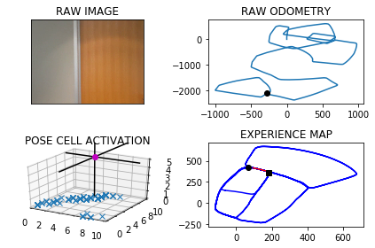

over

over

over

The counter is 8420

The angle is reset to 303.4312925784549

Energy injection at [9, 9]

The counter is 8421

The angle is reset to 306.90190480491844

Energy injection at [8, 8]

min_delta_val

1.4142135623730951

e_pc 7 9

current pc 8 8

loop closure

The counter is 8422

The angle is reset to 309.3313333634429

Energy injection at [8, 8]

The counter is 8423

The angle is reset to 311.55693335441

Energy injection at [8, 8]

The counter is 8424

The angle is reset to 313.11485334808697

Energy injection at [8, 8]

min_delta_val

0.0

e_pc 8 8

current pc 8 8

The counter is 8425

The angle is reset to 313.68039734366084

Energy injection at [8, 8]

The counter is 8431

The angle is reset to 314.0762781405626

Energy injection at [8, 8]

min_delta_val

0.0

e_pc 8 8

current pc 8 8

loop closure

The counter is 8432

The angle is reset to 314.3533946983938

Energy injection at [7, 6]

hash collision

The counter is 8433

The angle is reset to 314.5473762888756

Energy injection at [8, 8]

min_delta_val

0.0

e_pc 8 8

current pc 8 8

The counter is 8434

The angle is reset to 314.6831634022129

Energy injection at [8, 8]

min_delta_val

0.0

e_pc 8 8

current pc 8 8

loop closure

The counter is 8435

The angle is reset to 315.303214381549

Energy injection at [8, 8]

The counter is 8436

The angle is reset to 315.2122500670843

Energy injection at [8, 8]

The counter is 8439

The angle is reset to 314.623575046959

Energy injection at [7, 7]

min_delta_val

0.0

e_pc 7 7

current pc 7 7

loop closure

The counter is 8442

The angle is reset to 313.68650253287126

Energy injection at [5, 7]

The counter is 8443

The angle is reset to 314.0805517730099

Energy injection at [5, 7]

The counter is 8446

The angle is reset to 314.3563862411069

Energy injection at [5, 8]

min_delta_val

1.0

e_pc 5 8

current pc 5 7

loop closure

The counter is 8447

The angle is reset to 314.5494703687748

Energy injection at [5, 8]

The counter is 8448

The angle is reset to 314.68462925814237

Energy injection at [5, 8]

min_delta_val

1.4142135623730951

e_pc 5 8

current pc 4 9

The counter is 8449

The angle is reset to 314.2542404806996

Energy injection at [5, 8]

hash collision

The counter is 8450

The angle is reset to 314.4779683364897

Energy injection at [5, 8]

min_delta_val

0.0

e_pc 5 8

current pc 5 8

loop closure

The counter is 8451

The angle is reset to 314.6345778355428

Energy injection at [4, 0]

The counter is 8452

The angle is reset to 314.7442044848799

Energy injection at [4, 0]

The counter is 8453

The angle is reset to 314.82094313941593

Energy injection at [4, 0]

The counter is 8454

The angle is reset to 314.87466019759114

Energy injection at [4, 0]

The counter is 8455

The angle is reset to 314.9122621383138

Energy injection at [4, 0]

The counter is 8456

The angle is reset to 314.9385834968196

Energy injection at [4, 0]

The counter is 8457

The angle is reset to 314.95700844777366

Energy injection at [4, 0]

min_delta_val

1.0

e_pc 4 0

current pc 4 1

loop closure

The counter is 8458

The angle is reset to 314.96990591344155

Energy injection at [4, 0]

min_delta_val

1.0

e_pc 4 0

current pc 4 1

The counter is 8459

The angle is reset to 314.9789341394091

Energy injection at [4, 0]

The counter is 8460

The angle is reset to 314.98525389758635

Energy injection at [4, 0]

min_delta_val

0.0

e_pc 4 0

current pc 4 0

The counter is 8461

The angle is reset to 314.98967772831037

Energy injection at [4, 0]

The counter is 8462

The angle is reset to 314.9927744098173

Energy injection at [4, 0]

min_delta_val

0.0

e_pc 4 0

current pc 4 0

The counter is 8463

The angle is reset to 314.9949420868721

Energy injection at [4, 0]

The counter is 8464

The angle is reset to 314.99645946081046

Energy injection at [3, 1]

min_delta_val

1.0

e_pc 4 0

current pc 3 0

loop closure

The counter is 8465

The angle is reset to 314.9975216225673

Energy injection at [3, 1]

min_delta_val

0.0

e_pc 3 1

current pc 3 1

loop closure

The counter is 8466

The angle is reset to 314.9982651357971

Energy injection at [3, 1]

The counter is 8473

The angle is reset to 314.47378559505796

Energy injection at [2, 1]

min_delta_val

0.0

e_pc 2 1

current pc 2 1

loop closure

The counter is 8474

The angle is reset to 314.10664991654056

Energy injection at [2, 1]

The counter is 8475

The angle is reset to 314.3746549415784

Energy injection at [1, 1]

min_delta_val

0.0

e_pc 1 1

current pc 1 1

The counter is 8476

The angle is reset to 314.5622584591049

Energy injection at [2, 2]

min_delta_val

1.0

e_pc 2 2

current pc 2 1

loop closure

The counter is 8477

The angle is reset to 314.6935809213734

Energy injection at [2, 2]

min_delta_val

0.0

e_pc 2 2

current pc 2 2

The counter is 8478

The angle is reset to 314.78550664496134

Energy injection at [2, 2]

The counter is 8479

The angle is reset to 315.37485465147296

Energy injection at [2, 2]

The counter is 8480

The angle is reset to 315.7873982560311

Energy injection at [2, 2]

min_delta_val

1.0

e_pc 1 3

current pc 1 2

The counter is 8481

The angle is reset to 316.0761787792217

Energy injection at [2, 2]

The counter is 8482

The angle is reset to 329.25332514545516

Energy injection at [9, 6]

min_delta_val

5.0

e_pc 9 6

current pc 2 2

new experience map with case 2

The counter is 8483

The angle is reset to 324.9773276018187

Energy injection at [9, 6]

The counter is 8484

The angle is reset to 321.98412932127303

Energy injection at [9, 6]

The counter is 8485

The angle is reset to 319.8888905248911

Energy injection at [8, 7]

hash collision

The counter is 8486

The angle is reset to 317.89722336742375

Energy injection at [8, 7]

min_delta_val

0.0

e_pc 8 7

current pc 8 7

loop closure

The counter is 8487

The angle is reset to 317.0280563571966

Energy injection at [8, 7]

The counter is 8488

The angle is reset to 316.41963945003755

Energy injection at [8, 6]

min_delta_val

1.0

e_pc 8 6

current pc 8 7

The counter is 8489

The angle is reset to 329.4937476150263

Energy injection at [9, 7]

min_delta_val

1.0

e_pc 9 7

current pc 8 7

The counter is 8490

The angle is reset to 338.6456233305184

Energy injection at [9, 8]

The counter is 8491

The angle is reset to 345.57693633136284

Energy injection at [9, 8]

The counter is 8492

The angle is reset to 350.428855431954

Energy injection at [9, 7]

min_delta_val

1.0

e_pc 9 7

current pc 9 8

loop closure

The counter is 8493

The angle is reset to 353.3001988023678

Energy injection at [9, 7]

min_delta_val

1.0

e_pc 9 8

current pc 9 7

loop closure

The counter is 8494

The angle is reset to 355.31013916165745

Energy injection at [9, 7]

min_delta_val

0.0

e_pc 9 7

current pc 9 7

loop closure

The counter is 8495

The angle is reset to 356.71709741316016

Energy injection at [9, 7]

The counter is 8496

The angle is reset to 357.7019681892121

Energy injection at [9, 7]

-----------------------------------------------------------

The current number of the iteration is 8500

75.8180000782 seconds are elapsed per 100 frames.

The number of units of the VT is 3208

The number of units of the experience map is 3405

02/20/19 09:38:41

-----------------------------------------------------------

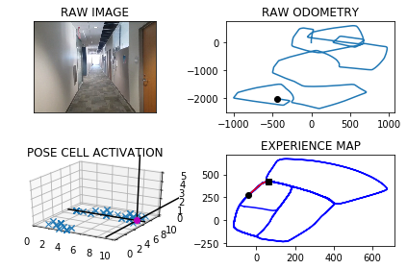

The counter is 8501

The angle is reset to 357.8663777324484

Energy injection at [9, 0]

The counter is 8502

The angle is reset to 358.5064644127139

Energy injection at [9, 0]

The counter is 8505

The angle is reset to 358.9545250888997

Energy injection at [9, 0]

min_delta_val

0.0

e_pc 9 0

current pc 9 0

loop closure

The counter is 8508

The angle is reset to 358.2181675622297

Energy injection at [9, 1]

min_delta_val

0.0

e_pc 9 1

current pc 9 1

loop closure

The counter is 8509

The angle is reset to 358.7527172935608

Energy injection at [9, 0]

min_delta_val

1.0

e_pc 9 1

current pc 9 0

loop closure

The counter is 8510

The angle is reset to 359.12690210549255

Energy injection at [9, 0]

The counter is 8511

The angle is reset to 359.3888314738448

Energy injection at [9, 2]

min_delta_val

1.0

e_pc 9 2

current pc 9 1

The counter is 8512

The angle is reset to 359.5721820316913

Energy injection at [9, 2]

The counter is 8513

The angle is reset to 359.7005274221839

Energy injection at [9, 1]

min_delta_val

1.0

e_pc 9 1

current pc 9 2

loop closure

The counter is 8515

The angle is reset to 359.7903691955287

Energy injection at [9, 2]

min_delta_val

0.0

e_pc 9 2

current pc 9 2

loop closure

The counter is 8516

The angle is reset to 359.8532584368701

Energy injection at [9, 2]

min_delta_val

1.0

e_pc 9 2

current pc 9 3

The counter is 8517

The angle is reset to 359.897280905809

Energy injection at [9, 2]

The counter is 8518

The angle is reset to 359.9280966340663

Energy injection at [9, 3]

min_delta_val

0.0

e_pc 9 3

current pc 9 3

loop closure

The counter is 8519

The angle is reset to 359.4246676438464

Energy injection at [9, 3]

min_delta_val

0.0

e_pc 9 3

current pc 9 3

loop closure

The counter is 8526

The angle is reset to 359.5972673506925

Energy injection at [9, 5]

min_delta_val

0.0

e_pc 9 5

current pc 9 5

loop closure

The counter is 8527

The angle is reset to 0.24308714548473187

Energy injection at [9, 5]

The counter is 8529

The angle is reset to 0.17016100183931232

Energy injection at [9, 5]

min_delta_val

0.0

e_pc 9 5

current pc 9 5

loop closure

The counter is 8530

The angle is reset to 0.11911270128751861

Energy injection at [9, 5]

The counter is 8541

The angle is reset to 1.133378890901263

Energy injection at [9, 7]

min_delta_val

0.0

e_pc 9 7

current pc 9 7

loop closure

The counter is 8545

The angle is reset to 0.26836522363088405

Energy injection at [9, 8]

min_delta_val

0.0

e_pc 9 8

current pc 9 8

loop closure

The counter is 8547

The angle is reset to 0.7128556565416186

Energy injection at [9, 8]

min_delta_val

0.0

e_pc 9 0

current pc 9 8

loop closure

The counter is 8548

The angle is reset to 1.023998959579133

Energy injection at [9, 8]

min_delta_val

0.0

e_pc 9 8

current pc 9 8

loop closure

The counter is 8549

The angle is reset to 1.2417992717053927

Energy injection at [9, 8]

The counter is 8550

The angle is reset to 1.3942594901937748

Energy injection at [9, 9]

min_delta_val

0.0

e_pc 9 9

current pc 9 9

The counter is 8551

The angle is reset to 0.9759816431356424

Energy injection at [9, 9]

The counter is 8556

The angle is reset to 0.15818715019494964

Energy injection at [9, 0]

The counter is 8557

The angle is reset to 0.11073100513646475

Energy injection at [9, 0]

min_delta_val

0.0

e_pc 9 0

current pc 9 0

loop closure

The counter is 8558

The angle is reset to 0.07751170359552531

Energy injection at [9, 0]

The counter is 8559

The angle is reset to 0.5792581925168676

Energy injection at [9, 0]

The counter is 8560

The angle is reset to 0.9304807347618071

Energy injection at [9, 0]

min_delta_val

1.0

e_pc 9 1

current pc 9 0

loop closure

The counter is 8561

The angle is reset to 1.701336514333265

Energy injection at [9, 1]

min_delta_val

1.0

e_pc 9 1

current pc 9 0

loop closure

The counter is 8562

The angle is reset to 2.240935560033285

Energy injection at [9, 1]

min_delta_val

1.0

e_pc 9 1

current pc 9 2

loop closure

The counter is 8565

The angle is reset to 5.243654892023298

Energy injection at [9, 1]

min_delta_val

0.0

e_pc 9 1

current pc 9 1

loop closure

The counter is 8566

The angle is reset to 5.770558424416308

Energy injection at [9, 1]

min_delta_val

1.0

e_pc 9 2

current pc 9 1

The counter is 8579

The angle is reset to 80.3893908970914

Energy injection at [0, 4]

min_delta_val

1.0

e_pc 0 4

current pc 1 4

loop closure

The counter is 8580

The angle is reset to 84.847573627964

Energy injection at [0, 4]

min_delta_val

1.0

e_pc 1 4

current pc 0 4

The counter is 8581

The angle is reset to 87.44330153957479

Energy injection at [1, 4]

min_delta_val

0.0

e_pc 1 4

current pc 1 4

The counter is 8584

The angle is reset to 89.78531107770237

Energy injection at [1, 4]

min_delta_val

0.0

e_pc 1 4

current pc 1 4

loop closure

The counter is 8585

The angle is reset to 89.84971775439165

Energy injection at [1, 4]

The counter is 8589

The angle is reset to 91.99480242807414

Energy injection at [2, 4]

min_delta_val

0.0

e_pc 3 4

current pc 3 4

loop closure

The counter is 8590

The angle is reset to 91.9213616996519

Energy injection at [2, 4]

min_delta_val

0.0

e_pc 2 4

current pc 2 4

loop closure

-----------------------------------------------------------

The current number of the iteration is 8600

75.0339999199 seconds are elapsed per 100 frames.

The number of units of the VT is 3246

The number of units of the experience map is 3445

02/20/19 09:39:56

-----------------------------------------------------------

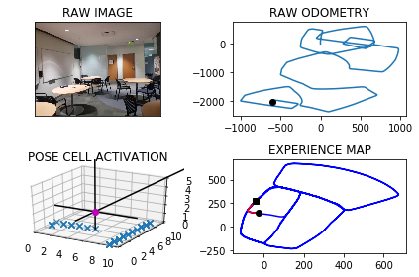

The counter is 8620

The angle is reset to 88.19495318975632

Energy injection at [9, 4]

min_delta_val

1.0

e_pc 9 4

current pc 0 4

loop closure

The counter is 8630

The angle is reset to 84.53646723282942

Energy injection at [2, 4]

min_delta_val

1.0

e_pc 3 4

current pc 2 4

loop closure

The counter is 8657

The angle is reset to 90.37552706298055

Energy injection at [7, 4]

min_delta_val

1.0

e_pc 8 4

current pc 7 4

loop closure

The counter is 8658

The angle is reset to 92.36286894408637

Energy injection at [8, 4]

min_delta_val

0.0

e_pc 8 4

current pc 8 4

loop closure

The counter is 8666

The angle is reset to 129.30400826086046

Energy injection at [1, 4]

-----------------------------------------------------------

The current number of the iteration is 8700

15.7329998016 seconds are elapsed per 100 frames.

The number of units of the VT is 3306

The number of units of the experience map is 3507

02/20/19 09:40:12

-----------------------------------------------------------

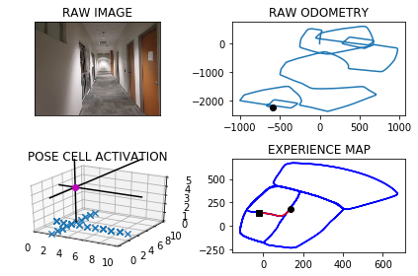

The counter is 8714

The angle is reset to 171.8128057826023

Energy injection at [5, 1]

The counter is 8716

The angle is reset to 174.2689640478216

Energy injection at [5, 1]

min_delta_val

0.0

e_pc 5 0

current pc 5 0

loop closure

The counter is 8774

The angle is reset to 173.8882748334751

Energy injection at [5, 6]

min_delta_val

0.0

e_pc 5 6

current pc 5 6

loop closure

The counter is 8775

The angle is reset to 175.72179238343256

Energy injection at [5, 6]

The counter is 8776

The angle is reset to 177.00525466840278

Energy injection at [5, 6]

min_delta_val

0.0

e_pc 5 4

current pc 5 6

The counter is 8777

The angle is reset to 177.9036782678819

Energy injection at [5, 6]

The counter is 8778

The angle is reset to 178.53257478751735

Energy injection at [5, 3]

The counter is 8779

The angle is reset to 178.97280235126212

Energy injection at [5, 3]

The counter is 8780

The angle is reset to 179.80596164588349

Energy injection at [5, 3]

The counter is 8789

The angle is reset to 178.8141731521184

Energy injection at [5, 2]

min_delta_val

0.0

e_pc 5 2

current pc 5 2

loop closure

The counter is 8790

The angle is reset to 179.16992120648285

Energy injection at [5, 2]

The counter is 8793

The angle is reset to 179.418944844538

Energy injection at [5, 2]

min_delta_val

1.0

e_pc 5 2

current pc 5 1

loop closure

The counter is 8797

The angle is reset to 178.5432613911766

Energy injection at [5, 2]

min_delta_val

1.0

e_pc 5 2

current pc 5 1

loop closure

The counter is 8798

The angle is reset to 178.98028297382356

Energy injection at [5, 2]

The counter is 8799

The angle is reset to 179.2861980816765

Energy injection at [5, 2]

The counter is 8800

The angle is reset to 179.50033865717356

Energy injection at [5, 2]

-----------------------------------------------------------

The current number of the iteration is 8800

22.492000103 seconds are elapsed per 100 frames.

The number of units of the VT is 3362

The number of units of the experience map is 3565

02/20/19 09:40:34

-----------------------------------------------------------

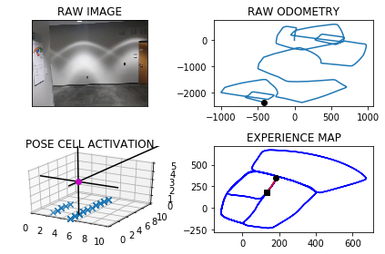

The counter is 8801

The angle is reset to 179.6502370600215

Energy injection at [5, 2]

The counter is 8802

The angle is reset to 179.75516594201505

Energy injection at [5, 2]

min_delta_val

1.0

e_pc 5 1

current pc 5 2

The counter is 8803

The angle is reset to 180.35361615941054

Energy injection at [5, 2]

The counter is 8811

The angle is reset to 178.67253131158736

Energy injection at [5, 0]

min_delta_val

0.0

e_pc 5 0

current pc 5 0

loop closure

The counter is 8812

The angle is reset to 179.07077191811112

Energy injection at [5, 0]

The counter is 8813

The angle is reset to 178.8245403426778

Energy injection at [5, 0]

The counter is 8814

The angle is reset to 179.70217823987443

Energy injection at [5, 0]

The counter is 8815

The angle is reset to 179.7915247679121

Energy injection at [5, 0]

The counter is 8816

The angle is reset to 179.85406733753845

Energy injection at [5, 0]

The counter is 8817

The angle is reset to 179.89784713627694

Energy injection at [5, 0]

The counter is 8818

The angle is reset to 179.40349299539383

Energy injection at [5, 9]

min_delta_val

0.0

e_pc 5 9

current pc 5 9

The counter is 8819

The angle is reset to 179.05744509677567

Energy injection at [5, 0]

min_delta_val

1.0

e_pc 5 0

current pc 5 9

loop closure

The counter is 8820

The angle is reset to 179.34021156774295

Energy injection at [5, 0]

The counter is 8821

The angle is reset to 179.53814809742005

Energy injection at [5, 0]

The counter is 8822

The angle is reset to 179.67670366819405

Energy injection at [5, 0]

The counter is 8823

The angle is reset to 179.7736925677358

Energy injection at [5, 0]

The counter is 8824

The angle is reset to 179.84158479741507

Energy injection at [5, 0]

The counter is 8825

The angle is reset to 180.41410935819053

Energy injection at [5, 9]

min_delta_val

0.0

e_pc 5 9

current pc 5 9

The counter is 8826

The angle is reset to 180.81487655073337

Energy injection at [5, 9]

The counter is 8827

The angle is reset to 181.09541358551337

Energy injection at [5, 9]

The counter is 8828

The angle is reset to 181.29178950985937

Energy injection at [5, 9]

The counter is 8829

The angle is reset to 180.90425265690152

Energy injection at [5, 9]

The counter is 8830

The angle is reset to 181.15797685983108

Energy injection at [5, 9]

min_delta_val

0.0

e_pc 5 9

current pc 5 9

The counter is 8831

The angle is reset to 182.91058380188176

Energy injection at [5, 9]

min_delta_val

0.0

e_pc 5 9

current pc 5 9

The counter is 8832

The angle is reset to 185.1874086613172

Energy injection at [5, 9]

min_delta_val

0.0

e_pc 5 9

current pc 5 9

The counter is 8833

The angle is reset to 187.30618606292202

Energy injection at [5, 9]

min_delta_val

0.0

e_pc 5 9

current pc 5 9

The counter is 8834

The angle is reset to 189.83933024404544

Energy injection at [5, 9]

min_delta_val

0.0

e_pc 5 9

current pc 5 9

The counter is 8835

The angle is reset to 191.6125311708318

Energy injection at [5, 9]

min_delta_val

1.0

e_pc 5 8

current pc 5 9

The counter is 8837

The angle is reset to 195.47877181958228

Energy injection at [5, 8]

min_delta_val

0.0

e_pc 5 8

current pc 5 8

loop closure

The counter is 8838

The angle is reset to 209.06014027370762

Energy injection at [5, 8]

min_delta_val

0.0

e_pc 5 8

current pc 5 8

The counter is 8839

The angle is reset to 217.5170981915953

Energy injection at [5, 8]

min_delta_val

0.0

e_pc 5 8

current pc 5 8

The counter is 8845

The angle is reset to 247.43696873411668

Energy injection at [5, 7]

min_delta_val

0.0

e_pc 5 7

current pc 5 7

loop closure

The counter is 8846

The angle is reset to 254.73087811388166

Energy injection at [5, 7]

The counter is 8847

The angle is reset to 259.8366146797171

Energy injection at [5, 7]

min_delta_val

0.0

e_pc 5 7

current pc 5 7

The counter is 8848

The angle is reset to 263.41063027580196

Energy injection at [5, 7]

The counter is 8849

The angle is reset to 265.38744119306136

Energy injection at [5, 7]

The counter is 8850

The angle is reset to 266.77120883514294

Energy injection at [5, 7]

min_delta_val

1.0

e_pc 4 7

current pc 5 7

The counter is 8851

The angle is reset to 267.73984618459997

Energy injection at [5, 7]

The counter is 8852

The angle is reset to 268.41789232921997

Energy injection at [5, 7]

The counter is 8853

The angle is reset to 268.8925246304539

Energy injection at [5, 7]

The counter is 8854

The angle is reset to 269.22476724131775

Energy injection at [5, 7]

The counter is 8855

The angle is reset to 256.4823370689224

Energy injection at [4, 7]

min_delta_val

0.0

e_pc 4 7

current pc 4 7

The counter is 8856

The angle is reset to 247.56263594824568

Energy injection at [4, 7]

The counter is 8857

The angle is reset to 241.31884516377195

Energy injection at [4, 7]

min_delta_val

0.0

e_pc 4 7

current pc 4 7

The counter is 8858

The angle is reset to 236.42319161464036

Energy injection at [4, 7]

The counter is 8859

The angle is reset to 233.52123413024827

Energy injection at [4, 7]

min_delta_val

0.0

e_pc 4 7

current pc 4 7

The counter is 8860

The angle is reset to 230.96486389117376

Energy injection at [4, 7]

The counter is 8861

The angle is reset to 242.6754047238216

Energy injection at [4, 7]

min_delta_val

0.0

e_pc 4 7

current pc 4 7

loop closure

The counter is 8862

The angle is reset to 236.8477833066751

Energy injection at [4, 7]

min_delta_val

0.0

e_pc 4 7

current pc 4 7

loop closure

The counter is 8863

The angle is reset to 246.79344831467256

Energy injection at [4, 7]

hash collision

The counter is 8864

The angle is reset to 240.25541382027077

Energy injection at [4, 7]

The counter is 8865

The angle is reset to 235.67878967418952

Energy injection at [3, 6]

min_delta_val

0.0

e_pc 3 6

current pc 3 6

The counter is 8866

The angle is reset to 232.47515277193267

Energy injection at [3, 6]

The counter is 8867

The angle is reset to 230.23260694035287

Energy injection at [3, 6]

The counter is 8868

The angle is reset to 229.18782485824698

Energy injection at [3, 6]

hash collision

The counter is 8869

The angle is reset to 227.93147740077288

Energy injection at [3, 6]

hash collision

The counter is 8870

The angle is reset to 214.077034180541

Energy injection at [3, 5]

hash collision

The counter is 8873

The angle is reset to 203.32892392637868

Energy injection at [3, 5]

hash collision

The counter is 8874

The angle is reset to 195.80524674846507

Energy injection at [3, 5]

hash collision

The counter is 8875

The angle is reset to 191.06367272392552

Energy injection at [3, 5]

hash collision

The counter is 8876

The angle is reset to 201.24457090674784

Energy injection at [3, 6]

min_delta_val

1.0

e_pc 3 6

current pc 3 5

loop closure

The counter is 8877

The angle is reset to 208.3711996347235

Energy injection at [3, 6]

The counter is 8878

The angle is reset to 213.35983974430644

Energy injection at [3, 6]

The counter is 8879

The angle is reset to 216.8518878210145

Energy injection at [3, 6]

min_delta_val

0.0

e_pc 3 6

current pc 3 6

The counter is 8880

The angle is reset to 219.29632147471014

Energy injection at [3, 6]

The counter is 8881

The angle is reset to 221.00742503229708

Energy injection at [3, 6]

min_delta_val

1.4142135623730951

e_pc 3 6

current pc 2 5

The counter is 8882

The angle is reset to 222.20519752260793

Energy injection at [3, 6]

min_delta_val

1.4142135623730951

e_pc 3 6

current pc 2 5

loop closure

The counter is 8883

The angle is reset to 223.04363826582554

Energy injection at [3, 6]

none

DONE!

n_ templates: 3372

n_ experiences: 3575